

PAPER EVALUATION USING ARTIFICIAL INTELLIGENCE (HYBRID AI FRAMEWORK FOR RESEARCH PAPER EVALUATION AND REVIEWER RECOMMENDATION)
PeerScope: a local web application that turns a research-paper PDF into a preliminary assessment and an auditable reviewer ranking
A project report submitted in partial fulfilment of the requirements for the award of the degree of
BACHELOR OF TECHNOLOGY
in
COMPUTER SCIENCE AND ENGINEERING
Submitted by
Mula Sreebindu | 23K91A05G3
Puramshetty Vishnu Vardhan | 23K91A05K2
K Sampoorna | 24K95A0512
Korsa Shivashankar | 24K95A0515
Batch C8 (CSE-C)
Under the esteemed guidance of
M Anupama
[DESIGNATION]
DEPARTMENT OF COMPUTER SCIENCE AND ENGINEERING
TKR COLLEGE OF ENGINEERING & TECHNOLOGY (AN AUTONOMOUS INSTITUTION)
Medbowli, Meerpet, Balapur, Hyderabad, Telangana - 500 097
Academic year [ACADEMIC YEAR]

CERTIFICATE
This is to certify that the project report entitled "Paper Evaluation Using Artificial Intelligence (Hybrid AI Framework for Research Paper Evaluation and Reviewer Recommendation)" is a bonafide record of the work carried out by Mula Sreebindu (23K91A05G3), Puramshetty Vishnu Vardhan (23K91A05K2), K Sampoorna (24K95A0512), Korsa Shivashankar (24K95A0515), in partial fulfilment of the requirements for the award of the degree of Bachelor of Technology in Computer Science and Engineering, during the academic year [ACADEMIC YEAR], under my supervision.

Project Guide | Head of the Department | Principal
M Anupama | [HOD NAME] | [PRINCIPAL NAME]
[DESIGNATION] | Department of Computer Science and Engineering | TKR College of Engineering & Technology

External Examiner: [NAME AND SIGNATURE]
Place: [PLACE]
Date: [DATE]

DECLARATION
We hereby declare that the project report entitled "Paper Evaluation Using Artificial Intelligence (Hybrid AI Framework for Research Paper Evaluation and Reviewer Recommendation)", submitted to the Department of Computer Science and Engineering, TKR College of Engineering & Technology, in partial fulfilment of the requirements for the award of the degree of Bachelor of Technology in Computer Science and Engineering, is a record of original work carried out by us under the guidance of M Anupama, [DESIGNATION]. The results embodied in this report have not been submitted to any other university or institution for the award of any degree or diploma.

Mula Sreebindu 23K91A05G3
Puramshetty Vishnu Vardhan 23K91A05K2
K Sampoorna 24K95A0512
Korsa Shivashankar 24K95A0515

Place: [PLACE]
Date: [DATE]

ACKNOWLEDGEMENT
We express our sincere gratitude to our project guide, M Anupama, [DESIGNATION], for valuable guidance, encouragement and constructive suggestions throughout this project.
We thank [HOD NAME], Head of the Department of Computer Science and Engineering, for providing the facilities and support needed to complete this work, and [PRINCIPAL NAME], Principal, TKR College of Engineering & Technology, for the encouragement given to us.
We thank the project coordinators and all faculty and staff members of the department for their help, and our families and friends for their constant support.
We also acknowledge the authors of the base paper, the maintainers of the open-source software used in this project (FastAPI, React, Vite, scikit-learn, sentence-transformers, PyMuPDF, Hugging Face Transformers, PyTorch and SQLAlchemy), the OpenAlex project for its open scholarly index, and the Qwen team for the open-weight language model.

Mula Sreebindu
Puramshetty Vishnu Vardhan
K Sampoorna
Korsa Shivashankar
Journals and conferences receive more submissions than their reviewer pools can absorb. Choosing a suitable reviewer is slow and depends on an editor's personal knowledge of the field, keyword matching favours reviewers who share vocabulary rather than expertise, and first-pass screening of submissions is inconsistent. This project presents PeerScope, a local web application that turns a research-paper PDF into a preliminary, clearly caveated assessment and an auditable ranking of candidate reviewers. The paper is extracted with PyMuPDF, split into sections and described by structural signals; a TF-IDF and logistic-regression model gives a historical decision signal; a locally run instruction-tuned language model (Qwen2.5-1.5B) drafts a critique when it can be loaded; and related literature is retrieved from OpenAlex. Reviewers are ranked by a transparent score that combines sentence-embedding similarity (all-MiniLM-L6-v2), keyword and method overlap, availability and a conflict-of-interest penalty, and every recommendation shows its score breakdown. The work extends the auditable-matching idea of the base paper [1] with paper assessment, a reviewer directory, history and export.
On a held-out split of 280 synthetic labelled papers the decision model reaches 55.0% accuracy (macro F1 0.509); because the labels were generated from the same phrases that appear in the text, no text classifier can exceed about 56% on that data, so the model demonstrates the pipeline and is not evidence of predicting real peer-review decisions. On 40 probe abstracts written by the team, the hybrid ranking puts an acceptable reviewer first in 95% of cases with sentence embeddings and 75% with the offline TF-IDF fallback; all 12 literal conflict links injected into papers were flagged, and none of the paraphrased links was. The deterministic analysis takes seconds; with the local language model one analysis of a three-page paper takes about 9 minutes on a CPU-only PC. The reviewer pool is a set of six demo profiles, the probe labels are the team's own, novelty is not assessed, and no real peer-review data or user study was used; the base paper's results, obtained on 663 papers and 524 reviewers, are therefore not comparable.
Keywords: artificial intelligence, research paper evaluation, reviewer recommendation, natural language processing, semantic similarity, sentence embeddings, large language model, peer review, conflict of interest, decision support, FastAPI, React.

TABLE OF CONTENTS
CERTIFICATE i
DECLARATION ii
ACKNOWLEDGEMENT iii
TABLE OF CONTENTS v
LIST OF FIGURES vii
LIST OF TABLES ix
LIST OF ABBREVIATIONS x
CHAPTER 1: INTRODUCTION 1
1.1 Domain and Background 1
1.2 Motivation 2
1.3 Problem Statement 2
1.4 Need for the Project 3
1.5 Objectives 3
1.6 Scope of the Work 4
1.7 Contributions 5
1.8 Limitations and Assumptions 5
1.9 Organisation of the Report 6
CHAPTER 2: LITERATURE SURVEY 7
2.1 Overview 7
2.2 Analysis of the Base Paper 7
2.3 Related Work by Theme 9
2.4 Data and Algorithms Used in This Project 11
2.5 Strengths and Limitations of Existing Approaches 12
2.6 Additional Sources Named in the Project Literature Survey 12
2.7 Summary Comparison 12
2.8 Research Gap 12
2.9 How PeerScope Differs 13
CHAPTER 3: FEASIBILITY STUDY 14
3.1 Technical Feasibility 14
3.2 Economic Feasibility 14
3.3 Operational Feasibility 15
3.4 Schedule Feasibility 15
3.5 Advantages, Constraints and Risks 16
3.6 Risk Analysis 16
3.7 Feasibility Conclusion 16
CHAPTER 4: SYSTEM REQUIREMENTS AND ANALYSIS 17
4.1 Existing System and its Limitations 17
4.2 Proposed System and its Advantages 17
4.3 Functional Requirements 17
4.4 Non-Functional Requirements 18
4.5 Hardware Requirements 18
4.6 Software Requirements 19
4.7 Data Requirements 19
4.8 User Roles 19
4.9 Constraints and Assumptions 20
4.10 Requirements Against Objectives 20
CHAPTER 5: SYSTEM DESIGN 21
5.1 Design Goals and Architecture 21
5.2 High-Level Workflow 22
5.3 Data Flow Diagrams 22
5.4 UML Diagrams 24
5.5 Database Design 27
5.6 Module Design 28
5.7 Scoring Design 30
5.8 User Interface Design 30
5.9 Key Design Decisions 31
CHAPTER 6: METHODOLOGY AND SOFTWARE IMPLEMENTATION 33
6.1 Overall methodology 33
6.2 Datasets 34
6.3 Extraction and preprocessing 36
6.4 Algorithm choice and justification 37
6.5 Mathematical formulation 39
6.6 Model training and configuration 40
6.7 Application architecture and implementation 42
6.8 API design 43
6.9 Security and error handling 44
6.10 Installation and execution 45
CHAPTER 7: SYSTEM TESTING 46
7.1 Testing strategy 46
7.2 Unit testing 46
7.3 Integration testing 47
7.4 Functional testing, validation and edge cases 47
7.5 Performance testing 48
7.6 Experiments used as tests 49
7.7 Regression and known failures on real PDFs 50
7.8 User acceptance testing and the limits of the testing done 50
CHAPTER 8: RESULTS AND OUTPUT SCREENS 52
8.1 Experimental set-up 52
8.2 Output screens 52
8.3 Decision-model performance 57
8.4 Reviewer-matching results 58
8.5 Conflict-of-interest results 60
8.6 The pipeline on real papers 61
8.7 Performance and latency 62
8.8 Comparison with the base paper 63
8.9 Sample input and output 63
8.10 Success and failure analysis 64
8.11 Limitations of the results 65
8.12 Objectives against outcomes 65
CHAPTER 9: CONCLUSION 66
9.1 Summary 66
9.2 Objectives achieved and key findings 66
9.3 Applications and known limitations 67
CHAPTER 10: FUTURE SCOPE 68
10.1 Improvements and additional features 68
10.2 Scalability and deployment 68
10.3 Further research 68
REFERENCES 69
APPENDIX A: IMPORTANT CODE 71
A.1 Section detection (`app/services/pdf_extract.py`) 71
A.2 Structural score (`app/services/features.py`) 71
A.3 Conflict detection and reviewer ranking (`app/services/matching.py`) 72
A.4 The analysis pipeline (`app/services/pipeline.py`) 73
A.5 Training the decision model (`scripts/train_model.py`) 73
APPENDIX B: INSTALLATION AND USER GUIDE 74
B.1 Requirements 74
B.2 Installation and start 74
B.3 Using the application 74
B.4 Tests and troubleshooting 75
APPENDIX C: ADDITIONAL SCREENS 76

LIST OF FIGURES
Figure 1: High-level workflow of PeerScope from the uploaded PDF to the ranked reviewers. 4
Figure 2: Four-tier architecture of PeerScope: React web app, FastAPI application, Python services and local data stores. 21
Figure 3: High-level workflow of PeerScope for one POST /api/analyze request. 22
Figure 4: Training and serving pipeline of the decision model. 22
Figure 5: Flow of PDF extraction and structural scoring in PeerScope. 22
Figure 6: Context diagram (DFD level 0) of PeerScope with its two users and one external service. 24
Figure 7: DFD level 1 of PeerScope: seven processes and three data stores. 24
Figure 8: DFD level 2 of PeerScope: expansion of the analysis pipeline into eight sub-processes. 24
Figure 9: UML class diagram of PeerScope showing the ORM tables, the request schema, the FastAPI application and the service modules. 25
Figure 10: Sequence diagram of a paper analysis, from the browser upload to the stored JSON response. 26
Figure 11: Use-case diagram of PeerScope with its two human actors and two supporting systems. 26
Figure 12: Entity-relationship diagram of the PeerScope SQLite tables and file-based stores. 27
Figure 13: Flowchart of the auditable reviewer-matching algorithm. 29
Figure 14: Analyze page after an analysis: summary tiles and the Overview tab. 31
Figure 15: Model performance page with the synthetic-data notice and confusion matrix. 31
Figure 16: Text extraction, section detection and structural scoring of an uploaded paper. 34
Figure 17: Class counts of the synthetic corpus and how the label relates to the text signal that the classifier can see. 35
Figure 18: Weighted contribution of each component to the match score of the five best reviewers for the demo paper. 40
Figure 19: Training pipeline of the decision model. 41
Figure 20: Median reviewer-ranking time against the size of the reviewer directory. 49
Figure 21: Landing page, dark theme: pitch, WebGL hero and entry buttons. 52
Figure 22: Landing page, how-it-works section: the pipeline steps. 52
Figure 23: Landing page, light theme (sun button in the header). 53
Figure 24: Dashboard: 6 reviewers, 3 analyses, accuracy 55.0% flagged as synthetic, AI status "Loaded". 53
Figure 25: Dashboard, light theme. 53
Figure 26: Analyze screen before upload: drop zone and matching filters. 53
Figure 27: Result overview: structural score 65.2, 2 concerns, top reviewer Gamma 28.4, decision signal borderline 58%, AI review by Qwen2.5-1.5B. 54
Figure 28: Review tab: strengths, concerns, recommendations, coverage bars and the AI synthesis (with visible errors, Section 8.10). 54
Figure 29: Literature tab: six OpenAlex works, three of them the paper itself. 54
Figure 30: Reviewers tab: five ranked cards with the opened audit table of the first. 54
Figure 31: Audit and export tab: formula, analysis id 3, module statuses, JSON and PDF export. 55
Figure 32: Saved analysis reopened from history: the stored result, no recomputation. 55
Figure 33: Reviewer directory: search, load bars, status, CSV import and export. 55
Figure 34: Add-reviewer dialog with its eleven fields. 55
Figure 35: Model performance: metrics, class distribution, confusion matrix and the synthetic-data banner. 56
Figure 36: History of three analyses; its times are UTC without a zone (defect F8). 56
Figure 37: About and responsible use: pipeline, weights, rules, privacy, live status. 56
Figure 38: Confusion matrix of the shipped model. 58
Figure 39: Shipped model against baselines and the label-construction ceiling (dashed). 58
Figure 40: Top-1, top-3 and MRR for four score configurations, MiniLM (left) and TF-IDF fallback (right). 60
Figure 41: Conflict detection by kind of link. 61
Figure 42: Weighted score components of the five active reviewers for the demo paper. 61
Figure 43: Where the time goes in one analysis of the demo paper (CPU only). 62
Figure 44: Class counts of the synthetic dataset and how each label relates to the phrases in the text. 76
Figure 45: Median ranking time against the number of reviewers (MiniLM and TF-IDF fallback). 76
Figure 46: Share of papers kept and accuracy on them as the minimum confidence rises. 76
Figure 47: Structural signals on four real PDFs. 76

LIST OF TABLES
Table 1: Abbreviations used in this report x
Table 2: Objectives of the project and the status reached 3
Table 3: Organisation of the report 6
Table 4: Results of the base paper as stated in the paper 8
Table 5: Algorithms used in PeerScope and their sources 11
Table 6: Sources named in the batch literature survey 12
Table 7: Comparison of the surveyed work 12
Table 8: Technical feasibility checks 14
Table 9: Project phases and their products 15
Table 10: Advantages, constraints and mitigated risks 16
Table 11: Risks and mitigations 16
Table 12: Existing practice compared with PeerScope 17
Table 13: Functional requirements 17
Table 14: Non-functional requirements 18
Table 15: Hardware used and observed needs 18
Table 16: Software requirements 19
Table 17: User roles 19
Table 18: Objectives and the requirements that serve them 20
Table 19: Level 1 processes and their data 23
Table 20: Columns of the two tables 27
Table 21: Modules of app/ and their public functions 28
Table 22: Configuration read by app/config.py 30
Table 23: Design decisions and reasons 31
Table 24: Extraction steps and the reason for each 36
Table 25: Algorithms used and why they were chosen 37
Table 26: Training configuration 41
Table 27: Endpoints 43
Table 28: Test layers and results 46
Table 29: Automated pytest cases 46
Table 30: Functional, validation and edge-case checks 47
Table 31: Stage timings of one analysis (milliseconds, in-process) 48
Table 32: HTTP latency with the AI review off (milliseconds, 127.0.0.1) 49
Table 33: Measured test cases 49
Table 34: Real PDFs through the pipeline 50
Table 35: Shipped model: per-class results and confusion-matrix row (predicted accept / borderline / reject) 58
Table 36: Baselines on the same split and the five-split spread 58
Table 37: Matching quality on 40 probe abstracts 59
Table 38: Extraction and signals on four PDFs 61
Table 39: Time per stage and over HTTP (127.0.0.1) 62
Table 40: What the two works cover 63
Table 41: Cases that worked 64
Table 42: Failure cases observed 64
Table 43: Objectives against outcomes 65
Table 44: Objectives against outcomes 66
Table 45: Main settings (.env, defaults) 74
Table 46: User guide 74
Table 47: Common problems 75
Table 48: Alternate states of the application 76

LIST OF ABBREVIATIONS
Table 1: Abbreviations used in this report
Abbreviation | Expansion
AI | Artificial Intelligence
API | Application Programming Interface
AUC | Area Under the Curve
COI | Conflict of Interest
CORS | Cross-Origin Resource Sharing
CPU | Central Processing Unit
CRUD | Create, Read, Update, Delete
CSV | Comma-Separated Values
DFD | Data Flow Diagram
ER | Entity-Relationship
HTTP | Hypertext Transfer Protocol
JSON | JavaScript Object Notation
LLM | Large Language Model
MAP | Mean Average Precision
ML | Machine Learning
MRR | Mean Reciprocal Rank
NLP | Natural Language Processing
ORM | Object-Relational Mapping
PDF | Portable Document Format
RAP | Reviewer Assignment Problem
REST | Representational State Transfer
ROC | Receiver Operating Characteristic
SBERT | Sentence-BERT
SPA | Single-Page Application
SQL | Structured Query Language
TF-IDF | Term Frequency - Inverse Document Frequency
UI | User Interface
UML | Unified Modeling Language

CHAPTER 1: INTRODUCTION
This chapter introduces the domain of the project, the motivation for building PeerScope, the problem it addresses, the objectives set for it, the scope that was actually delivered, the contributions, and the limitations and assumptions that govern every result reported later. It closes with a map of the rest of the report.

1.1 Domain and Background
Scholarly publishing rests on peer review: before a journal or conference accepts a manuscript, one or more independent experts read it and advise the editor or programme chair. Two decisions precede every review. The editor must first judge whether a submission is complete and sound enough to deserve reviewers' time, and must then choose, from a pool of qualified people, the reviewers whose knowledge fits the paper. The second decision is known in the literature as the reviewer assignment problem, and it has been studied for about thirty years [8], [9].
The volume of work has grown faster than the pool of reviewers. A large study of the NeurIPS 2021 process, in which two independent committees reviewed a tenth of the submissions, found that the committees disagreed on about 23 % of the accept or reject outcomes [13]. Such disagreement does not mean that reviewers are careless; it shows how much depends on which reviewers a paper happens to meet. Choosing the right reviewers is therefore an important lever, and it is mostly done by hand.
Natural language processing (NLP) offers a way to support both decisions. A paper and a reviewer can each be represented as a vector of numbers computed from their text, so that texts on similar topics lie close together; sentence embeddings such as Sentence-BERT [19] and document embeddings such as SPECTER [21] are widely used for this purpose. Large language models (LLMs) can in addition read a paper and write a critique. These capabilities are attractive, but they bring new risks: an LLM that reads a manuscript can be steered by instructions hidden in it [2], [27], and many publishers restrict uploading manuscripts to external AI services, a concern the base paper itself raises [1].
This project, PeerScope, works in that setting. It is a local web application that turns a research-paper PDF into a preliminary assessment and a ranked, explainable list of suggested reviewers, and it keeps the final judgement with a human editor.

1.2 Motivation
Three observations motivate the project. First, the assignment of reviewers is slow and depends on an editor's personal knowledge of the field. A mismatched reviewer produces a weak review and delays the decision, while a good match shortens both.
Second, the work published on the two halves of the editorial workload is separate. The base paper chosen for this batch, "LLM-Assisted Reviewer Assignment via Auditable Expertise Matching" [1], improves and audits the scoring of reviewer expertise but does not look at the submission itself. Work on automated review, in contrast, predicts decisions or writes review text [22], [23], [24], [7] but does not recommend reviewers. A system that joins the two - a first-pass assessment of the paper and a ranking of suitable reviewers in one tool - is the gap the batch literature survey identifies.
Third, the strongest recent systems depend on cloud services or on expensive multi-model pipelines, and they give scores that an editor cannot easily inspect. An editor who must justify an assignment needs to see why a reviewer was ranked first. The team therefore decided to build a tool that runs on one ordinary computer, processes the PDF locally, and shows the arithmetic behind every recommendation.

1.3 Problem Statement
The problem statement recorded for the batch is reproduced here in the words of the project documents.
• Reviewer assignment is manual and depends on an editor's personal knowledge of the field.
• Keyword matching assigns reviewers who share vocabulary with the paper but not genuine expertise.
• Review turnaround is slow, delaying the publication of valid research.
• Evaluation quality varies widely between reviewers, with no consistency check.
Need. A framework that assesses submissions automatically and assigns each to the most topically expert reviewer, while remaining transparent enough for the editor to audit and override its suggestions. In this report the problem is stated more precisely as follows: given a PDF and a directory of reviewer profiles, produce (a) a preliminary assessment of the paper made of readable signals and (b) a ranking of the reviewers in which every score can be decomposed into its parts.

1.4 Need for the Project
The need follows from the gaps described above. An editor receiving a submission wants a quick, honest first view of it and a short list of candidate reviewers, and wants to be able to explain the list. Existing options either rank reviewers with opaque dense embeddings, or screen papers with tools that know nothing about the reviewer pool, or hand the whole manuscript to an external chatbot. None of the works surveyed in Chapter 2 delivers PDF intake, a preliminary assessment and an auditable ranking in one application that a small editorial office can run locally.
The need for care is equally clear. Automated reviews can be wrong, biased towards acceptance and open to manipulation [27], so the project is framed as decision support: every screen carries a disclaimer, an unavailable component is reported as unavailable rather than faked, and the assessment never replaces a reviewer.

1.5 Objectives
Six objectives were set at the start of the project. the table below repeats them and gives the status reached at the end of the work, which Chapters 8 and 9 substantiate with measurements.
Table 2: Objectives of the project and the status reached
No. | Objective | Status at the end of the project
1 | Build a corpus of submitted papers and reviewer publication profiles | Partly met: every analysis is stored; the reviewer directory holds 6 demo profiles with CSV import; no real publication corpus was assembled and the decision data set is synthetic
2 | Extract topics, methods and keywords from paper text using NLP | Met with simple methods: frequency keywords and fixed lists of method terms and topic hints
3 | Represent reviewer expertise as comparable vectors | Met: profile text and publication titles are embedded with a sentence-embedding model; real publication histories were not used
4 | Compute semantic similarity to rank candidate reviewers | Met: cosine similarity inside an auditable score; top-1 95.0% on the project's 40-paper probe set
5 | Provide a preliminary assessment of structure, novelty signals and completeness | Met for structure, evidence, method clarity and presentation; novelty is not measured and is reported as inconclusive
6 | Evaluate assignment quality against expert judgement and conflict handling | Partly met: labels come from the team, not independent experts; 12 of 12 literal conflict links were detected

Two points about the table deserve emphasis. The abstract of the batch also mentions deep-learning models for classifying research areas, an originality score drawn from a corpus, and ranking by h-index and publication history. The delivered system does not implement these: research areas are inferred from term lists, originality is not scored, and reviewers carry a free-text list of publication titles instead of a harvested record. The report states these differences wherever the abstract's wording would otherwise suggest more than was built.

1.6 Scope of the Work
PeerScope is a complete, runnable application, and the scope reflects that. Within scope are: PDF intake with validation (PDF files up to 20 MB); local extraction of text, sections and references; structural signals; a trained three-class decision signal; a review made of deterministic rules and, when the model can be loaded, a three-step critique written by a local language model; literature grounding through the OpenAlex service; reviewer matching with an itemised score and a conflict check; a reviewer directory with create, update, delete, activate and CSV import and export; stored analyses with JSON and PDF export; and a web interface with a landing page, dashboard, analysis page, directory, model-performance page, history and a page on responsible use.
Outside the scope are: a global assignment optimiser that balances the load across a whole conference, reviewer bidding, harvesting of real publication records, a user-account system, multi-user deployment, languages other than English, scanned documents without a text layer, and any claim that the assessment predicts the real outcome of a peer review. Chapter 10 returns to several of these as future work.
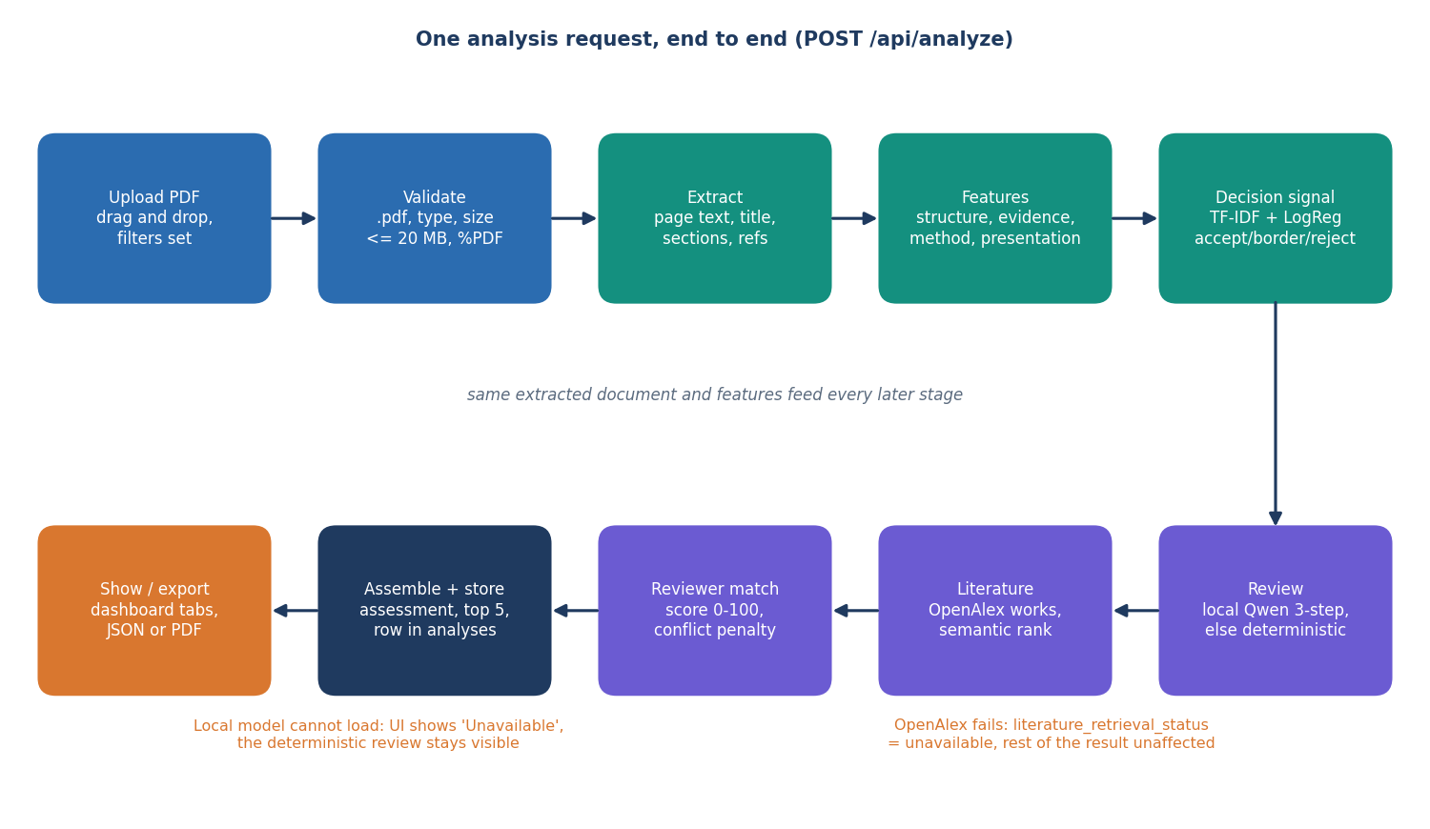
Figure 1: High-level workflow of PeerScope from the uploaded PDF to the ranked reviewers.

1.7 Contributions
The contributions of the project, stated at the level the evidence supports, are the following.
1. An end-to-end local application. One tool takes a research-paper PDF through extraction, assessment, literature context and reviewer matching and stores and exports the result, which the surveyed systems treat as separate problems.
2. An auditable matching score. Following the auditable principle of the base paper, every recommendation shows its weighted terms (0.55 expertise similarity, 0.20 keyword overlap, 0.15 method and topic overlap, 0.10 availability, minus a 0.60 conflict penalty), the matched terms and a plain-language explanation; availability and conflict of interest are part of the score instead of being left to a later step.
3. A hybrid assessment with honest fall-backs. Structural signals, a trained decision signal and a local-LLM critique are combined, and each component reports its own status; when the language model or the literature service is unavailable the interface says so.
4. A measured evaluation that states its limits. The decision model scores 55% accuracy on a synthetic data set whose labelling caps accuracy near 0.56; the matcher reaches top-1 95.0% with sentence embeddings and 75.0% with the offline fallback on a team-written probe set; both results are reported with the reasons they cannot be compared directly with the base paper.
What is not claimed is as important. The project does not show that the decision signal predicts real review outcomes, does not compare against independent expert assignments, and does not assess novelty.

1.8 Limitations and Assumptions
• The decision model was trained on a synthetic, template-generated set of 1,400 labelled texts because no public review corpus was obtained. The label "borderline" cannot be told from the text, so the best accuracy any text classifier can reach on this data is about 0.56. The measured accuracy (55%) is close to that ceiling; accept versus reject is separated correctly 93% of the time, and the borderline class is almost never predicted.
• The reviewer pool contains 6 demo profiles, and the matching probe set of 40 abstracts was written by the team, so the matching results are optimistic.
• Conflict detection compares literal strings; reworded affiliations and partial names are not recognised.
• Novelty is not measured. The assessment reports structure and evidence, not originality.
• The local language model runs on a processor only, at roughly three tokens per second, so a full analysis with the critique takes several minutes.
The assumptions are that uploaded files are English-language research papers with a text layer; that the reviewer directory is maintained by the editorial office and its conflict terms are filled in; that the application runs on a trusted local machine used by one person at a time; and that an editor reads the output as advice.

1.9 Organisation of the Report
The remaining chapters are organised as shown in the table below.
Table 3: Organisation of the report
Chapter | Title | Content
1 | Introduction | Domain, motivation, problem, objectives, scope, contributions, limitations
2 | Literature Survey | Base paper, related work by theme, algorithms, research gap
3 | Feasibility Study | Technical, economic, operational and schedule feasibility
4 | System Requirements and Analysis | Existing and proposed system, requirements, hardware, software, users
5 | System Design | Architecture, workflow, data-flow and UML diagrams, database, modules, interface
6 | Methodology and Software Implementation | Pipeline, data, algorithms, formulation, API, security, installation
7 | System Testing | Strategy, unit, integration, functional, security, performance, limits
8 | Results and Output Screens | Measurements, output screens, comparison with the base paper, objectives
9 | Conclusion | Summary, findings, applications, known limitations
10 | Future Scope | Improvements, features, scalability, further research

CHAPTER 2: LITERATURE SURVEY

2.1 Overview
This chapter reviews the work on which PeerScope builds and against which it must be judged. It starts with the base paper assigned to the batch [1], analyses it in detail, and then groups related work by theme: reviewer assignment, text representation, automated review and decision prediction, the integrity of LLM-based review, and the tools used in the implementation. It then describes the data and algorithms that the project itself uses, summarises strengths and limitations, lists the additional sources named in the project's literature survey, and ends with the research gap.

2.2 Analysis of the Base Paper
The base paper is "LLM-Assisted Reviewer Assignment via Auditable Expertise Matching" by Bagheri, Buscaldi and Reforgiato Recupero of the University of Cagliari and Sorbonne Paris Nord, published in IEEE Access, volume 14, pages 127834-127863, in 2026 [1]. It runs to 30 pages. Its subject is the reviewer assignment problem (RAP): match submissions to qualified reviewers under constraints of expertise coverage, reviewer capacity and conflict of interest.

Problem and central idea
The authors argue that the central difficulty of RAP is the construction of the affinity score between a paper and a reviewer, and that dense embeddings, although effective, are hard to audit. Their idea is to confine the language models to a narrow, checkable task. LLMs never rank reviewers and never decide; they only induce keywords, and every later step is deterministic or stored so that it can be inspected. This is what the title means by auditable expertise matching.

Method
1. Producer ensemble. Several heterogeneous LLMs each return 6 to 12 keyphrases of one to three words, as a strict JSON array, for a view of the paper (title, abstract summary or full abstract) or for each prior publication of a reviewer. The models named in the text include Qwen 3, Grok 4 and LLaMA 4.
2. Judge. A stronger LLM chooses the single best candidate list for faithfulness, coverage, specificity and non-redundancy; it may choose but not rewrite.
3. Deterministic normalisation. Lower-casing, trimming, lemmatisation with WordNet and de-duplication.
4. Audit trail. Prompts, model identifiers, raw candidates, the winning index, final keywords, score matrices and top-3 lists are stored at every stage.
5. Matchers. The paper compares TF-IDF cosine, keyword-set Jaccard and their mean; an SBERT bi-encoder with the all-MiniLM-L6-v2 checkpoint (a reviewer is represented by the mean-pooled embeddings of publications); a two-stage bi-encoder plus cross-encoder re-ranker (cross-encoder/ms-marco-MiniLM-L-6-v2); keyword-aware SBERT variants; and keyword knowledge-graph matchers built with Node2Vec.

Data and protocol
The authors' own data set contains 663 papers from 85 computer-science conferences, with 1,989 assignments (about three reviewers per paper), and 524 unique reviewer profiles of up to 20 most-cited publications each, taken from Semantic Scholar. Historical assignments are the relevance labels. The metrics are MRR@3, P@3 and MAP@3, macro-averaged over papers, with paired two-sided t-tests, 95 % confidence intervals and a bootstrap fallback of 10,000 resamples; the Gini coefficient of reviewer load is reported as a workload diagnostic. The data are stated to be available on reasonable request.

Reported results
Table 4: Results of the base paper as stated in the paper
Item | Reported value
Best MRR@3 on titles | 0.7778 (keyword-aware two-stage re-ranking)
Best MRR@3 and MAP@3 on abstracts | 0.7843 and 0.2991 (knowledge-graph edge Jaccard)
Best P@3 on summaries | 0.4545 (keyword-aware SBERT)
Best MAP@3 on summaries | 0.3232 (keyword-aware SBERT)
TF-IDF cosine on titles (MRR@3 / P@3 / MAP@3) | 0.7078 / 0.3882 / 0.2941
SBERT cosine on titles (MRR@3 / P@3 / MAP@3) | 0.6571 / 0.3873 / 0.2636
Cross-encoder re-ranking on titles | MRR@3 +0.1173 (+17.76 %), P@3 -0.0133 against the keyword-aware bi-encoder
Gini coefficient of load, SBERT baseline | 0.375 (titles), 0.376 (summaries), 0.373 (abstracts)

Most differences among the text encoders are not statistically significant; for example, on titles the keyword-aware bi-encoder against the SBERT baseline gives a P@3 difference of +0.0030 with a 95 % interval of [-0.0022, 0.0082] (p = 0.257). The local knowledge-graph matcher on titles is significantly worse (MAP@3 difference -0.0414). The paper also cites two facts about the task: the NeurIPS 2021 repeat committees disagreed on about 23 % of submissions, and 91 % of the top-100 medical journals prohibit uploading manuscripts to AI tools.

Limitations stated by the authors and our reading
• Historical assignments are an imperfect proxy for expertise, because availability, bidding, conflicts and workload also shaped them; no human expert judgements are used.
• No capacity- or conflict-aware end-to-end allocation was benchmarked, because the metadata were not available.
• LLM keywords may hallucinate, drift between model versions and carry bias; the stored artefacts do not allow a producer-by-producer ablation, so the advantage of the ensemble over a single LLM is not established.
• The system only matches reviewers. It makes no assessment of the submission itself, and it has no user interface; its scoring runs offline over a fixed data set, and availability and conflict are left to a downstream solver.
For this project the base paper supplies three things: the principle that a recommendation must be auditable, the observation that the all-MiniLM-L6-v2 bi-encoder is a strong and simple baseline, and a clear statement of what remains untested - conflict and capacity inside the score. Section 2.9 states how PeerScope differs.

2.3 Related Work by Theme

2.3.1 Reviewer assignment
A scoping review of the reviewer assignment problem retained 26 studies from Scopus, Google Scholar and DBLP and notes that the problem has been studied for about thirty years and that a recent systematic synthesis was missing [8]. A survey of algorithms from 1992 to 2022 organises them into three parts: a database of candidate reviewers, the computation of a matching degree, and the optimisation of the assignment [9].
Early work learned the match from text. Mimno and McCallum compared two language-model approaches with a new Author-Persona-Topic model against human relevance judgements on documents from the Rexa database, and the new model performed best [11]. Charlin, Zemel and Boutilier learned suitability scores from a few provided scores and then solved an integer program for the assignment, testing on two conference data sets [10]. Stelmakh, Shah and Singh's PeerReview4All maximises the quality for the most disadvantaged paper through an incremental max-flow algorithm and proposes an experiment design for comparing algorithms without ground truth [12].

2.3.2 Text representation and similarity
Sentence-BERT uses siamese BERT networks to produce sentence embeddings that can be compared by cosine; it reduces the search for the most similar pair among 10,000 sentences from about 65 hours with BERT to about 5 seconds [19]. MiniLM compresses large transformers by deep self-attention distillation [20]; the checkpoint all-MiniLM-L6-v2 that PeerScope uses belongs to this family, and the base paper names the same checkpoint for its SBERT baseline. SPECTER trains document-level embeddings for scientific papers with citation information and is evaluated on the SciDocs benchmark of seven tasks [21].

2.3.3 Automated review and decision prediction
PeerRead provides 14.7 thousand paper drafts with accept or reject decisions from ACL, NIPS and ICLR, and 10.7 thousand textual reviews; simple models predict acceptance with up to 21 % error reduction over the majority baseline [22]. Yuan, Liu and Neubig use summarisation models to generate first-pass reviews; the generated reviews cover more aspects than human ones but are less constructive [23].
Large language models changed the scale. Liang and co-authors gave GPT-4 the full PDF of 3,096 papers from Nature journals and 1,709 ICLR papers; the overlap between the model's points and a human reviewer was 30.85 % and 39.23 %, against 28.58 % and 35.25 % between two human reviewers, and in a study with 308 researchers 57.4 % found the feedback helpful or very helpful [24]. DeepReview adds multi-stage reasoning, literature retrieval and evidence-based argumentation; its 14-billion-parameter reviewer reports win rates of 88.21 % against GPT-o1 and 80.20 % against DeepSeek-R1 [25]. ReViewGraph simulates reviewer-author debates with LLM agents, builds a heterogeneous graph of opinion edges and predicts accept or reject with a graph network; on ICLR 2023, 2024 and 2025 submissions its accuracy is 70.29, 66.10 and 71.65 % and its macro-F1 is 69.89, 65.54 and 71.65 % [7]. A survey from Yale, NYU and TCS Research catalogues this field [6], and a second survey covers LLMs for automated scholarly review [26] (only its record was verified).

2.3.4 Integrity and risks of LLM-based review
The preprint of Torrielli and co-authors studies indirect prompt injection in peer review, in which hidden instructions in a manuscript try to steer an AI reviewer. In 5,600 controlled experiments on NeurIPS and ICLR manuscripts with two general-purpose chatbots the hidden instructions were followed in 78 % of cases for ChatGPT and 86 % for Gemini, and instructions placed early in the text were the most influential; the journal version reports positive steering, refusal or redirection above 98 % success on 100 OpenReview papers [2]. Keuper generated reviews of 1,000 ICLR 2024 papers with several LLMs and found that very simple prompt injections reach up to 100 % acceptance scores and that the reviews are biased towards acceptance, above 95 % for many models [27]. These findings argue for local processing, a deterministic fall-back and a human in the loop, which are the choices made in PeerScope.

2.4 Data and Algorithms Used in This Project
Decision data. No public review corpus could be obtained during the project, so the decision model is trained on a synthetic set of 1,400 labelled texts generated from templates of strength and weakness phrases. Section 6.2 and Chapter 8 describe the generator and show why it limits what the model can learn. PeerRead [22] is the natural real replacement and is listed as future work.
Reviewer profiles. Six demonstration profiles, each with an expertise description, topic, method and keyword lists, publication titles, load and conflict terms. Matching quality is measured on 40 abstracts written by the team (Chapter 8).
Algorithms. The choices follow the literature above and are justified in Chapter 6.
Table 5: Algorithms used in PeerScope and their sources
Step | Algorithm | Source
Decision signal | Word (1-2 gram) and character (3-5 gram) TF-IDF features with balanced logistic regression | [17], [18], [31]
Expertise similarity | all-MiniLM-L6-v2 sentence embeddings compared by cosine; offline TF-IDF fall-back | [19], [20], [1]
Keyword and method overlap | Set overlap with partial substring matches over extracted terms | this project
Audit score | Weighted sum of similarity, overlap and availability minus a conflict penalty | audit principle of [1]
Critique | Three-step prompt (analyse, critique, synthesise) with Qwen2.5-1.5B-Instruct on CPU | [29], [30]
Literature context | OpenAlex works search ranked by embedding similarity | [32]

2.5 Strengths and Limitations of Existing Approaches

2.6 Additional Sources Named in the Project Literature Survey
Table 6: Sources named in the batch literature survey
Title as recorded | Year | Reference | Verification
LLM-Assisted Reviewer Assignment via Auditable Expertise Matching | 2026 | [1] | Read in full from the PDF
How to get your paper accepted by an AI reviewer: indirect prompt injection in peer review | 2026 | [2] | Abstract and bibliographic record verified (preprint; journal version in Scientometrics)
Unveiling the Reviewer Mindset: Evidence-Based Insights into Scholarly Peer Review | 2025 | [3] | Title, authors and date verified; content not read
Review of: Performance evaluation of adaptive introgression classification methods, Round 1, Reviewer 2 | 2024 | [4] | Record exists; an anonymous review report from another field, not research literature; text not read
Review of: Performance evaluation of adaptive introgression classification methods, Round 2, Reviewer 2 | 2024 | [5] | As above

2.7 Summary Comparison
Table 7: Comparison of the surveyed work
Work | Approach | Data | Reported result | Limitation
Bagheri et al. [1] | LLM keyword ensemble + judge; TF-IDF, SBERT, graph matchers | 663 papers, 524 reviewers | MRR@3 up to 0.7843 | No paper assessment; COI and capacity not benchmarked
Charlin et al. [10] | Learned suitability + integer program | Two conference sets | Not quoted | Needs provided scores
Mimno & McCallum [11] | Author-Persona-Topic model | Rexa documents | Best of three models | Human labels needed
Kang et al. [22] | Accept/reject prediction | 14.7K drafts, 10.7K reviews | Up to 21 % error reduction | Decision only
Liang et al. [24] | GPT-4 feedback on PDFs | 3,096 + 1,709 papers | 30.85 % / 39.23 % overlap | No reviewer matching
Li et al. [7] | Debate simulation + graph network | ICLR 2023-2025 | Accuracy 66.10-71.65 % | Decision only; costly
Torrielli et al. [2] | Hidden-instruction attack | NeurIPS, ICLR papers | 78 % / 86 % compliance | Describes the risk, not a remedy
This project (PeerScope) | Local assessment + auditable matching | Synthetic decision set; 6 demo reviewers; 40-paper probe | Top-1 95.0% (probe) | Optimistic evaluation; novelty not measured

2.8 Research Gap
1. The base paper improves and audits the affinity matrix only: it scores 663 papers against 524 reviewers but performs no assessment of the paper, so an editor still needs a separate tool for first-pass screening [1], [6].
2. Automated review work predicts decisions or writes reviews but does not recommend reviewers [22], [23], [24], [25], [7]; the two halves of the workload are served by separate lines of research.
3. The base paper's evaluation uses historical assignments as labels and leaves conflict of interest and capacity out of the experiments [1]; how availability and conflict should enter an auditable score is untested, and randomisation [15] is not a transparent per-reviewer score.
4. LLM-based reviewing is vulnerable to hidden instructions (78-86 % compliance [2]; up to 100 % acceptance scores [27]) and tends towards acceptance, which argues for local processing, a deterministic fall-back and a human in the loop.
5. Dense-embedding matchers are hard to audit [1]; per-recommendation score breakdowns with matched terms and explicit availability and conflict terms are rare, and none of the assignment works [10], [11], [12], [14], [15], [16] is an end-to-end local application with PDF intake.
6. Published decision-prediction results depend on real review corpora [22], [7]; a project without such data must say plainly that a classifier trained on synthetic labels demonstrates the pipeline and not real-world predictive power.

2.9 How PeerScope Differs
PeerScope adopts the auditable principle of the base paper [1] but changes the design in four ways. First, it does not use an LLM ensemble to induce keywords: keywords and method terms come from deterministic frequency and lexicon extraction, and the local Qwen model writes review text only; it never ranks. Second, expertise similarity is a single bi-encoder cosine with all-MiniLM-L6-v2, the encoder the base paper uses for its SBERT baseline, with a TF-IDF fall-back. Third, availability and a conflict penalty are inside the score, and no global optimiser is run. Fourth, it adds what the base paper lacks: PDF intake, a preliminary assessment (structural signals, a decision signal and a critique), literature grounding, a reviewer directory, history and export.
The price of these choices is a much smaller evaluation. PeerScope was measured on 6 demonstration reviewers and 40 abstracts written by the team: top-1 95.0% with sentence embeddings and 75.0% with the offline fall-back. These figures are not comparable with the base paper's MRR@3 and MAP@3 on 663 real papers, and Chapter 8 says so wherever the two are mentioned.

CHAPTER 3: FEASIBILITY STUDY
The feasibility of PeerScope was settled partly by analysis and partly by building the system and measuring it. Where a question could not be settled with the data available to the team, the entry says so.

3.1 Technical Feasibility
The risks lay in PDF extraction, in running a classifier, an embedding model and a small language model without a GPU, and in combining them into one auditable ranking. The development machine is a desktop with an 12th Gen Intel(R) Core(TM) i5-12500 (6 cores, 12 threads) and 15.7 GB of RAM.
Table 8: Technical feasibility checks
Question | Measurement | Verdict
PDF text, sections, references locally? | PyMuPDF reads 17-30 page papers in 251-431 ms; section detection is regex based | Feasible, with misses
Decision model on a CPU, and is it useful? | full evaluation took about 9 s; accuracy 55.0%, macro F1 0.509 on 280 synthetic papers | Demonstration only
Embeddings rank reviewers on a CPU? | MiniLM loads in 17 s; 6 reviewers ranked in 86 ms, 500 in 5.2 s; top-1 95.0% on 40 team-written probes | Feasible (small test)
Local language model drafts the review? | Qwen2.5-1.5B-Instruct (fp32, CPU) loads in 9 s; one analysis with the three-step AI review takes about 9 minutes (no GPU) | Feasible but slow
Related literature? | OpenAlex answered 3 queries in 1.3-2.1 s; offline the tab reports 'unavailable' | Needs internet

The weakest check is the data. The decision model was trained on a synthetic corpus of 1,400 texts, so predicting real decisions was not shown to be feasible; the pipeline around the signal was. The matching test is also small: six demo reviewers and forty probe abstracts.

3.2 Economic Feasibility
The stack is open source and no paid API is used; the only outgoing request is a title query to OpenAlex, which needs no key [32]. No hardware was bought and no money figures were measured, so none are given. Measured resources are about 2.9 GB of disk for the cached language-model weights and roughly 4 to 6 GB of memory in the process that held the model. PyMuPDF is distributed under the AGPL or a commercial licence, and the model licences were not audited; both must be checked before redistribution.
The software stack is open source: Python, FastAPI, Uvicorn, SQLAlchemy, PyMuPDF, scikit-learn, sentence-transformers, PyTorch, Transformers, ReportLab, React, Vite, Recharts, Framer Motion, GSAP and three.js. The decision model, the embedding model and the language model all run on the user's machine, so there is no per-analysis fee and no subscription. An institution that deployed the system would add a server with that much memory and staff time to keep the reviewer directory current; compared with the staff time spent on manual first-pass screening the team expects this to be modest, but that comparison was not measured. The reviewer profiles shipped with the project are marked demo data.

3.3 Operational Feasibility
One script, run.bat, creates the environment, installs the packages, trains the decision model if its files are missing, and starts the API on port 8408 and the web app on port 5408. Settings live in one .env file and the reviewer directory is edited in the browser or imported from CSV. The first analysis after start-up is slow because the models load lazily. There is no login, so the system suits one trusted user or a small office on a private network.

3.4 Schedule Feasibility
Calendar dates were not recorded in the project artefacts, so none are given. The work was organised in dependent phases, listed in the order in which their products exist in the repository.
Table 9: Project phases and their products
Phase | Work | Product
1 | Literature survey, base paper study, problem statement and objectives | Batch documents 2 to 6
2 | Dataset preparation and decision-model training | scripts/prepare_dataset.py, scripts/train_model.py, models/
3 | Extraction, features, review, literature, embeddings and matching services | app/services/ (12 modules)
4 | API, validation, SQLite storage and export | app/main.py, app/models.py, app/schemas.py
5 | Web interface (first a plain static page, then the React application) | static/, frontend/src/ (8 pages)
6 | Tests, smoke test, measurements and screenshots | tests/, scripts/smoke_test.py, scripts/measure_metrics.py, docs/
7 | Documentation, decks and report | Batch documents 7 to 19

The services are functions that take and return plain dictionaries, so phases 3 and 4 are loosely coupled and can be developed and tested separately, as the unit tests do. The matching evaluation needed a hand-written probe set because no real labelled data existed for it.

3.5 Advantages, Constraints and Risks
Table 10: Advantages, constraints and mitigated risks
Aspect | Advantage | Constraint or risk and mitigation
Privacy | PDFs are processed locally | A title query reaches OpenAlex; hidden instructions in a PDF are possible [2], [27] (local, deterministic fallback)
Transparency | Score breakdown, matched terms, conflict reason | Weights are not fitted to data
Robustness | A missing model or OpenAlex leaves the rest of the result | Deterministic review is less informative; status always shown
Speed and scale | Everything but the language model finishes in well under a second | AI review takes minutes; profiles re-embedded per request (5.2 s for 500)
Data | Runs without real review data | Decision signal is synthetic; banner and wording say so
Conflicts | Literal terms, names and affiliations are caught | Reworded links are missed; disclaimer asks for independent checks

3.6 Risk Analysis
The main risks were identified during development and each has a mitigation in the implementation. The ratings are the team's qualitative judgement, not measured probabilities.
Table 11: Risks and mitigations
Risk | Effect | Mitigation in PeerScope
The language model cannot be loaded | No AI review text | Fallback to the 0.5B model, then to the deterministic review, with a visible status and note
OpenAlex unreachable or slow | No related literature | 8 s timeout; the literature tab reports 'unavailable'
Embedding model cannot be downloaded | Weaker ranking | TF-IDF fallback keeps matching working; status shown in the health route
Unusual PDF layout defeats section or title detection | Wrong structural signals | Signals labelled preliminary; evidence excerpts shown for checking
Reviewer directory out of date | Wrong availability or missing experts | Editable in the browser; active flag, load fields, CSV import
A conflict is worded in a way the matcher does not know | A conflicted reviewer is not penalised | Disclaimer asks the user to verify conflicts; the limit is measured and reported
Decision signal misused as a verdict | Unfair treatment of a paper | Synthetic-data banner, 'not a judgment of scientific correctness' wording, human in the loop

3.7 Feasibility Conclusion
The project is technically, economically and operationally feasible as a decision-support tool for a single editor or committee and was completed on the available hardware. It is not feasible, with the data available, to claim that the system predicts real editorial decisions, and the documents do not make that claim.

CHAPTER 4: SYSTEM REQUIREMENTS AND ANALYSIS

4.1 Existing System and its Limitations
Reviewer assignment is still largely manual: an editor reads the title and abstract, recalls who works on the topic, searches the reviewer list by keyword and checks workload and conflicts by hand. The reviewer assignment problem has been studied for about thirty years [8], [9], and the paper-reviewer affinity score remains hard to audit [1]. Human judgement is not a fixed point either: two NeurIPS 2021 committees disagreed on about 23 % of outcomes [13]. The limitations are that reviewer choice depends on memory, keyword matching shares vocabulary but not expertise, workload is tracked separately, conflicts are checked by eye, first-pass screening is manual, and choices are rarely explained.

4.2 Proposed System and its Advantages
PeerScope takes one PDF and returns a preliminary assessment and a ranked, explained list of reviewers. It adopts the auditable principle of the base paper [1] and adds paper intake, a first-pass assessment, availability and conflict terms inside the score, a reviewer directory, history and export. Final judgement stays with the editor.
Table 12: Existing practice compared with PeerScope
Aspect | Existing practice | PeerScope
Reviewer choice | Memory and keyword search | MiniLM cosine plus keyword and method overlap
Explanation | None or informal | Per-reviewer breakdown and reasoning sentence
Workload and conflicts | Spreadsheet and manual check | Availability and conflict penalty inside the score
First-pass screening | Manual reading | Structural score, concerns, page-anchored evidence
Privacy | Depends on the tool | Local processing; only a title query leaves the machine

4.3 Functional Requirements
Table 13: Functional requirements
ID | Requirement | Realised by
FR-1 | Accept a PDF up to 20 MB; reject other types, empty, headerless and oversize files with a clear message | POST /api/analyze; Analyze page
FR-2, FR-3 | Extract text, title, nine sections and references; compute counts, keywords, lexicon hits and four structural signals | pdf_extract, features
FR-4 | Give a three-class decision signal with probabilities | ml_predict
FR-5, FR-6 | Deterministic review always; AI review when the local model loads, with a plain notice when it cannot | review_synthesis, llm_service
FR-7 | Retrieve and rank related literature; report 'unavailable' on failure | literature
FR-8, FR-9 | Reviewer directory CRUD, activation, CSV import and export | /api/reviewers routes; Reviewers page
FR-10, FR-11 | Weighted ranking with breakdown and explanation; conflict detection and penalty | matching
FR-12 | Filter by active status, minimum score, topic, method; return the top five | pipeline
FR-13, FR-14 | Store analyses; history, reopen, JSON and PDF export | analyses table; History page; export route
FR-15 to FR-18 | Model metrics with synthetic-data notice; dashboard status; disclaimers; seeded demo reviewers | /api/model/metrics, /api/health, About, seed

4.4 Non-Functional Requirements
Table 14: Non-functional requirements
ID | Requirement | How met
NFR-1 | Privacy: documents are not sent to a third party | All processing is local; the only outgoing call is the OpenAlex title or keyword query
NFR-2 | Responsiveness of routine operations | Reads are database or file reads. Over HTTP on 127.0.0.1 the directory and history reads take a median of 2 ms and 2 ms, and a complete analysis without the local language model takes a median of 1.3 s for the three-page demo paper.
NFR-3 | Bounded cost of one analysis without the language model | Extraction 251-431 ms for 17-30 page papers, then features, decision signal and matching in milliseconds
NFR-4 | Graceful degradation | A missing language model, embedding model or OpenAlex leaves the rest of the result and a visible status
NFR-5 | Auditability | Weights, per-signal values, matched terms, conflict reason and model status are shown and exported
NFR-6 | Input safety | Extension, content type, 20 MB size, %PDF header; temporary file deleted after each request
NFR-7 | Reproducibility | Fixed seed 42, stratified split, saved metrics, measurement scripts in scripts/
NFR-8 | Usability | One launcher; responsive layout, dark and light themes, empty, loading and error states
NFR-9 | Portability | run.bat; Docker image of the API; Python 3.11 or 3.12; Node.js 18 or newer
NFR-10 | Honesty of output | Disclaimers on every screen; synthetic-data banner; no fabricated content when a component is down
NFR-11 | Configurability | Weights, model names, limits and ports in .env without code changes

No accuracy target was fixed for the decision signal and no throughput target for the AI review, because no real labelled data exist and speed depends on the hardware; both are reported as measurements.

4.5 Hardware Requirements
Table 15: Hardware used and observed needs
Item | Used for all measurements | Observation
Processor | 12th Gen Intel(R) Core(TM) i5-12500 | CPU only; no GPU code path
Memory | 15.7 GB | The language-model process used about 4 to 6 GB
Disk | Local SSD | About 2.9 GB for the cached Qwen2.5-1.5B-Instruct weights
Network | Internet on first use | Models are downloaded once; OpenAlex needs a connection

Smaller machines were not tested, so no minimum is claimed; the 0.5B fallback model or the deterministic review can be used on less memory.

4.6 Software Requirements
Table 16: Software requirements
Component | Version used in the measurements
Operating system, Python | Windows 11, build 10.0.26200; Python 3.11.9 (3.11 or 3.12 supported)
Web and database | FastAPI 0.120.4, Uvicorn 0.35.0, Pydantic 2.14.1, SQLAlchemy 2.1.6 (SQLite)
PDF and machine learning | PyMuPDF 2.0, scikit-learn 1.9.1, pandas 3.0.6, numpy 2.4.6, scipy 1.17.1
Embeddings and language model | sentence-transformers 6.2.0, torch 2.14.1, transformers 5.20.2
Web app and browser | Node.js 18 or newer; React 19, Vite 8, Recharts 3 (frontend/package.json); Chrome, Edge or Firefox

4.7 Data Requirements
Three kinds of data are handled: the uploaded PDF; the reviewer profile (display name of 1 to 200 characters, affiliation, expertise text, topics, methods, keywords, publication titles, current and maximum load, active flag and conflict terms), validated by a Pydantic schema; and the analysis result, stored as JSON and exported.

4.8 User Roles
PeerScope has no login, so roles describe what a person does, not what the system enforces; everyone who can open the web address can do everything.
Table 17: User roles
Role | Goal | Main screens
Editor or programme chair | Screen a submission and choose reviewers | Analyze, Saved analysis, History, Dashboard
Reviewer-directory administrator | Keep profiles, loads and conflict terms current | Reviewers (create, edit, activate, import, export)
Operator or developer | Install, configure, retrain, test | run.bat, .env, scripts/, API documentation at /docs

The two human roles are normally one person in a small office, which is why the system has no accounts; authentication is future work.

4.9 Constraints and Assumptions
Extraction reads the text layer, so scanned PDFs yield little text; the section patterns, lexicon and demo reviewers are English; measurements use six demo reviewers; the decision model is trained on synthetic data; conflicts are found only as literal strings in the first 3,000 characters; the system is single-user, with open CORS and one SQLite file.

4.10 Requirements Against Objectives
Table 18: Objectives and the requirements that serve them
Objective | Requirements
1. Corpus of papers and reviewer profiles | FR-8, FR-9, FR-13, FR-18
2. Topics, methods and keywords with NLP | FR-2, FR-3
3. Reviewer expertise as comparable vectors | FR-10
4. Rank reviewers by semantic similarity | FR-10, FR-12
5. Preliminary assessment | FR-3 to FR-7
6. Assignment quality and conflict handling | FR-11, NFR-5, NFR-7

CHAPTER 5: SYSTEM DESIGN
This chapter turns the requirements of Chapter 4 into a design. Every diagram was drawn from the code in the repository, and all twelve are listed again, with explanations, in the block-diagram document.

5.1 Design Goals and Architecture
Four goals shaped the design: local-first operation (a paper never leaves the machine except as a short query); graceful degradation (the system always returns something useful and says which part is missing); auditability, as in the base paper [1]; and simple operation (one launcher, one configuration file, one database file).
The architecture has four tiers. The presentation tier is a React application on port 5408 with eight pages and a thin fetch client. The application tier is a FastAPI service on port 8408 whose routes are all in app/main.py; it validates input, opens a database session per request and converts errors into JSON. The service tier, app/services, holds the working modules, orchestrated for one paper by pipeline.run_analysis. The data tier is SQLite, the model files, the training CSV and the Hugging Face cache. OpenAlex is the only external system. The service modules are plain functions that take and return dictionaries, so each stage can be tested alone and the result stored as JSON.
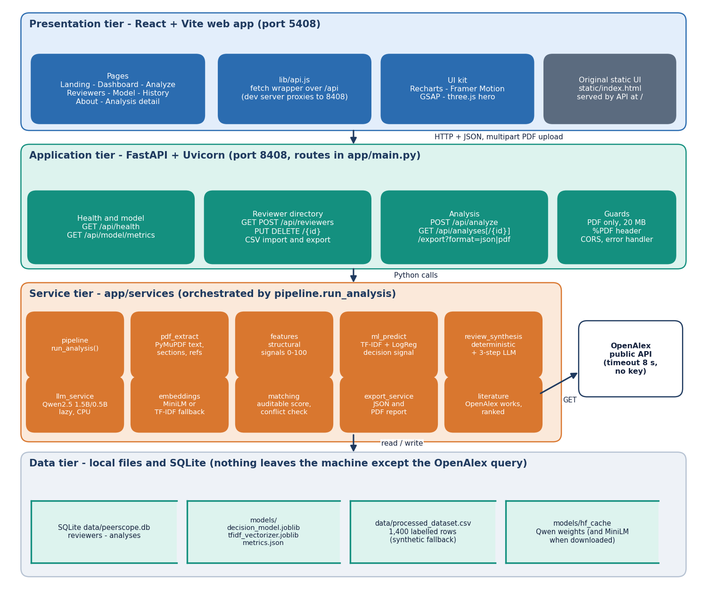
Figure 2: Four-tier architecture of PeerScope: React web app, FastAPI application, Python services and local data stores.

5.2 High-Level Workflow
The workflow is that of one POST /api/analyze request: the upload is validated; text, title, sections and references are extracted; structural features are computed; the classifier gives a decision signal; a review is drafted by the local language model or, if it cannot load, by deterministic rules; related literature is requested from OpenAlex; reviewers are scored; the filters are applied and the best five kept; and the result is stored and returned. An unavailable language model or an unreachable OpenAlex leaves the other stages intact. The training pipeline of the decision model and the PDF extraction and scoring flow are drawn below.
Figure 3: High-level workflow of PeerScope for one POST /api/analyze request.
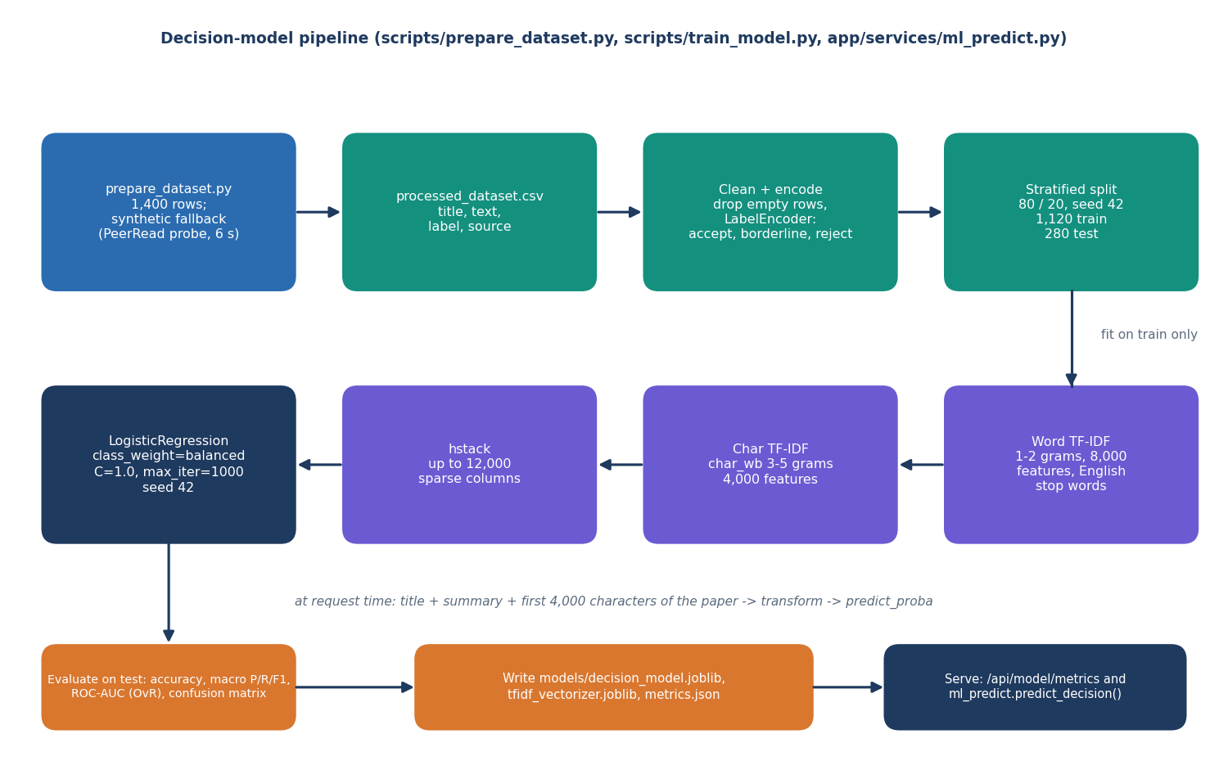  Figure 4: Training and serving pipeline of the decision model. | 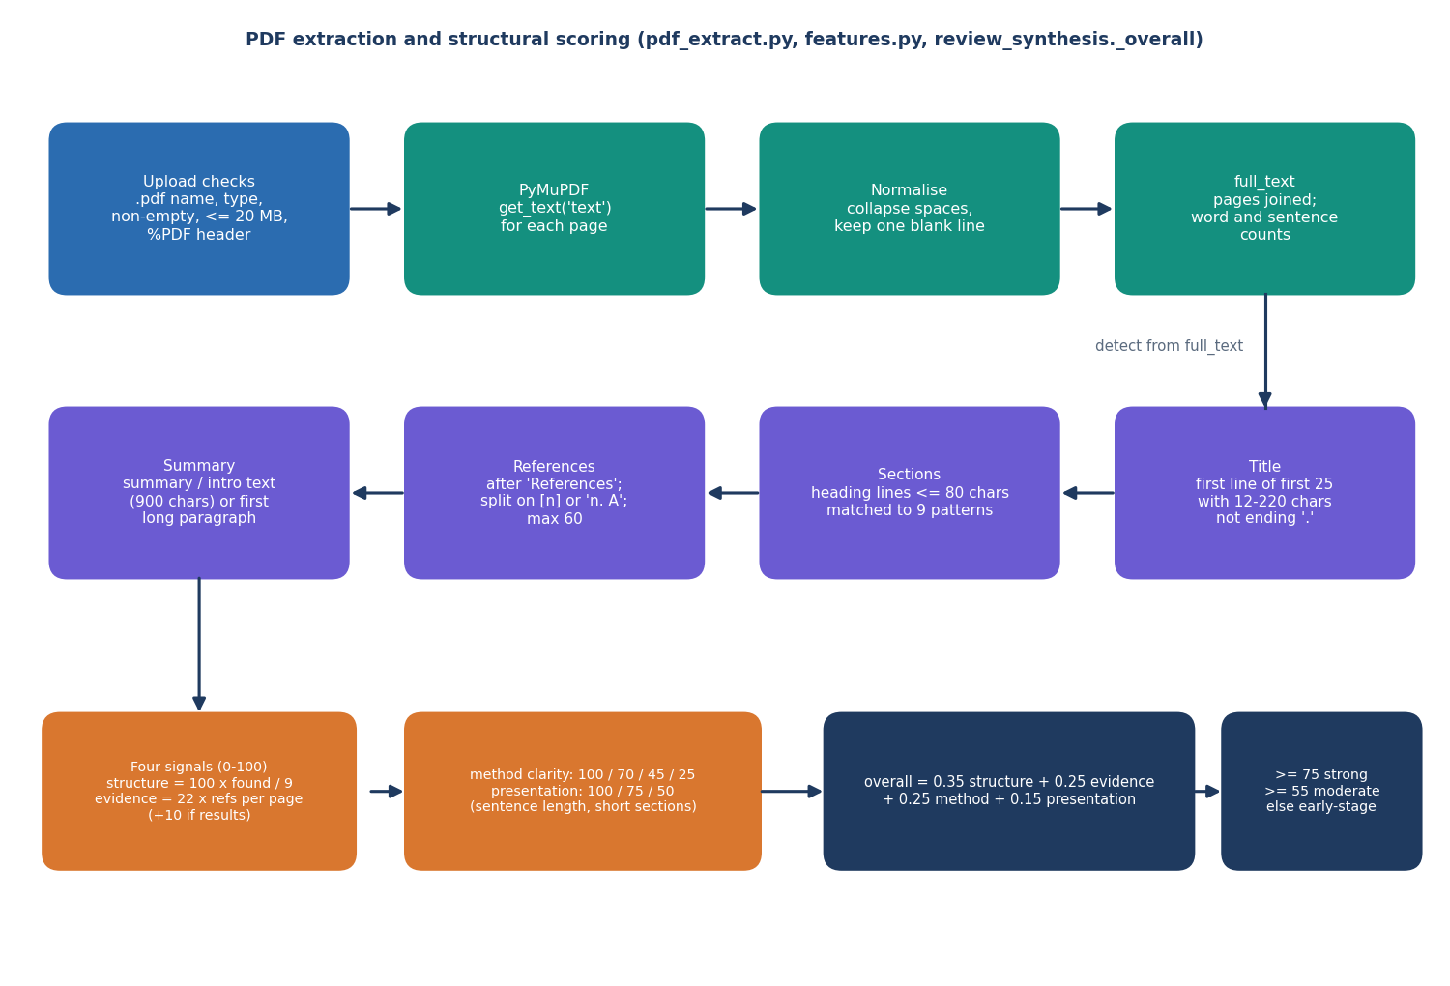  Figure 5: Flow of PDF extraction and structural scoring in PeerScope.

5.3 Data Flow Diagrams

5.3.1 Level 0: context
PeerScope is one process with three neighbours: the editor (sends a PDF and filters, receives assessment, ranking, history and exports), the directory administrator (sends profiles or CSV, receives the directory) and OpenAlex (receives a query, returns related works).

5.3.2 Level 1: main processes
Level 1 has seven processes: 1.0 validate and extract, 2.0 assess, 3.0 retrieve literature, 4.0 match reviewers, 5.0 manage the directory, 6.0 store, show and export, and 7.0 report model performance, over three stores: D1 the reviewers table, D2 the analyses table and D3 the model files.

5.3.3 Level 2: the analysis pipeline
Level 2 expands processes 1.0 to 4.0 into the steps of run_analysis: page text (1.1), title, sections and references (1.2), structural features (2.1), decision signal (2.2), review (2.3), literature (3.1), profiles and embeddings (4.1) and scoring and ranking (4.2). Each step adds its output to one result dictionary handed to process 6.0.
Table 19: Level 1 processes and their data
No. | Process | Inputs | Outputs | Stores
1.0 | Validate and extract paper | PDF, filters | Text, sections, references, errors | -
2.0 | Assess paper | Text, sections; model files | Features, decision signal, review | D3 (read)
3.0 | Retrieve literature | Title, keywords, topics | Related works | OpenAlex
4.0 | Match reviewers | Keywords, methods, topics, profiles | Ranked reviewers with breakdown | D1 (read)
5.0 | Manage directory | Profiles, CSV file | Directory, CSV export, errors | D1 (read, write)
6.0 | Store, show and export | Assessment, literature, ranking | Result, history, JSON and PDF | D2 (read, write)
7.0 | Report model performance | Saved metrics | Metrics, confusion matrix | D3 (read)

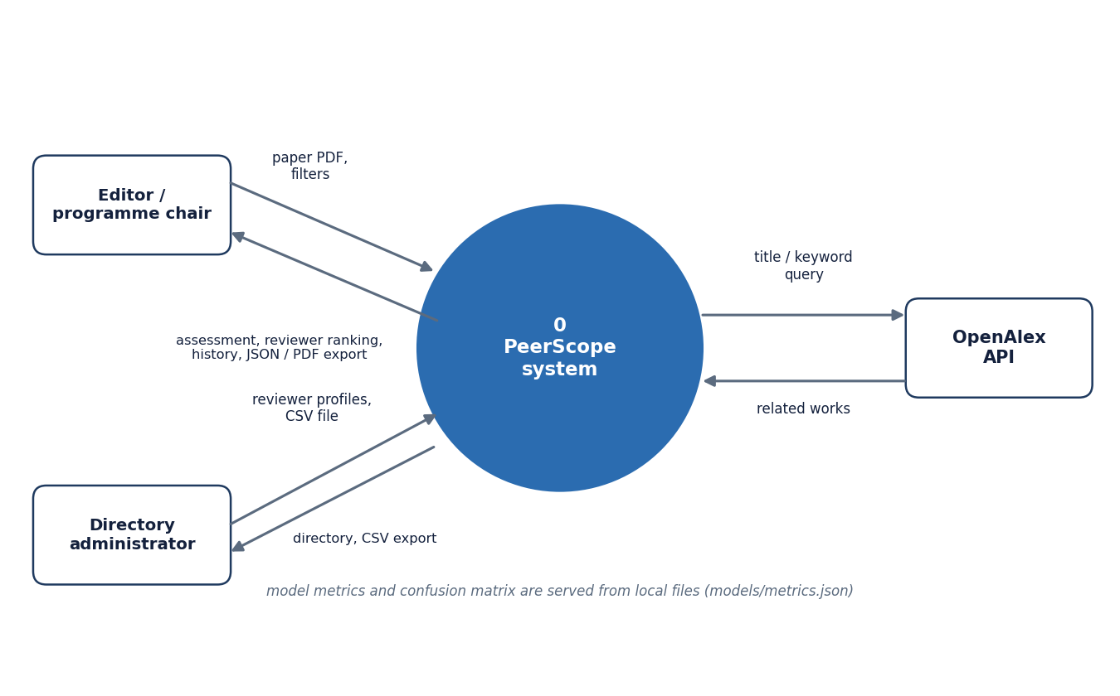  Figure 6: Context diagram (DFD level 0) of PeerScope with its two users and one external service. | 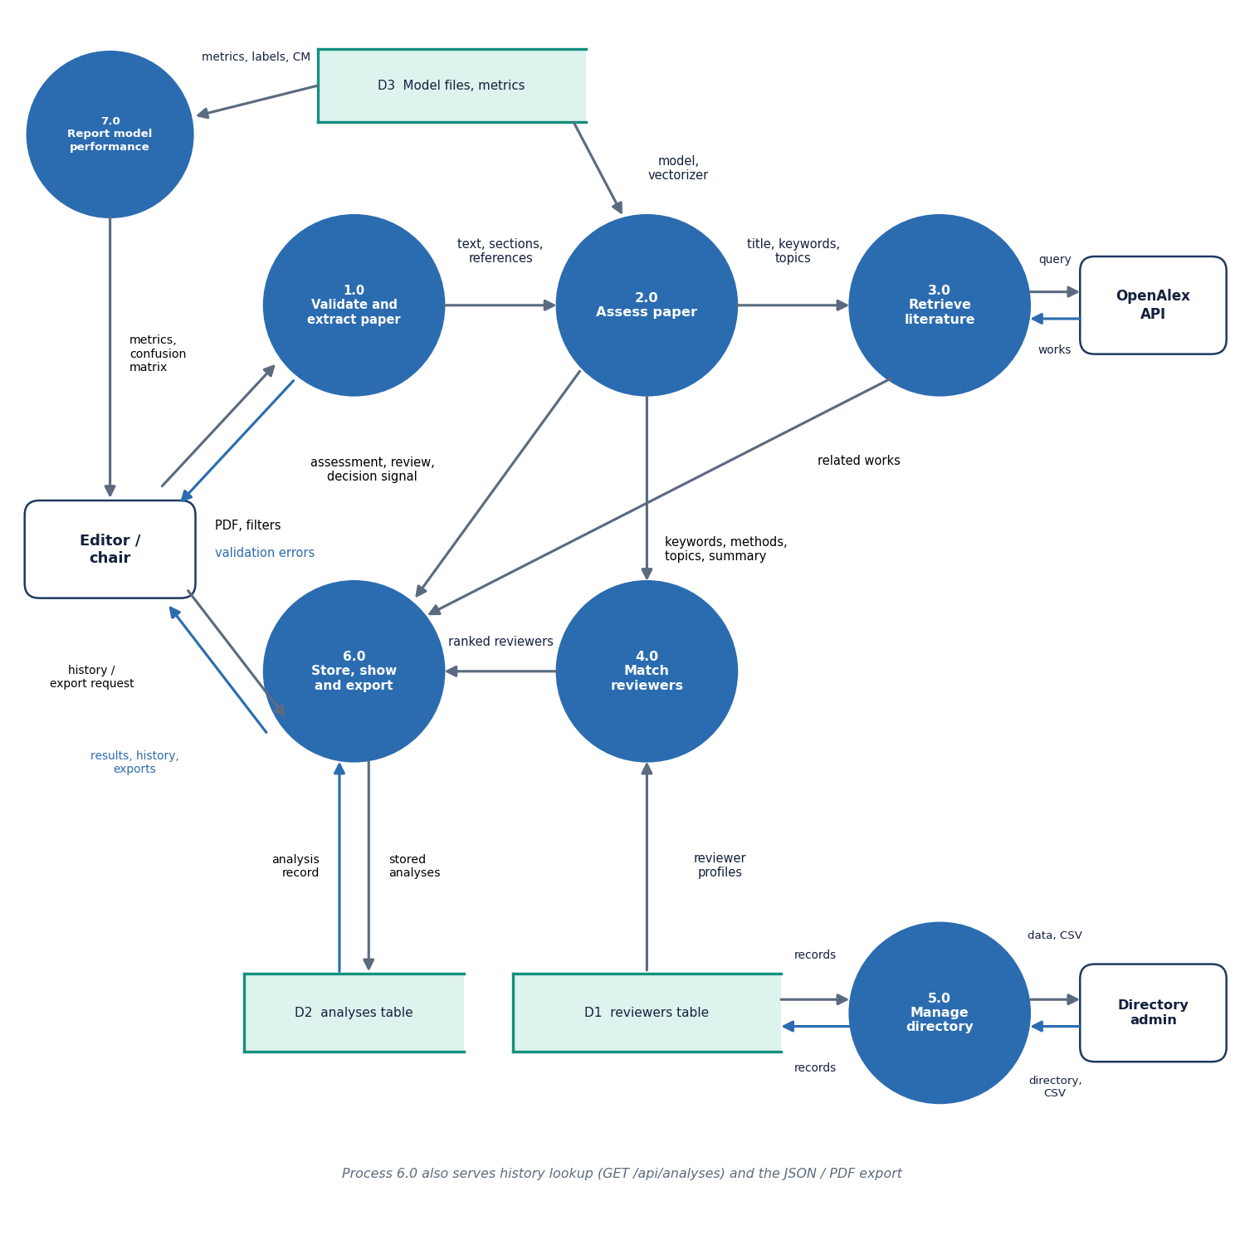  Figure 7: DFD level 1 of PeerScope: seven processes and three data stores.

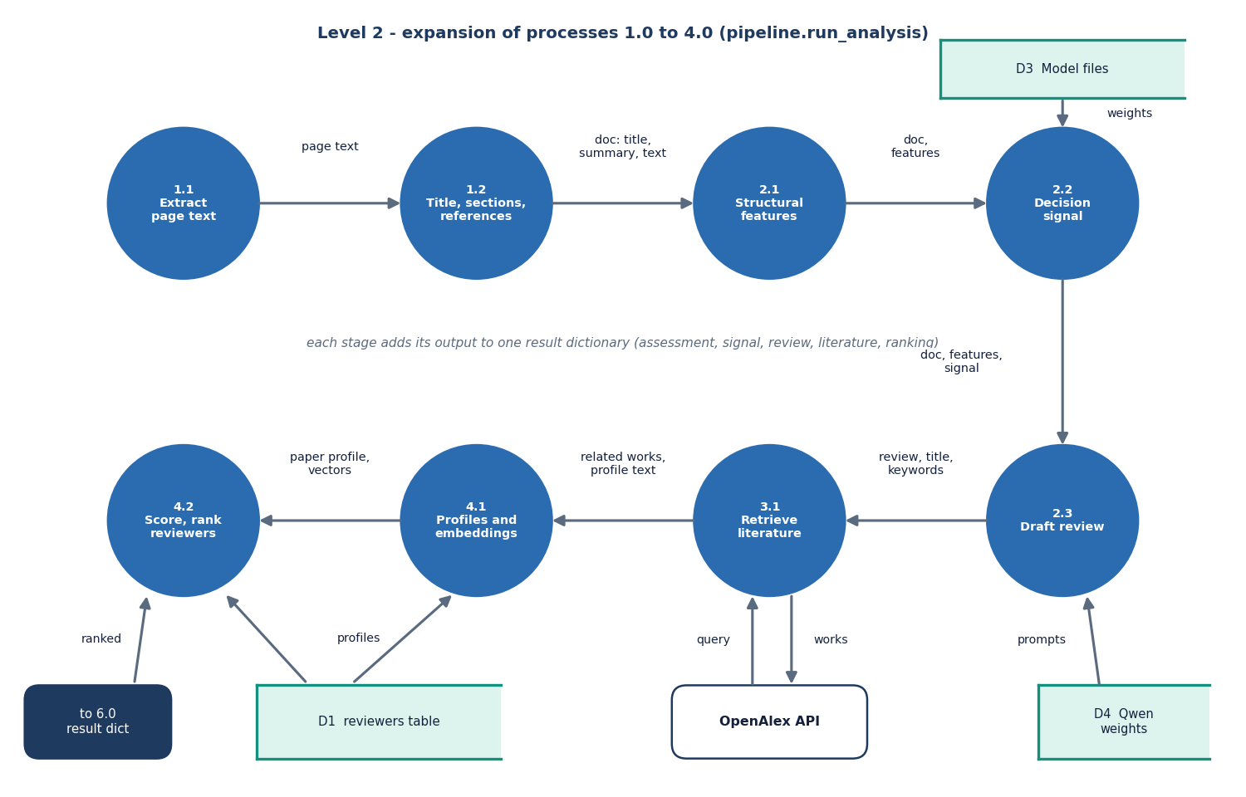
Figure 8: DFD level 2 of PeerScope: expansion of the analysis pipeline into eight sub-processes.

5.4 UML Diagrams

5.4.1 Class diagram
Two classes are persistent, Reviewer and Analysis, mapped to the two tables; ReviewerIn is the Pydantic schema that validates reviewer input. The FastAPI application has one method per route, and below it the Pipeline calls PdfExtractor, FeatureExtractor, MLPredictor, ReviewSynthesis, LiteratureService and MatchingService; ReviewSynthesis optionally uses LLMService and both LiteratureService and MatchingService depend on EmbeddingService. In the code these are modules of functions; the class notation shows what each owns.
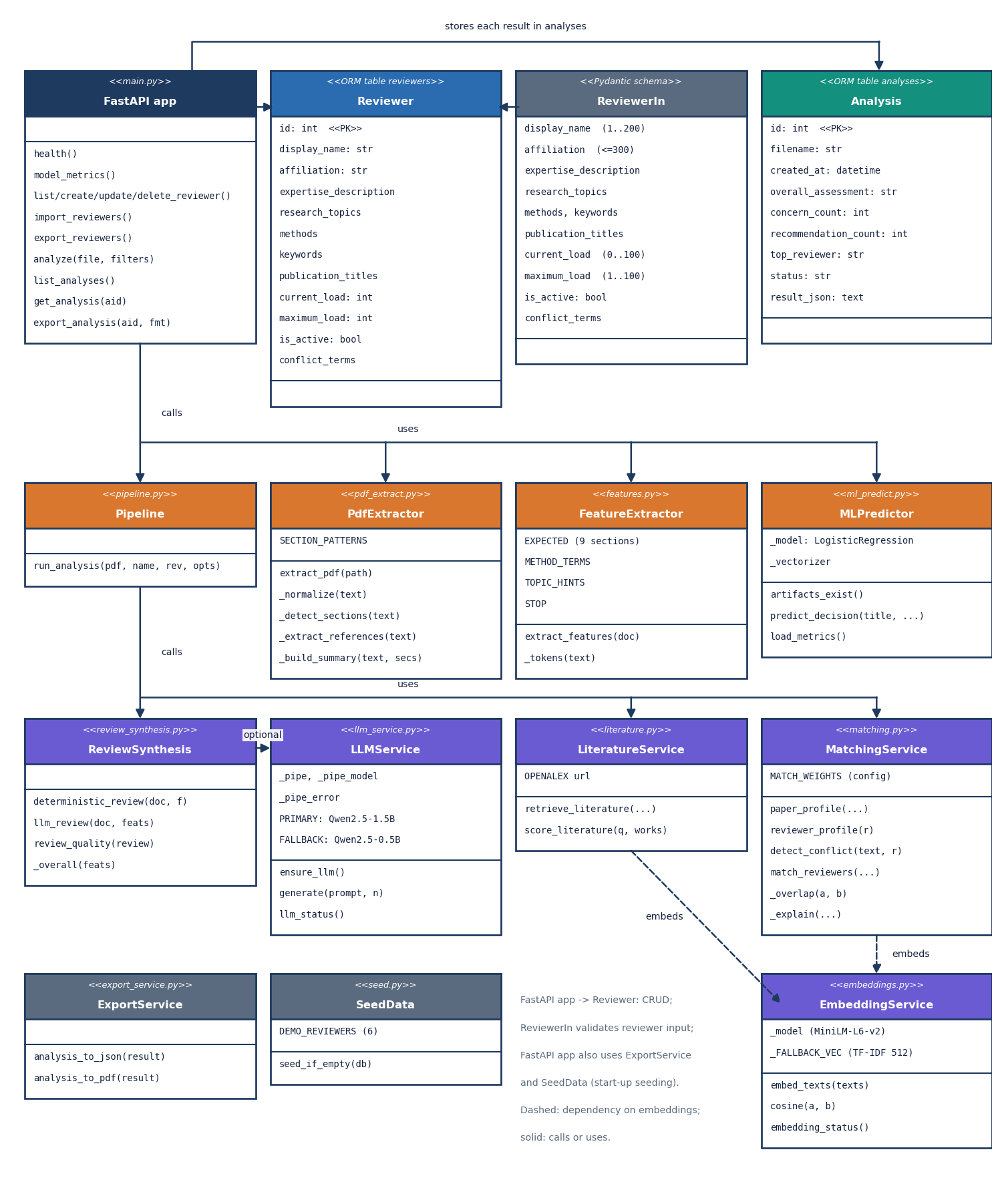
Figure 9: UML class diagram of PeerScope showing the ORM tables, the request schema, the FastAPI application and the service modules.

5.4.2 Sequence diagram
The browser posts the PDF with four filter fields. FastAPI checks the extension, content type, size and %PDF header, writes a temporary file, loads the reviewer rows and calls run_analysis, which calls the extraction, feature, decision, review, literature and matching modules in order, applies the filters and keeps five reviewers. FastAPI inserts one row into analyses, deletes the temporary file in a finally block and returns the JSON with the new identifier.
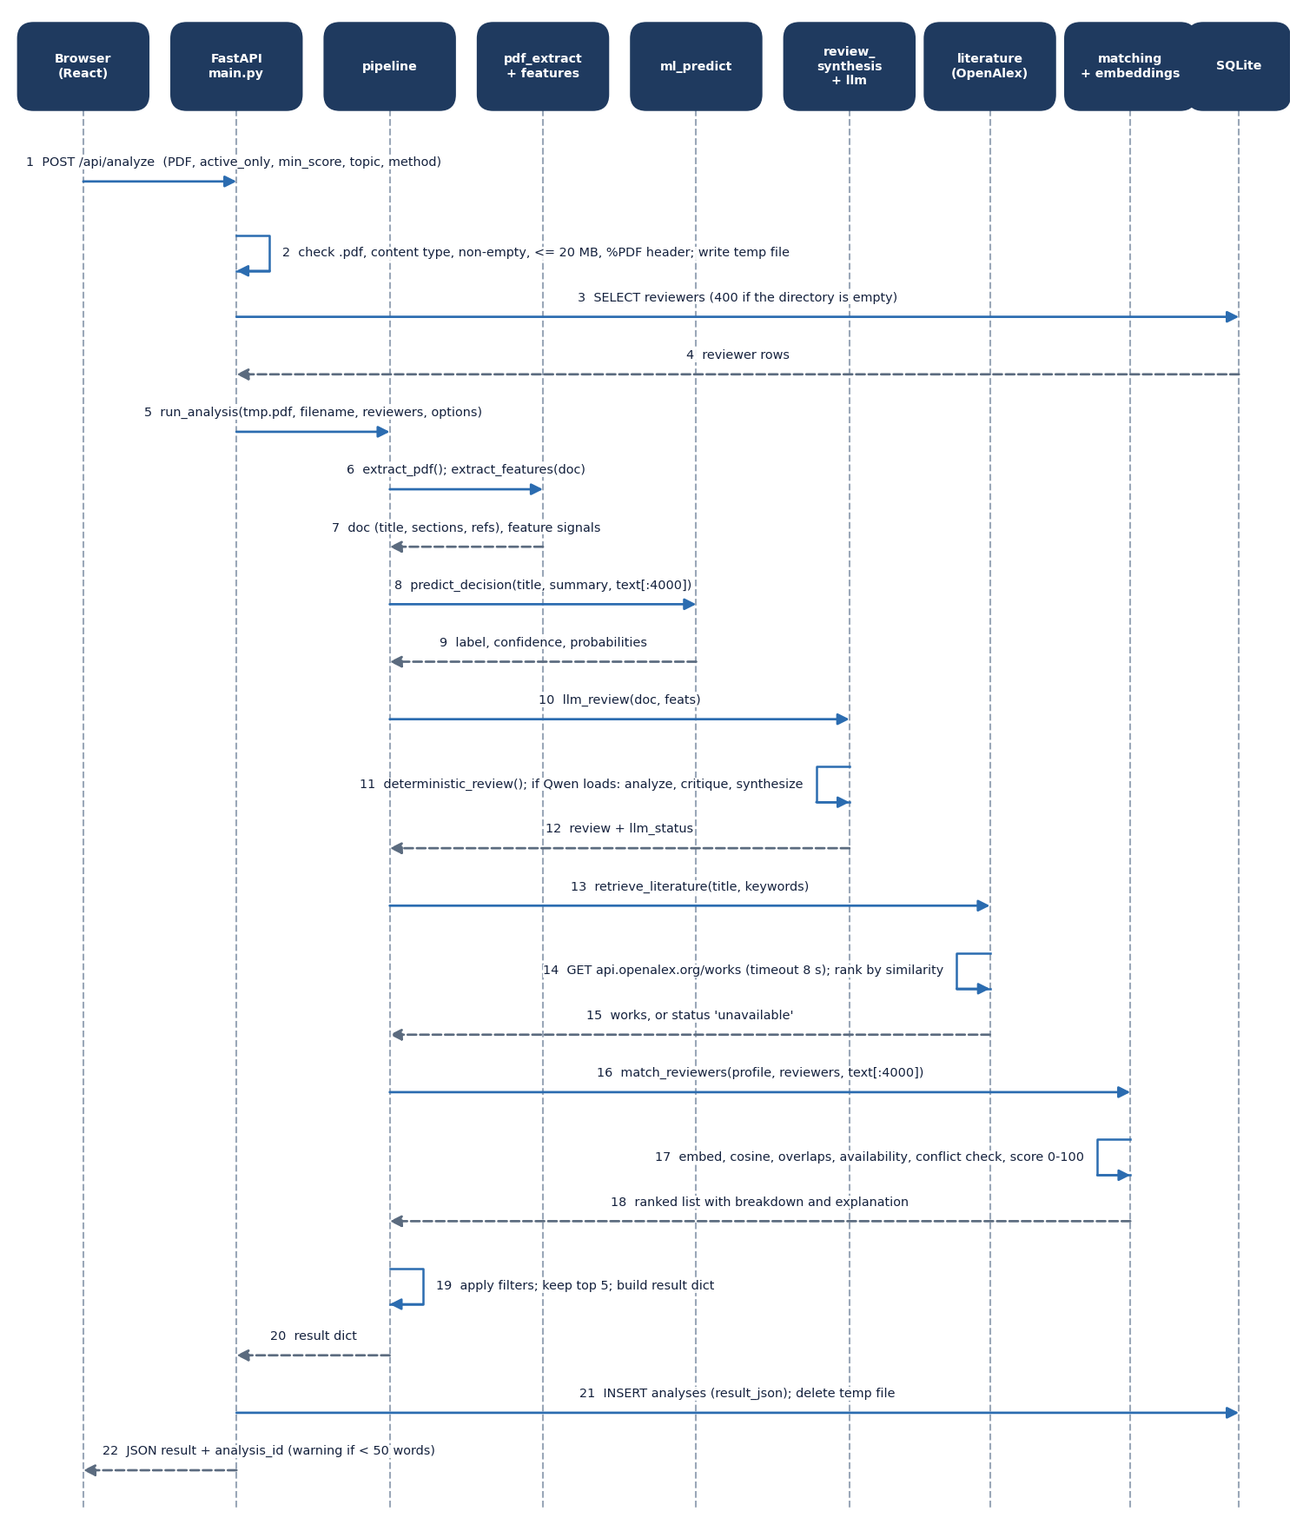
Figure 10: Sequence diagram of a paper analysis, from the browser upload to the stored JSON response.

5.4.3 Use-case diagram
The editor uploads a paper, reads the assessment and review, sees literature, obtains ranked reviewers (which includes the conflict check), exports, browses the history and views model performance; the administrator manages and imports reviewers. The local language model and OpenAlex appear as supporting systems.
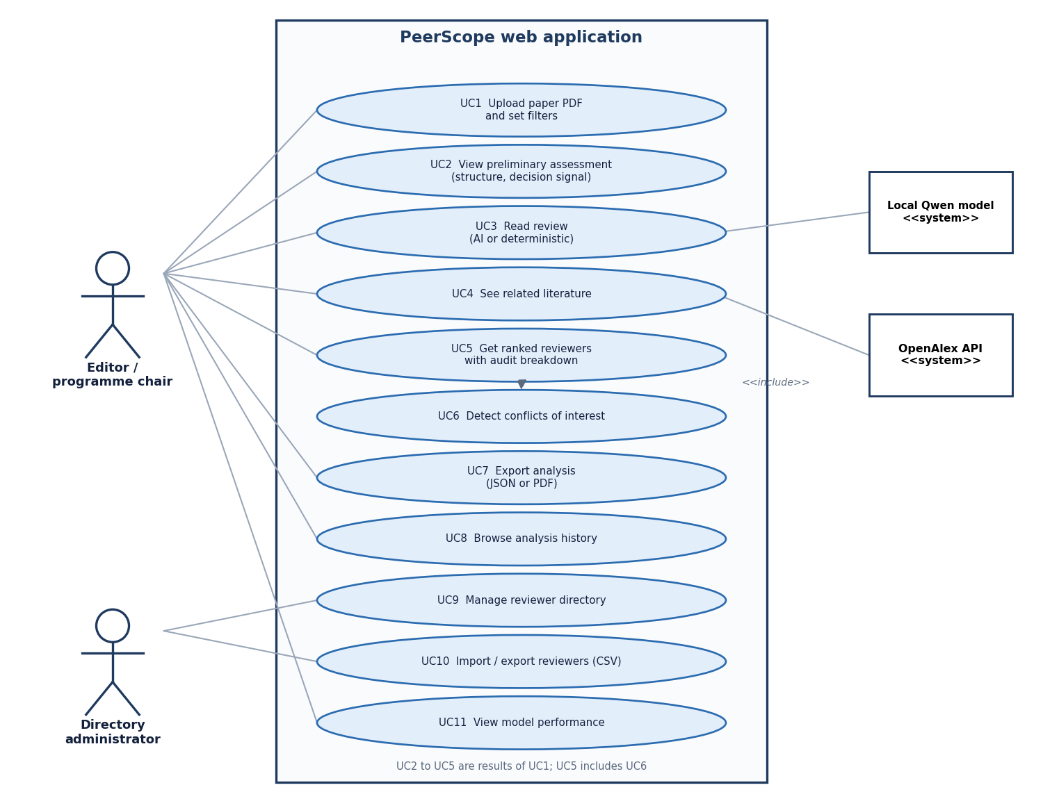
Figure 11: Use-case diagram of PeerScope with its two human actors and two supporting systems.

5.5 Database Design
Two tables are kept in the SQLite file data/peerscope.db, created by create_all at start-up. SQLite suits a single-user local tool: no server, and a backup is one file copy.
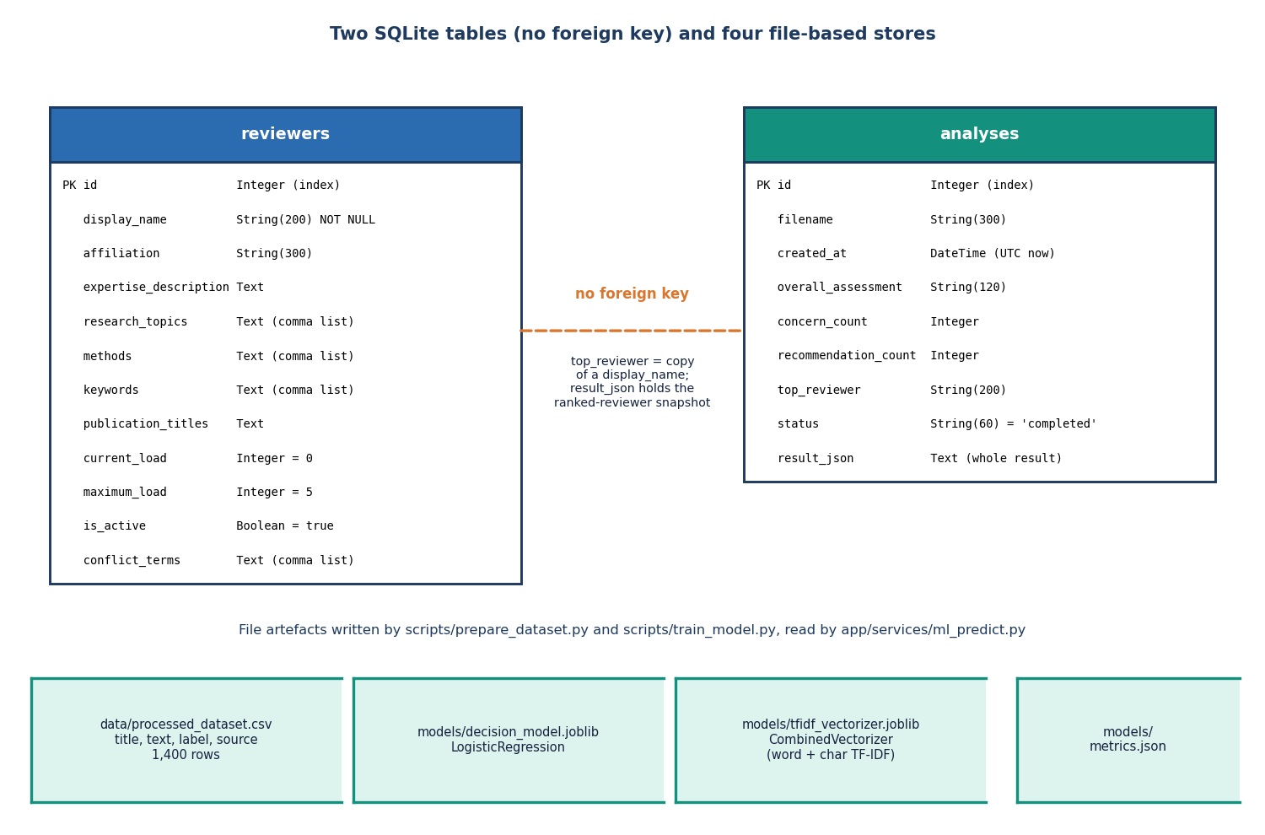
Figure 12: Entity-relationship diagram of the PeerScope SQLite tables and file-based stores.

5.5.1 The reviewers table

5.5.2 The analyses table
Table 20: Columns of the two tables
Table | Columns
reviewers | id (integer, primary key); display_name (String 200, not null); affiliation (String 300); expertise_description, research_topics, methods, keywords, publication_titles, conflict_terms (Text, lists comma-separated); current_load (integer, default 0); maximum_load (integer, default 5); is_active (boolean, default true)
analyses | id (integer, primary key); filename (String 300); created_at (DateTime, UTC now); overall_assessment (String 120); concern_count, recommendation_count (integer); top_reviewer (String 200); status (String 60, default 'completed'); result_json (Text, the whole result)

There is no foreign key between the tables, by design: an analysis is a snapshot. result_json holds the five ranked reviewers as scored that day and top_reviewer is a copy of a name, so later edits or deletions never break the history. Lists are stored as comma-separated text so that CSV import and export are a straight copy of the columns.

5.5.3 File-based stores
The training CSV (data/processed_dataset.csv, 1,400 rows) is written by prepare_dataset.py; decision_model.joblib, tfidf_vectorizer.joblib and metrics.json are written by train_model.py and read by ml_predict and the metrics route; models/hf_cache holds the language-model weights; data/tmp holds each upload only until its request ends.

5.6 Module Design
The service tier has twelve modules, each with one responsibility; names beginning with an underscore are internal.
Table 21: Modules of app/ and their public functions
Module | Responsibility | Functions
main.py | FastAPI app, routes, upload guards, error handler, start-up seeding | health, model_metrics, reviewer CRUD, import and export, analyze, list_analyses, get_analysis, export_analysis
config.py | Tunable settings from the environment and .env | paths, ports, upload limit, model names, MATCH_WEIGHTS
database.py, models.py, schemas.py | Engine and session, ORM classes, Pydantic validation | get_db, init_db, Reviewer, Analysis, ReviewerIn
services/pipeline.py | Orchestrates one analysis and applies filters | run_analysis
services/pdf_extract.py | Text, title, sections, references, summary | extract_pdf
services/features.py | Counts, keywords, lexicon hits, four structural signals | extract_features
services/ml_predict.py | Lazy loading and prediction of the decision model | artifacts_exist, predict_decision, load_metrics
services/review_synthesis.py | Deterministic review and 3-step language-model review | deterministic_review, llm_review, review_quality
services/llm_service.py | Lazy, thread-safe loading of Qwen2.5 with a fallback model | ensure_llm, generate, llm_status
services/embeddings.py | MiniLM embeddings with a TF-IDF fallback | embed_texts, cosine, embedding_status
services/literature.py | OpenAlex retrieval and relevance ranking | retrieve_literature, score_literature
services/matching.py | Profiles, overlaps, conflict check, score, explanation | paper_profile, reviewer_profile, detect_conflict, match_reviewers
services/export_service.py | JSON and A4 PDF report | analysis_to_json, analysis_to_pdf
services/seed.py, textvec.py | Six demo reviewers when empty; importable vectoriser class | seed_if_empty, CombinedVectorizer

5.6.1 Extraction and features
extract_pdf reads each page with PyMuPDF, normalises whitespace, takes as title the first of the first 25 lines that is 12 to 220 characters long and does not end with a full stop, finds sections as short heading lines that match nine pattern groups, splits references after a References heading, and takes a summary from the summary or introduction. extract_features adds counts, the fifteen most frequent keywords, hits from a 21-term method lexicon and an 18-term topic list, and four signals (structure completeness, evidence coverage, method clarity, presentation) combined as 0.35, 0.25, 0.25 and 0.15 into the overall structural score. These weights are the team's heuristics and were not fitted to human judgements.

5.6.2 Decision signal and review
ml_predict transforms the title, summary and first 4,000 characters with the saved vectoriser and returns class probabilities, label and confidence, or 'model_unavailable'. The deterministic review always runs and turns the features into strengths, concerns, standing recommendations, a coverage view and page-anchored evidence; the novelty text always says novelty cannot be settled locally. llm_review optionally sends the first 6,000 characters to the local Qwen model in three steps (analysis, critique, synthesis; 512, 512 and 700 new tokens) with prompts that restrict it to the supplied text. llm_service loads the model once under a lock, tries the 1.5B model then the 0.5B one, runs on the CPU with greedy decoding and remembers a failed attempt.

5.6.3 Literature, embeddings and matching
retrieve_literature queries OpenAlex with the title and ranks works by cosine similarity to the query. embed_texts encodes the first 2,000 characters of each text with all-MiniLM-L6-v2, or, if it cannot load, with a 512-feature TF-IDF vectoriser fitted on the first batch and then reused, so its vocabulary is frozen by the first request. match_reviewers embeds the paper and every reviewer profile and computes cosine similarity, keyword overlap, method and topic overlap and availability, following the flowchart below.
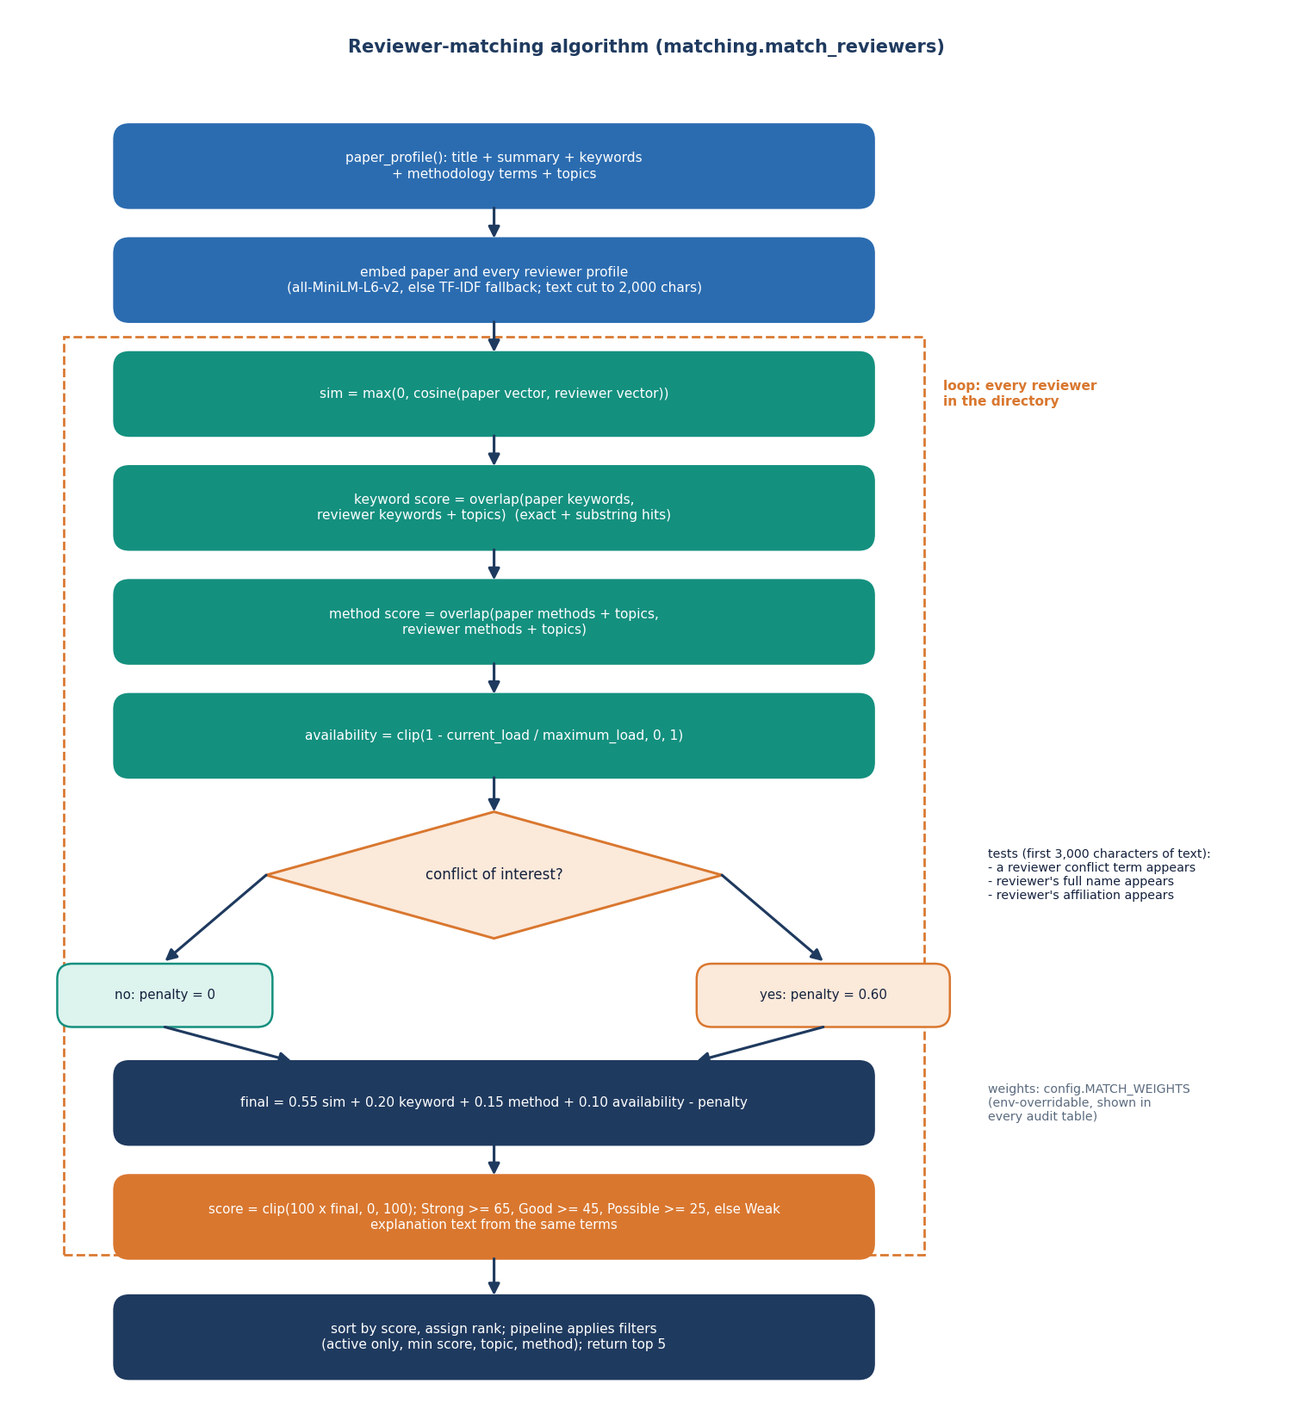
Figure 13: Flowchart of the auditable reviewer-matching algorithm.

5.6.4 Conflict of interest
detect_conflict searches the first 3,000 characters of the paper for any conflict term, the reviewer's full display name (a first name alone is not enough) or the affiliation string. A flagged reviewer has the penalty of 0.60 subtracted, which in practice moves them to the bottom. The method is simple and auditable; its limit is that it finds only literal strings.

5.6.5 Pipeline filters and storage
After scoring, run_analysis applies the filters (active only by default, minimum score, topic and method substrings), keeps five reviewers and builds the result; main.analyze stores it and warns if fewer than 50 words were extracted. Ports, the upload limit, model names, the literature count and the weights are read from the environment by config.py.
Table 22: Configuration read by app/config.py
Setting | Default | Effect
PEERSCOPE_HOST, PEERSCOPE_PORT | 127.0.0.1, 8408 | Where the API listens
PEERSCOPE_MAX_UPLOAD_MB | 20 | Largest accepted PDF
PEERSCOPE_LLM_MODEL, PEERSCOPE_LLM_FALLBACK | Qwen2.5-1.5B-Instruct, Qwen2.5-0.5B-Instruct | Local language models
PEERSCOPE_EMBED_MODEL | all-MiniLM-L6-v2 | Sentence encoder
PEERSCOPE_LITERATURE_COUNT, _TIMEOUT | 6, 8 s | OpenAlex works requested and timeout
PEERSCOPE_W_EXPERTISE, _KEYWORD, _METHOD, _AVAIL, _CONFLICT | 0.55, 0.20, 0.15, 0.10, 0.60 | Matching weights

5.7 Scoring Design
For a paper p and a reviewer r, with sim the cosine similarity (negative values set to zero), kw and me the keyword and method overlaps, av the availability and pen the conflict penalty:
score(p, r) = 100 x clip( 0.55 sim + 0.2 kw + 0.15 me + 0.1 av - 0.6 pen , 0 , 1 ) (1)
where av = clip(1 - current load / maximum load, 0, 1) and pen is 1 for a flagged reviewer and 0 otherwise. The result is Strong at 65 or more, Good at 45, Possible at 25 and Weak below. The weights follow the structure of the base paper's affinity construction [1] but were set by the team and not fitted; they are read from the environment so that an editor can tune them. The explanation sentence is built from the same values.

5.8 User Interface Design
The interface has eight routes: the landing page and, under /app, Dashboard, Analyze, Saved analysis, Reviewers, Model performance, History and About. Pages load lazily, an error boundary keeps one failure from blanking the others, and every asynchronous view has loading, empty and error states. The 'Depth Studio' kit supplies Sora, Inter and JetBrains Mono type, a dark theme with a light theme that follows the operating system, an emerald accent, a 248-pixel sidebar (a slide-in drawer on narrow screens) and a 64-pixel top bar. The result view shows four summary tiles and five tabs: Overview, Review, Literature, Reviewers, and Audit and export. A banner on the Dashboard and Model pages states that the decision model was trained on synthetic data.
  Figure 14: Analyze page after an analysis: summary tiles and the Overview tab. | 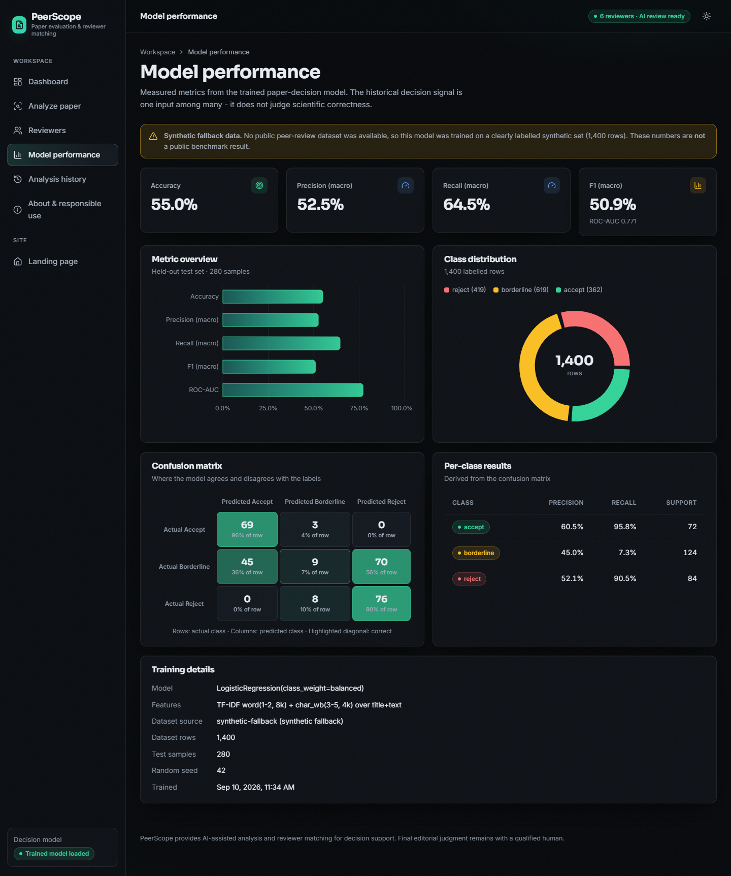  Figure 15: Model performance page with the synthetic-data notice and confusion matrix.

5.9 Key Design Decisions
Table 23: Design decisions and reasons
Decision | Reason
Process PDFs locally; send only a title query out | Review material is confidential and hosted tools raise manipulation risks [2], [27]
Deterministic review always runs; language model optional | A useful, honest result when the model cannot load or the machine is slow
Linear weighted score with explicit availability and conflict terms | No labelled assignments exist; a linear score can be audited line by line [1]
MiniLM embeddings with a TF-IDF fallback | Fast on a CPU, the encoder family of the base paper's baseline; the fallback works offline
TF-IDF and logistic regression for the decision signal | No real decision data and CPU only; fast to train and explain; output is a labelled demonstration
SQLite with a JSON snapshot per analysis | Single user, no server; a stored analysis must not change when the directory changes
Functions over dictionaries; weights from the environment | Testable stages, JSON-storable results, tuning without code changes
No authentication; top five reviewers only | Out of scope for a local tool (future work); a short list is what an editor needs

The coverage view in the Review tab uses a fixed value for the Novelty axis, because novelty cannot be measured from the paper alone, and the Model page shows a notice whenever the metrics file says the data were synthetic. The design errs on the side of showing what the system does not know.

CHAPTER 6: METHODOLOGY AND SOFTWARE IMPLEMENTATION

6.1 Overall methodology
PeerScope follows a hybrid method: deterministic text processing, one trained statistical classifier, a local language model used only to draft review text, and an embedding-based matching stage whose score can be audited term by term. The method has two outputs for every uploaded paper: a preliminary assessment (structural signals, a historical decision signal, a reviewer-style critique and related literature) and a ranked list of reviewers with the arithmetic behind every rank. The design follows the principle of auditable matching stated in the base paper [1], but the project's scope is broader (it adds the assessment of the paper) and its scale is much smaller (Chapter 8 states the differences). The steps are:
1. Upload and validate a PDF (extension, content type, size at most 20 MB, %PDF header).
2. Extract page text with PyMuPDF, normalise whitespace, guess the title, detect up to nine sections and parse the reference list.
3. Derive features: frequency keywords, method terms from a 21-term lexicon, topic hints from an 18-term list, and four structural signals combined into one structural score.
4. Classify the opening text with the trained TF-IDF + logistic-regression model to give a historical decision signal (accept / borderline / reject) with class probabilities.
5. Review: always produce the deterministic rule-based review; when the local Qwen2.5 model loads, add a three-step analyse, critique and synthesise pass; otherwise say plainly that it is unavailable.
6. Ground the paper in literature by querying OpenAlex with the title and ranking the six returned works by embedding similarity.
7. Match the paper profile against every reviewer profile: embedding cosine, keyword overlap, method and topic overlap, availability and a conflict penalty, combined with fixed, documented weights.
8. Store and export the result in SQLite and offer it as JSON or as a PDF report.
Figure 16: Text extraction, section detection and structural scoring of an uploaded paper.

6.2 Datasets

6.2.1 Decision-model data: a synthetic corpus
The project looked for a public corpus of papers with reviewer decisions. The preparation script (scripts/prepare_dataset.py) probes one PeerRead-style file on a public repository [22] with a six-second timeout and, because no usable data came back, falls back to a generated corpus. The shipped model is therefore trained on 1,400 synthetic rows; models/metrics.json records dataset_source: synthetic-fallback and the web application shows a visible warning beside every metric. This is the most important limitation of the decision model and the rest of this section explains exactly what the data can and cannot show.
Each row is made by a seeded random generator (seed 42). One of six topics is drawn (vision, language, learning, systems, security, data), each with seven topic words, and a latent quality value q is drawn uniformly from 0 to 1. If q is above 0.52 the paper is given three of seven strength phrases (for example "strong baselines", "comprehensive ablations"); otherwise it is given three of seven weakness phrases (for example "missing baselines", "unsupported claims"). The label is accept when q > 0.72, reject when q < 0.30 and borderline otherwise, which includes both the upper-middle strength papers (0.52 < q <= 0.72) and the lower-middle weakness papers (0.30 <= q <= 0.52). A title and a short template paragraph containing the phrases and topic words form the text. The resulting class counts are accept 362, borderline 619 and reject 419.
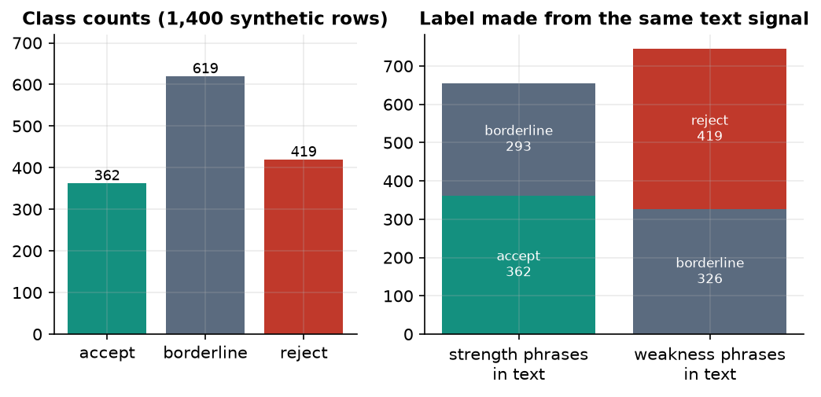
Figure 17: Class counts of the synthetic corpus and how the label relates to the text signal that the classifier can see.
The right-hand panel shows why the data are limited. Of the 655 papers that contain strength phrases, 362 are labelled accept and 293 borderline; of the 745 papers with weakness phrases, 419 are reject and 326 borderline. The borderline class is generated from both phrase groups, so the text alone cannot separate it from accept or reject. A rule that reads the phrases and always answers accept or reject reaches only 55.8% accuracy on the whole corpus, and no text classifier can do better than about 55.8%. Accuracy near 0.55 is therefore what the data allow, not a sign of a weak method; equally, it says nothing about real peer-review decisions.
The corpus is split 80/20 with a stratified split and seed 42 into 1,120 training and 280 test rows.

6.2.2 Reviewer data
The reviewer directory is seeded at first start with 6 clearly labelled demo profiles (Reviewer Alpha to Reviewer Zeta; Epsilon is inactive). Each profile has a display name, affiliation, free-text expertise description, comma-separated research topics, methods and keywords, publication titles, a current and a maximum review load, an active flag and comma-separated conflict terms. The areas are computer vision, language processing, applied machine learning and reproducibility, network security, medical informatics and robotics. The directory can be extended by form or by CSV import. No real person's publication history is stored, and no h-index is computed; the project abstract mentions publication history, and the closest implemented element is the publication_titles text field.

6.2.3 Probe set for the matching evaluation
To measure the matcher without real submissions the team wrote 40 short abstracts (scripts/eval_data.py): six for each of the six reviewer areas and four deliberately cross-area papers for which two reviewers are acceptable. The abstracts avoid copying the reviewers' keyword lists. A second list of 15 conflict cases adds one sentence to a paper that links it to a reviewer by a conflict term (6), an affiliation string (4), the reviewer's full name (2), a reworded affiliation (2) or a first name alone (1). The labels are the team's own judgement. They are not independent expert judgements, so the matching results in Chapter 8 are optimistic and are a check of the mechanism, not a validation on real submissions.

6.2.4 Real documents used for observation
Four real PDFs were run through the extraction, feature and decision stages to observe behaviour on genuine papers: the generated demo paper (3 pages) and three research PDFs kept with the batch (30, 17 and 30 pages). They are not labelled and therefore support no accuracy claim.

6.3 Extraction and preprocessing
All extraction is local and deterministic (app/services/pdf_extract.py). The steps, in order:
Table 24: Extraction steps and the reason for each
Step | Operation | Reason
1. Page text | page.get_text('text') for every page with PyMuPDF; text of each page is kept with its page number | Local, fast and layout-preserving; page numbers let the review point to evidence
2. Normalise | Collapse tabs and spaces, drop repeated blank lines, keep paragraph breaks | Makes sentence and section statistics stable
3. Title | First line among the first 25 that is 12-220 characters and does not end with a full stop | Cheap heuristic; fails on papers whose first lines are identifiers (observed on the IEEE base paper)
4. Sections | Lines shorter than 81 characters matched against regular expressions for nine sections (summary, introduction, related work, methodology, experiments, results, discussion, conclusion, references); the text up to the next heading is the section body | Gives per-section word counts for the structural signals; fragile for roman-numeral headings
5. References | Text after a line References (or Bibliography) split at [n] or n. markers; fall back to bracketed lines | Reference count and density feed the evidence signal
6. Summary | Preview of the summary or introduction section, else the first paragraph longer than 120 characters (max 900 characters) | Short text for the classifier, the matcher and the literature query

6.4 Algorithm choice and justification
Table 25: Algorithms used and why they were chosen
Component | Choice | Reason | Alternative not chosen
Text features for the decision model | TF-IDF, word 1-2-grams (8,000) + character 3-5-grams (4,000) [17, 18] | Strong, fast, interpretable baseline for short text; trains in seconds on a CPU | Fine-tuned transformer: needs real labelled data and a GPU
Decision classifier | Multinomial logistic regression, class_weight=balanced [31] | Gives calibrated-looking class probabilities for the confidence display; convex, deterministic with a seed | Boosted trees / neural network: no gain was possible on data with this label structure
Expertise similarity | Sentence embeddings all-MiniLM-L6-v2, cosine [19, 20] | Same encoder family as the base paper's bi-encoder baseline; 384 dimensions; runs on a CPU | SPECTER [21]: larger and not needed for the small pool; LLM keyword ensembles of the base paper: costly
Lexical evidence | Keyword overlap and method / topic overlap (exact and substring hits) | Gives the human-readable matching terms shown beside each rank | Embeddings alone cannot name what matched
Availability and conflict | Load ratio and literal-string conflict penalty inside the score | Makes workload and conflicts visible in the same audit table | External assignment solver: out of scope
Review drafting | Qwen2.5-1.5B-Instruct (fallback 0.5B), CPU, greedy decoding [29, 30] | Open weights, runs locally so no manuscript leaves the machine; small enough for 16 GB RAM | Hosted LLM: would send unpublished manuscripts to a third party
Literature context | OpenAlex works search [32] | Free, no key, open index | Paid APIs

The central design choice is separation of roles. The trained classifier gives one weak signal; the structural signals are deterministic; the language model writes prose but never ranks reviewers or changes a score; and the matching score is arithmetic that a reader can recompute from the audit table. This separation answers the concern that dense-embedding matchers are hard to audit [1] and the evidence that LLM reviewers can be steered by hidden text in a manuscript [2, 27]: the model's text is displayed as an aid and never feeds a number.

6.4.1 Deterministic review rules
The always-produced review (deterministic_review) is a set of explicit rules over the extracted features, so every sentence traces to a number: strengths when a methodology section, an experiments or results section, at least eight references or at least five sections are found; major concerns when the methodology is missing or under 120 words, no evaluation section is found, fewer than five references are found or the mean sentence exceeds 32 words; minor concerns for short or missing sections, a short title or summary; and five generic recommendations. A six-axis coverage object feeds the radar chart; its novelty axis is a fixed 55 because novelty cannot be measured from one paper, and the text says novelty is inconclusive.

6.4.2 Local language-model review
When the language model loads, three prompts run on the first 6,000 characters of the paper: analyse (problem, contribution, approach, claims, evidence, weaknesses), critique (method clarity, evidence, reproducibility, limitations, in cautious wording) and synthesise (a structured assessment with ten headings). System prompts forbid invented experiments, data or citations; decoding is greedy with budgets of 512, 512 and 700 tokens. If the model cannot be loaded or generation fails, llm_status records unavailable or error and the deterministic review is shown unchanged; the 0.5B model is a fallback.

6.4.3 Conflict-of-interest detection
detect_conflict tests the first 3,000 characters of the paper for any conflict term of the reviewer, the reviewer's full name and the full affiliation string; a match sets the flag, adds the penalty and replaces the explanation with the reason. The test is exact and therefore auditable, but it cannot see a reworded affiliation, a first name alone, co-authorship or citation links (Chapters 8 and 10).

6.4.4 Literature grounding and embeddings
The OpenAlex query uses the title (or the first six keywords), asks for six works and re-ranks them by embedding cosine, with a word-overlap fallback; any network error gives unavailable. Embeddings come from all-MiniLM-L6-v2; if it cannot be loaded, a TF-IDF vectoriser (512 features) is fitted on the first batch of texts and reused unchanged, so the vocabulary is frozen by the first request, which explains the lower offline accuracy (top-1 0.75 against 0.95).

6.4.5 Decision signal at inference time
At inference the classifier receives the title, summary and first 4,000 characters of the paper and returns the most probable label, its probability as the confidence, all three probabilities and a fixed note that the signal is not a judgement of correctness; if the artifacts are missing it returns model_unavailable.

6.5 Mathematical formulation

6.5.1 Text representation and classifier
With N training documents, a term t that occurs in df(t) of them and a raw count tf(t, d), the TF-IDF weight (scikit-learn's smoothed form) is
x(t,d) = tf(t,d) × [ ln((1 + N) / (1 + df(t))) + 1 ] (each vector then scaled to unit Euclidean length) (2)
The word and character vectors are concatenated into one 12,000-dimensional sparse vector x. For K = 3 classes the multinomial logistic model gives
P(y = k | x) = exp(wₖ·x + bₖ) / Σⱼ exp(wⱼ·x + bⱼ) (3)
and is fitted by minimising the class-weighted regularised log-loss
L(W, b) = − Σᵢ ωᵧᵢ · ln P(yᵢ | xᵢ) + (1 / 2C) · ‖W‖², ωₖ = n / (K · nₖ), C = 1 (4)
where nₖ is the number of training documents in class k; the weights ωₖ increase the influence of rarer classes. The reported confidence of a prediction is the largest class probability. Macro precision, recall and F1 average the per-class values with equal weight; the multi-class ROC-AUC is the one-versus-rest average.

6.5.2 Reviewer matching
For a paper profile p and a reviewer profile r (text, keyword set, method set), the expertise similarity is the clipped cosine of their embeddings u and v:
sim(p, r) = max(0, u·v / (‖u‖ ‖v‖)) (5)
Keyword and method overlaps compare two term sets A and B by the number h of hits, where a hit is an exact match or a term contained in a term of the other set:
overlap(A, B) = min(1, 1.1 · h / max(|A|, |B|)) (0 if either set is empty) (6)
Availability falls linearly with the reviewer's current load, and the conflict flag c is 1 when a conflict term, the reviewer's full name or the affiliation string occurs in the first 3,000 characters of the paper text:
avail(r) = clip(1 − load(r) / max_load(r), 0, 1) (7)
The final match score, reported from 0 to 100, is the audited weighted sum (weights from app/config.py, adjustable by environment variables):
score(p, r) = 100 · clip( 0.55·sim + 0.20·kw + 0.15·method + 0.10·avail − 0.60·c , 0, 1 ) (8)
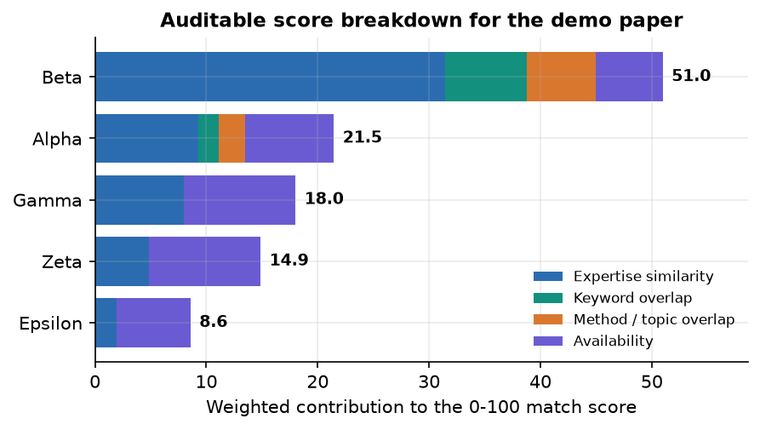
Figure 18: Weighted contribution of each component to the match score of the five best reviewers for the demo paper.

6.5.3 Structural score
Four signals in the range 0 to 100 are derived from the extracted document. With S the number of detected sections out of nine, R the number of references, G the page count, w̄ the mean sentence length in words and q the share of detected sections shorter than 40 words:
structure = 100·S/9; evidence = min(100, 22·R/G + 10·[experiments or results present]) (9)
method clarity = 100 if the methodology section has ≥ 120 words, 70 if it exists, 45 if method terms occur, else 25 (10)
presentation = 100 if 12 ≤ w̄ ≤ 26 and q < 40 %, 75 if 8 ≤ w̄ ≤ 32, else 50 (11)
structural score = 0.35·structure + 0.25·evidence + 0.25·method clarity + 0.15·presentation (12)
The weights and thresholds are design decisions chosen so that a complete, referenced paper scores high; they were not fitted to human judgements and the score is presented as one input among several. The overall wording (Strong, Moderate, Early-stage) uses cut-offs of 75 and 55.

6.6 Model training and configuration
scripts/train_model.py reads the CSV, joins title and text, encodes the labels alphabetically (accept, borderline, reject), splits 80/20 with a stratified split and seed 42, fits the two TF-IDF vectorisers on the training part only, fits the classifier and writes models/decision_model.joblib, models/tfidf_vectorizer.joblib and models/metrics.json.
Table 26: Training configuration
Item | Value
Rows / train / test | 1,400 / 1,120 / 280
Split | 80/20, stratified by label, random_state 42
Word TF-IDF | 1-2-grams, 8,000 features, English stop words removed, lower-cased
Character TF-IDF | char_wb 3-5-grams, 4,000 features
Classifier | LogisticRegression(max_iter=1000, class_weight='balanced', C=1.0, random_state=42)
Inference text | Title + summary + first 4,000 characters of the paper
Training time | Seconds on the CPU (measured step: all of decision_model evaluation, five re-fits and baselines took under 10 s)
Software | Python 3.11.9, scikit-learn 1.9.1, NumPy 2.4.6, pandas 3.0.6
Hardware | 12th Gen Intel(R) Core(TM) i5-12500, 15.7 GB RAM, none used (CPU only)

Figure 19: Training pipeline of the decision model.

6.6.1 Evaluation protocol
The decision model is evaluated on the held-out 20 % only, once, with accuracy, macro precision, macro recall, macro F1, one-versus-rest ROC-AUC, the confusion matrix and per-class scores. Because the classifier outputs probabilities, a confidence-threshold analysis reports the share of papers kept and the accuracy on the kept papers for thresholds from 0.4 to 0.9. Three baselines on the same split put the result in context: the majority class, multinomial Naive Bayes on word TF-IDF, and the same logistic regression without class weights or without character features. A last check re-fits the shipped configuration on five different splits to show how much the numbers depend on the split.

6.7 Application architecture and implementation
PeerScope is a three-tier local application of about 1,449 lines of Python (app/), 6,926 lines of React code and styles (frontend/src/) and 542 lines of supporting scripts, with 114 lines of tests. The architecture is shown in Chapter 5; the points below describe how it is realised.
API tier. app/main.py creates one FastAPI application, initialises the SQLite schema through SQLAlchemy, seeds the six demo reviewers if the table is empty (a seeding failure is logged and never stops start-up) and declares all routes. The routes are thin: file validation and persistence are in main.py, everything else is delegated to service modules in app/services/ (pdf_extract, features, ml_predict, review_synthesis, llm_service, literature, embeddings, matching, pipeline, export_service, seed). The services are plain function modules without hidden state, except three lazily created singletons: the classifier and vectoriser (loaded on first use), the sentence-embedding model and the language model. Each loader catches its own exceptions and records the error, so a missing package or an offline machine degrades one feature instead of the whole request.
Pipeline module. pipeline.run_analysis is the only place where the stages are composed. It runs them in a fixed order, applies the user's filters to the ranked reviewers (active only, minimum score, topic text, method text), keeps the five best and assembles the result dictionary that is returned to the browser and stored as JSON.
Web tier. The React application (Vite, port 5408) calls the API through a small client (lib/api.js) whose errors carry a message that is safe to show. It has eight views: landing page, dashboard, analysis form and result, reviewer directory, model performance, history, saved analysis and an about page that states responsible use. A result is shown in five tabs (Overview, Review, Literature, Reviewers, Audit and export), and each reviewer card opens a table with the five score components, their values and weights. The original vanilla-JavaScript interface remains in static/ and is served by the API at / as a fallback.
Storage. Two SQLite tables: reviewers and analyses. The second keeps a summary (file name, time, overall assessment, concern and recommendation counts, top reviewer name) and the complete result as a JSON text column, so a saved analysis can be re-opened and exported without recomputation. There is deliberately no foreign key between them; the ranked reviewers are a snapshot inside the JSON.

6.7.1 Key code: the match score
The function transcribes the formula of Section 6.5.2; every intermediate value is returned in a breakdown dictionary with the weights, and the explanation sentence is generated from the same values (listing in Appendix A).

6.7.2 Key code: the analysis pipeline
pipeline.run_analysis composes the stages in a fixed order; each stage that can fail returns an explicit status field (llm_status, literature_retrieval_status, the classifier's status) that the interface shows instead of hiding a missing component.

6.8 API design
The API is a JSON-over-HTTP interface on port 8408, documented automatically at /docs by FastAPI. Request bodies are validated by Pydantic schemas; the reviewer schema limits name length (1-200), text fields (2,000-4,000 characters) and loads (0-100, maximum load 1-100).
Table 27: Endpoints
Method and path | Request | Success response | Error responses
GET /api/health | - | Status, product, LLM state (loaded or lazy-not-loaded), embedding backend, model-loaded flag, reviewer count | -
GET /api/model/metrics | - | Contents of models/metrics.json, or status: missing | -
GET /api/reviewers | - | List of reviewers (12 fields) | -
POST /api/reviewers | JSON reviewer; display_name required | 201 and the stored reviewer | 422 invalid field; 400 save failure
PUT /api/reviewers/{id} | JSON reviewer | 200 and the updated reviewer | 404 unknown id; 422; 400
DELETE /api/reviewers/{id} | - | {"deleted": id} | 404 unknown id
GET /api/reviewers/export/csv | - | CSV attachment peerscope_reviewers.csv | -
POST /api/reviewers/import | Multipart CSV file | {"imported": n} | 400 unreadable or malformed CSV
POST /api/analyze | Multipart: file (PDF), active_only, min_score, topic, method | Full analysis result and analysis_id; a warning if fewer than 50 words were extracted | 400 not a PDF, empty, bad header or no reviewers; 413 over 20 MB; 500 analysis failure
GET /api/analyses | - | Stored analyses, newest first | -
GET /api/analyses/{id} | - | Stored result JSON | 404 unknown id; 500 corrupted record
GET /api/analyses/{id}/export | format=json or pdf | Attachment: JSON file or a PDF report built with ReportLab | 404 unknown id

The analysis result contains these top-level fields: paper (title, summary, pages, words, references, detected sections, preview of the first four pages), features, ml_decision_signal (label, confidence, probabilities, note), structural_assessment, review (strengths, major and minor concerns, method, evidence, clarity and reproducibility comments, novelty considerations, recommendations, a six-axis coverage object, evidence references, llm_status and, when available, the AI synthesis), review_quality, literature (status and works), reviewers (the five best, each with score, strength, matching terms, availability, conflict result, breakdown and explanation), the pool size, the disclaimer and the responsible-use statement.

6.9 Security and error handling
• Upload validation. The extension must be .pdf; a declared content type must mention pdf or octet; the body must be non-empty, at most 20 MB (configurable) and start with %PDF. The bytes are written to a temporary file that is deleted in a finally block whatever the outcome, and no uploaded paper is kept on disk or sent to a paid service.
• Input limits. Reviewer fields have maximum lengths and numeric ranges (Pydantic); CSV import truncates long names and affiliations, tolerates missing columns and turns any parsing error into a 400 after rolling back the transaction.
• Injection. All database access goes through the SQLAlchemy ORM with bound parameters; the React interface escapes text; the PDF export escapes &, < and > before ReportLab renders it.
• Degrade, do not fail. A missing classifier, embedding model, language model or network connection sets a status field and the interface says so; the pipeline continues with the deterministic parts.
• Privacy. Text extraction, classification, embeddings and the language model run on the local machine. Only the paper's title (or its keywords) is sent to OpenAlex, with an 8-second timeout.
• What is not protected. The API has no authentication and allows every origin because it is meant for one user on one machine; it must not be exposed to a network as it stands. PyMuPDF parses untrusted PDFs in the server process. Text hidden in a PDF could steer the local language model [2]; the mitigation is architectural (the model's text never changes a score and is labelled as AI output) rather than a filter.

6.10 Installation and execution
Quick start (Windows). Install Python 3.11 or 3.12 and Node.js 18 or newer and double-click run.bat. The script checks both tools, creates or repairs the virtual environment, installs requirements.txt, prepares the dataset and trains the decision model if the artifacts are missing, creates the demo PDF, installs the frontend packages, and starts the API on port 8408 and the web application on port 5408 in two windows. The first analysis downloads the sentence-embedding model and the Qwen language model (about 3 GB in models/hf_cache) from Hugging Face; if that fails the application keeps working with the deterministic analysis and a TF-IDF fallback embedder.

CHAPTER 7: SYSTEM TESTING

7.1 Testing strategy
Testing has five layers: unit tests of single functions, in-process API tests, a smoke test that drives a running server over HTTP, measured experiments on held-out data and probe sets (Chapter 8), and a browser walk that produces the screenshots. The tests (tests/, 114 lines, and scripts/smoke_test.py) check behaviour, not the scientific quality of the assessments, which only people can judge and which no one was asked to judge (Section 7.8).
Table 28: Test layers and results
Layer | What it covers | Result
Unit and integration (pytest) | Extraction, features, matching and conflict logic, classifier service, health, reviewer CRUD, full analysis of the demo PDF | 7 tests; Pass
Functional (smoke test) | Reviewer CRUD and CSV, bad uploads, analysis, history, export, CORS, web app | 24 of 24 checks pass
Validation probes | Upload rules, field limits, edge cases (Section 7.4) | Observed as listed
Measured experiments | Decision model, baselines, five splits, matching probe set, conflict injection, four real PDFs | Numbers in Chapter 8

7.2 Unit testing
Table 29: Automated pytest cases
ID | Test | Assertions | Result
T1 | test_pdf_extraction | Demo PDF parsed: at least one page, more than 200 words, methodology or experiments detected | Pass
T2 | test_features | Synthetic document: has_methodology true; structural score within 0-100 | Pass
T3 | test_matching_and_conflict | NLP reviewer ranked first; breakdown and explanation present; conflict flag true for a conflict term | Pass
T4 | test_ml_predict_service | Label is accept, borderline, reject or unavailable | Pass
T5 | test_api_health | 200 and product PeerScope | Pass
T6 | test_reviewer_crud | POST 201, PUT 200, DELETE 200 | Pass
T7 | test_pipeline_with_demo | Demo PDF through /api/analyze: 200, more than 100 words, at least one ranked reviewer, strengths listed | Pass

The suite ran in 34 seconds; T7 is the slowest because it runs the whole pipeline, and with the local language model enabled it takes minutes on a CPU. T2 and T4 are deliberately loose (code runs, values in range); the accuracy of the classifier and of the matcher is measured separately. The scoring rules, the section detector and the review rules have no unit tests of their own, which is a gap (Section 7.8).

7.3 Integration testing
T7 sends a real PDF through the full request path (validation, extraction, features, classifier, review, literature, matching, storage, response); T5 and T6 call the routes through the same application object; the smoke test repeats the paths over a real HTTP connection, where uploads and cross-origin handling behave as they do for the browser. The browser itself was exercised only by the capture script, which reports console errors, page errors and failed requests.

7.4 Functional testing, validation and edge cases
scripts/smoke_test.py creates its own reviewers, removes them afterwards and checks every step. The validation rows were probed for this report with the FastAPI test client on a scratch database with the AI review off; they are not part of the automated suite.
Table 30: Functional, validation and edge-case checks
ID | Check | Expected / observed | Result
S1-S3 | Health route; model metrics; confusion matrix as large as the label list | 200, product PeerScope, accuracy present | Pass
S4 | Reviewer list | Non-empty list | Pass
S5 | Reviewer with an empty name | 422 | Pass
S6-S7 | Reviewer create; deactivate | 201; 200 and is_active false | Pass
S8-S9 | Reviewer CSV export; CSV import | 200 with header and new reviewer; imported = 1 | Pass
S10-S11 | Clean-up; delete an unknown reviewer | Count restored; 404 | Pass
S12 | Text file posted as a paper | 400 "Only PDF files are accepted" | Pass
S13 | File named .pdf that is not a PDF | 400 missing PDF header | Pass
S14-S15 | Analyse the demo PDF; result has review, reviewers, literature, features | 200; fields present | Pass
S16-S17 | Top reviewer has a breakdown; disclaimer mentions a human decision-maker | Present | Pass
S18-S19 | New analysis in history; fetch by id | Listed; 200 | Pass
S20-S21 | JSON export; PDF export | 200 with attachment header; bytes start with %PDF | Pass
S22 | Unknown analysis id | 404 | Pass
S23-S24 | Web application served; CORS allows the web origin | index.html served; origin allowed | Pass
V1 | Zero-byte a.pdf; .pdf with content type image/png | 400 "Uploaded file is empty." / 400 "Unexpected file type" | Observed
V2 | 21 MB body starting with %PDF | 413 "File too large (21.0 MB). Limit is 20 MB." | Observed
V3 | Reviewer with load 101, maximum load 0 or a 201-character name; non-integer analysis id | 422 with the field and the limit | Observed
V4 | CSV with a non-numeric load; binary file posted as CSV | 400 "Malformed reviewer CSV", nothing stored | Observed
V5 | Corrupt body after a %PDF header; CSV rows without a name | Accepted: 200 with almost no text; 0 rows imported (better as explicit errors) | Observed
E1 | Empty reviewer directory | 400 "Reviewer directory is empty. Add reviewers first." | Observed
E2 | PDF with one short sentence | 200 with the warning "Very little extractable text was found" | Observed
E3 | Local model not installed | llm_status: unavailable, deterministic review shown with the reason | Observed (first screenshot session)
E4 | OpenAlex unreachable | unavailable, no crash (by code; three online queries returned six works each) | By code
E5 | Embedding model not loadable | TF-IDF fallback: top-1 0.75 against 0.95 with MiniLM | Measured
E6 | Classifier artifacts missing or from another scikit-learn release | model_unavailable; version warning seen for 1.9.0 artifacts under 1.9.1; run.bat retrains | By code / observed
E7 | Reviewer at full load; inactive reviewer | Availability 0 lowers the score; inactive reviewers are filtered when active_only is on | By formula / filter
E8 | Conflict term, name or affiliation in the paper text | 12 of 12 literal links flagged and the reviewer fell to the bottom | Measured

The probes show consistent validation and short, safe error messages. They also show what validation does not do: a file that starts with %PDF but is otherwise corrupt is accepted and returns 200 with almost no extracted text, and a CSV whose rows have no name is accepted with zero rows imported; neither is dangerous, but both would be better as explicit errors. Uploaded bytes go to a temporary file that is deleted in a finally block, database access uses bound parameters through the ORM, and the PDF export escapes &, < and >.
The API has no authentication and allows all origins (a design decision for a single-user local tool, listed in Chapter 10). No penetration test, PDF-parser fuzzing or prompt-injection test was carried out; hidden instructions in a PDF are a known risk [2], [27] addressed by design (the language model never changes a score), not by a measured defence.

7.5 Performance testing
Timings come from one CPU-only machine (12th Gen Intel(R) Core(TM) i5-12500, 15.7 GB RAM). Loading the embedding model took 20.4 s and the Qwen model 9.0 s, once per server start. A 48-token generation took about 15 s in a separate probe (roughly 3 tokens per second), so the AI review takes minutes while every other stage is far faster; it is therefore optional and the deterministic review is shown first.
Table 31: Stage timings of one analysis (milliseconds, in-process)
Stage | Demo paper (3 pages) | Survey (30 pages)
PDF extraction | 2,371 | 383
Feature extraction | 1 | 68
Decision signal (classifier) | 31 | 86
Local AI review (3 steps) | 509,418 | 521,732
Literature (OpenAlex, network) | 2,328 | 1,543
Reviewer matching (6 reviewers) | 136 | 664
Total | 514,284 | 524,478

Table 32: HTTP latency with the AI review off (milliseconds, 127.0.0.1)
Request | Calls | Median | 95th percentile / max
GET /api/health | 40 | 2.4 | 4.2
GET /api/reviewers | 40 | 2.4 | 3.0
GET /api/model/metrics | 40 | 1.7 | 2.3
GET /api/analyses | 40 | 2.4 | 3.4
POST /api/analyze, 3-page demo paper (AI review off) | 8 | 1,294 | max 1,601
POST /api/analyze, 30-page survey (AI review off) | 4 | 1,186 | max 1,283

The language-model review dominates the total: its three generations of up to 512, 512 and 700 tokens run in 32-bit precision on the CPU, which is why the review is labelled optional, the deterministic review is always shown first, and the API timings above were taken with the model switched off so that they describe the deterministic path.
Ranking time grows linearly with the reviewer pool because every profile is embedded on every request: with MiniLM 86 ms for 6 reviewers, 578 ms for 50, 1.7 s for 200 and 5.2 s for 500; the TF-IDF fallback needs 68 ms for 500. A conference-sized pool would need cached reviewer embeddings.
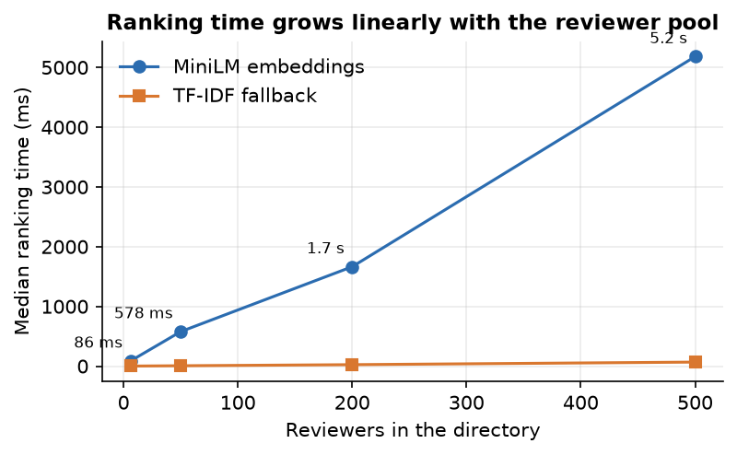
Figure 20: Median reviewer-ranking time against the size of the reviewer directory.

7.6 Experiments used as tests
Table 33: Measured test cases
ID | Case | Observed
X1 | Shipped classifier re-scored on its split | Reproduces models/metrics.json: accuracy 0.550, macro F1 0.509
X2 | Against the majority baseline | Accuracy 0.550 against 0.443; macro F1 0.509 against 0.205
X3 | Stability over five splits | Accuracy 0.545 ± 0.028 (range 0.511-0.586)
X4 | Accept versus reject only | 93.0% of the 156 accept and reject test papers correct
X5 | Borderline class | Recall 0.07 (cannot be recovered from the text by construction of the synthetic labels)
X6 | Matcher on 40 probe papers (MiniLM, shipped weights) | Top-1 0.95 against 0.18 for a random ranking; top-3 0.97; MRR 0.965
X7 | Lexical overlap alone; offline embedder | Top-1 0.62; top-1 0.75 and top-3 0.93
X8 | Literal conflict links injected | 12 of 12 flagged
X9 | Reworded affiliation, first name only | 3 of 3 missed, as expected of string matching
X10 | False conflict flags on clean pairs | 0 of 240 paper-reviewer pairs flagged

7.7 Regression and known failures on real PDFs
Table 34: Real PDFs through the pipeline
Document | Pages | Words | Sections found | Not detected | Refs | Structural score | Decision signal
Demo paper (fixture) | 3 | 431 | 9 / 9 | none | 1 | 68.1 | borderline (0.66)
Survey of AI peer review | 30 | 19,877 | 8 / 9 | summary | 13 | 68.5 | borderline (0.55)
Graph-reasoning review paper | 17 | 11,562 | 7 / 9 | summary, discussion | 9 | 65.2 | borderline (0.58)
IEEE Access base paper | 30 | 21,708 | 6 / 9 | summary, introduction, discussion | 55 | 75.9 | borderline (0.55)

Section detection is brittle: the IEEE paper's roman-numeral headings (I. INTRODUCTION) are not matched, so its introduction is missed (structure completeness 66.7) and its first line, a digital object identifier, becomes the title. The decision signal is not informative on real papers: all four receive borderline at confidence 0.55 to 0.66, as expected of a classifier trained on template sentences. The structural scores (65 to 76) look plausible but nothing shows that they track quality.

7.8 User acceptance testing and the limits of the testing done
No user-acceptance test was run: no editor, reviewer or chair used the application, so usability, trust and time saved are unmeasured. A scripted walkthrough (upload, read the five result tabs, open an audit table, add a reviewer, export) was performed by the capture script and recorded as screenshots (Chapter 8).
• Few automated tests: seven pytest tests and a smoke script of 24 checks; the scoring rules, section detector and review rules have no unit tests.
• Probe data written by the team: 40 abstracts and 15 conflict cases with the team's own labels show that the mechanism works as designed, not that it ranks real reviewers as an editor would.
• Synthetic training data and no judgement of the language model's text; it was read for the screenshots but not rated or fact-checked.
• One CPU-only machine, one browser at 1440 x 900; no concurrent users, phones or GPU, and no security assessment beyond the probes above.
The system is demonstrated, not validated: the tests support the claims that the pipeline runs end to end, rejects bad input politely, degrades visibly and produces an auditable ranking, but not any claim about the correctness of its assessments on real submissions.

CHAPTER 8: RESULTS AND OUTPUT SCREENS
This chapter reports what was measured and what the running application shows. Where a result is weak it is reported as weak. All numbers come from docs/metrics/; Appendix B lists the scripts.

8.1 Experimental set-up
Machine: 12th Gen Intel(R) Core(TM) i5-12500, 15.7 GB, no GPU, Python 3.11.9; scikit-learn 1.9.1, PyTorch 2.14.1, Transformers 5.20.2. Local model Qwen2.5-1.5B-Instruct [29] on the CPU; encoder all-MiniLM-L6-v2 [19]. Data: a synthetic 1,400-row corpus for the decision model (80/20 stratified split, seed 42, 280 test papers), six demo reviewer profiles, 40 probe abstracts written by the team for matching, 15 injected conflict sentences and four real PDFs. The shipped model, re-evaluated on its split, reproduces models/metrics.json exactly. No significance tests were run.

8.2 Output screens
All 17 screens of the running application are shown (Chrome, 1440 by 900 pixels, with the local language model and MiniLM loaded and three real papers stored: the base paper, the survey and the ReViewGraph paper). The Analyze and Saved-analysis screens show the ReViewGraph paper (17 pages, 11,562 words); its several-minute run was done once and its stored result replayed into the page by the capture script.
  Figure 21: Landing page, dark theme: pitch, WebGL hero and entry buttons. |   Figure 22: Landing page, how-it-works section: the pipeline steps.

  Figure 23: Landing page, light theme (sun button in the header). | 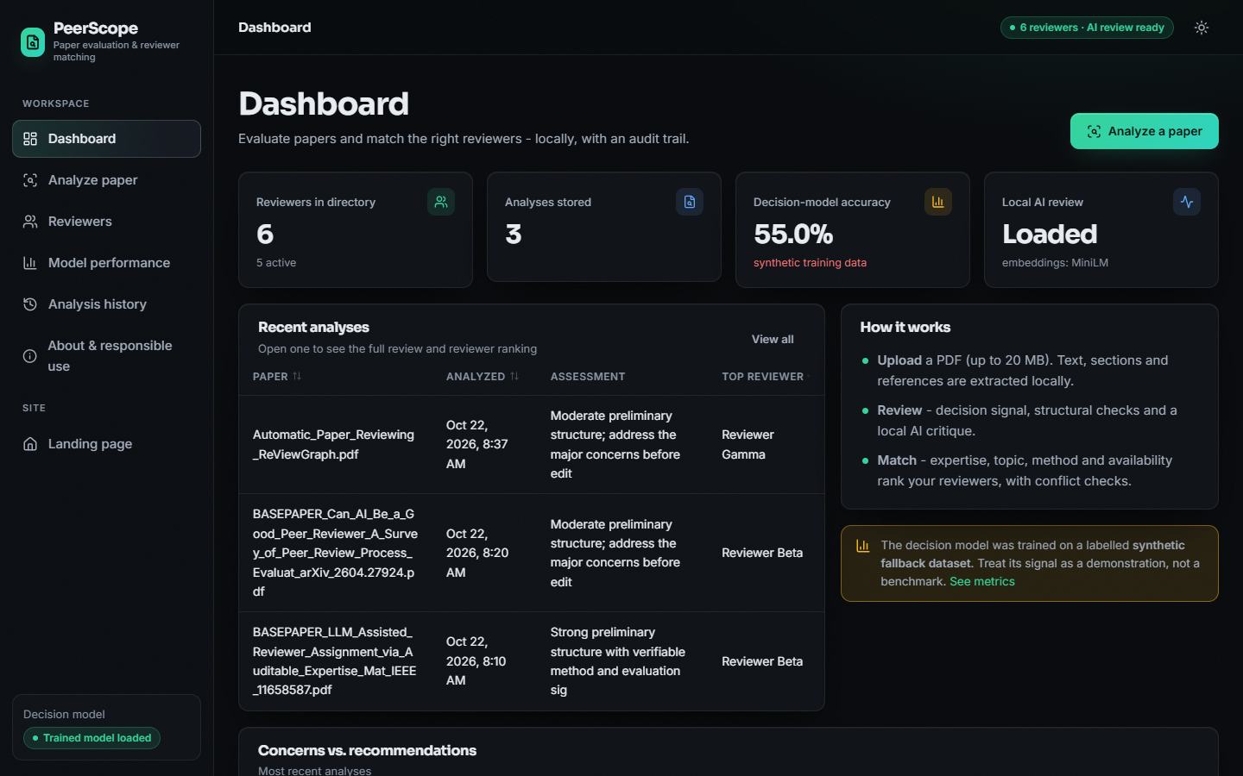  Figure 24: Dashboard: 6 reviewers, 3 analyses, accuracy 55.0% flagged as synthetic, AI status "Loaded".

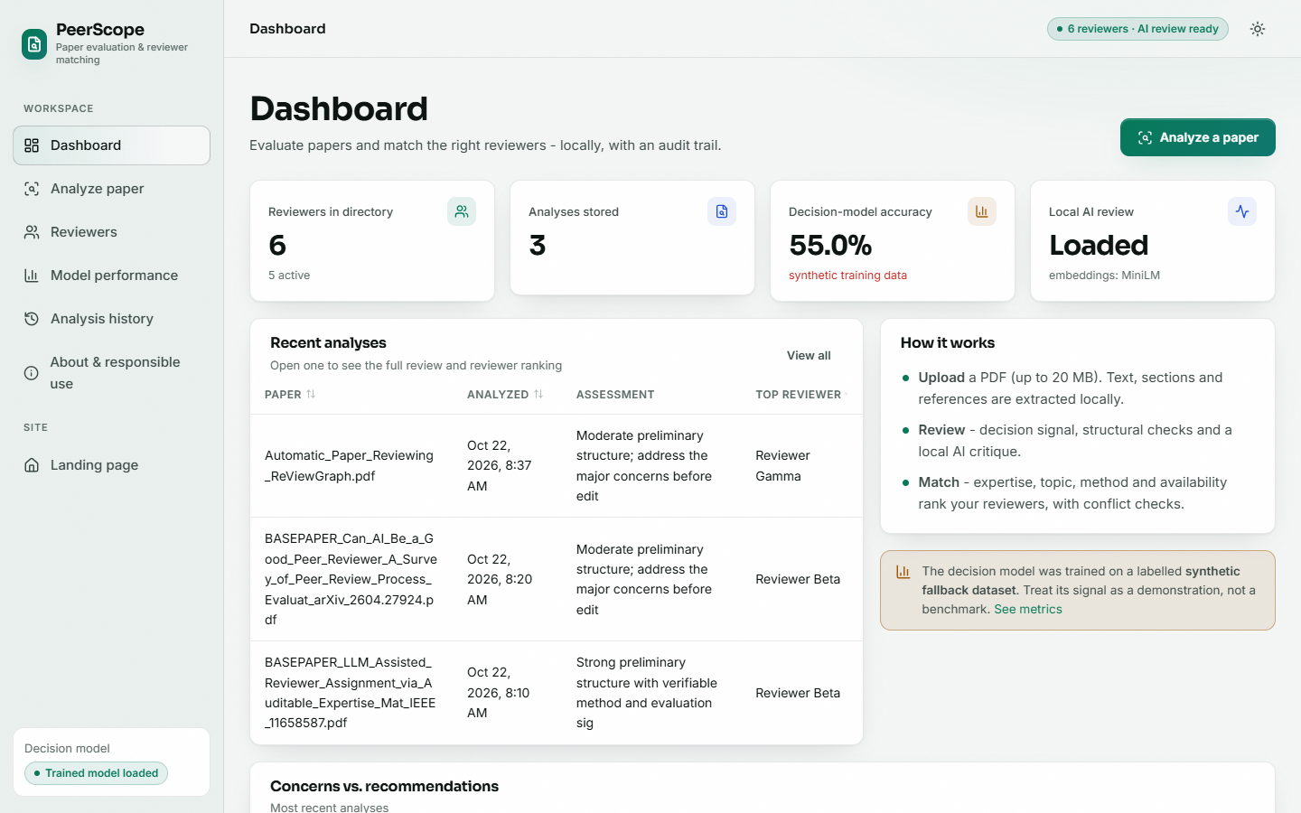  Figure 25: Dashboard, light theme. |   Figure 26: Analyze screen before upload: drop zone and matching filters.

Figure 27: Result overview: structural score 65.2, 2 concerns, top reviewer Gamma 28.4, decision signal borderline 58%, AI review by Qwen2.5-1.5B. |   Figure 28: Review tab: strengths, concerns, recommendations, coverage bars and the AI synthesis (with visible errors, Section 8.10).

  Figure 29: Literature tab: six OpenAlex works, three of them the paper itself. | 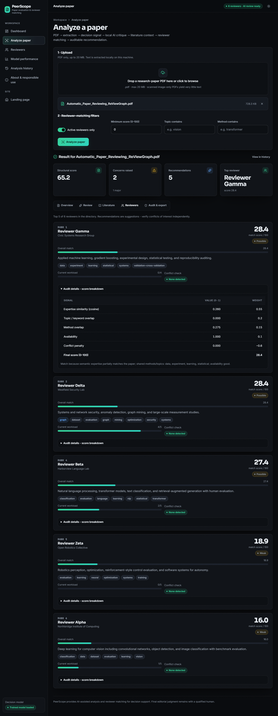  Figure 30: Reviewers tab: five ranked cards with the opened audit table of the first.

  Figure 31: Audit and export tab: formula, analysis id 3, module statuses, JSON and PDF export. |   Figure 32: Saved analysis reopened from history: the stored result, no recomputation.

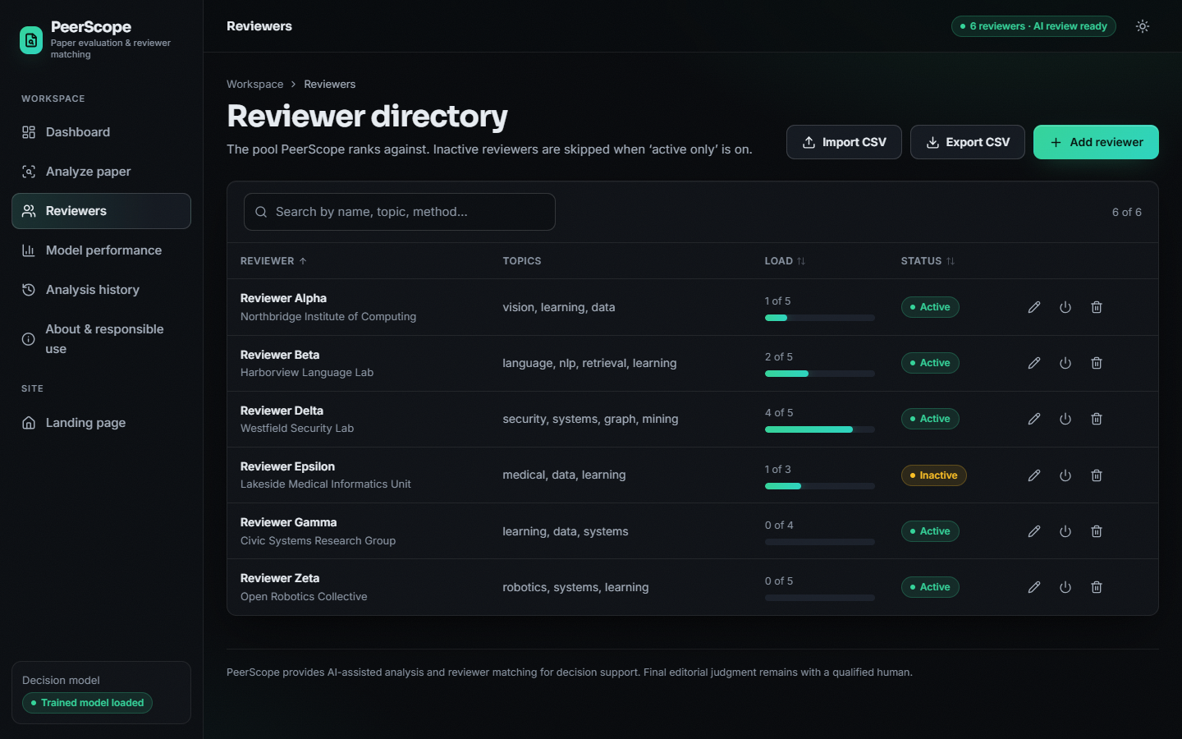  Figure 33: Reviewer directory: search, load bars, status, CSV import and export. | 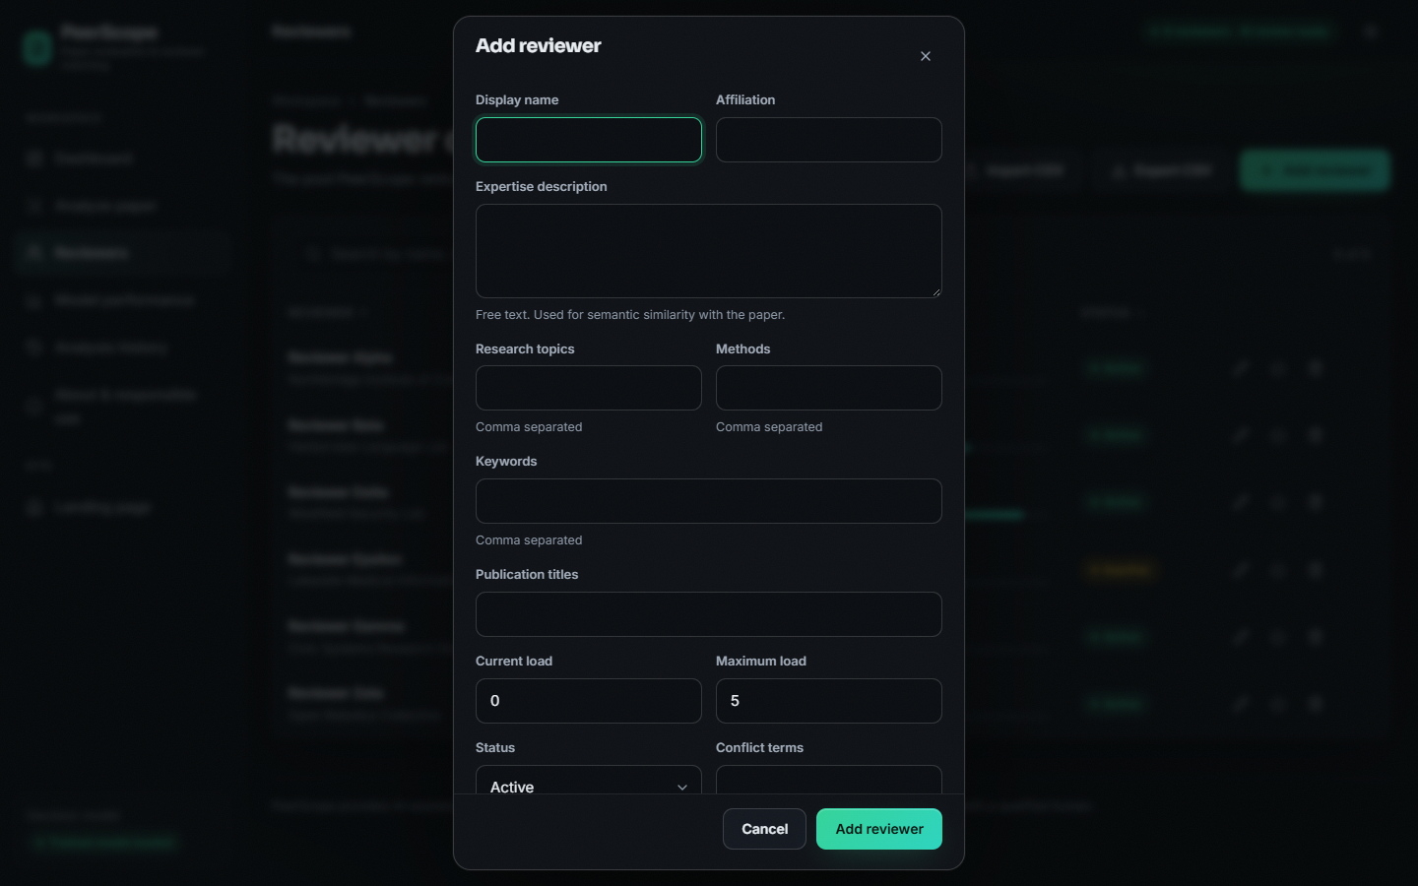  Figure 34: Add-reviewer dialog with its eleven fields.

Figure 35: Model performance: metrics, class distribution, confusion matrix and the synthetic-data banner. | 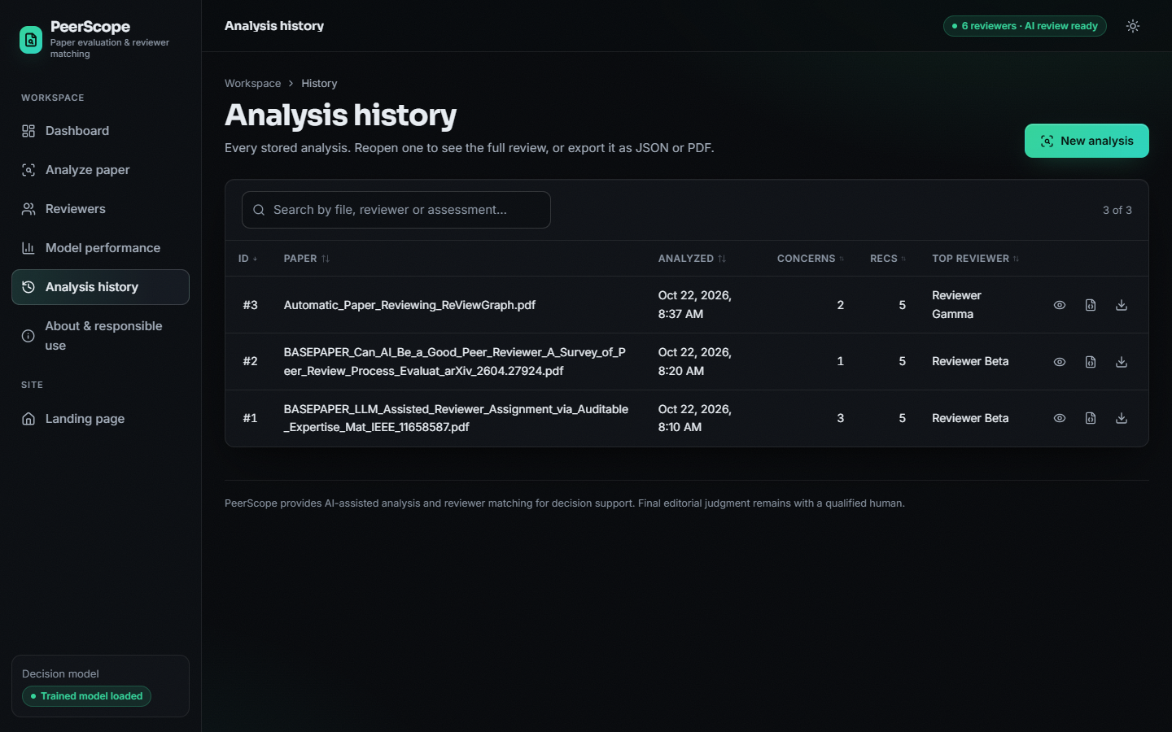  Figure 36: History of three analyses; its times are UTC without a zone (defect F8).


Figure 37: About and responsible use: pipeline, weights, rules, privacy, live status.

The Reviewers tab is the core of the recommendation: for Reviewer Gamma the audit table reads expertise 0.260 (x0.55), keyword 0.000 (x0.20), method 0.275 (x0.15), availability 1.000 (x0.10), conflict 0.000, final 28.4, so the score can be recomputed by hand. Gamma and Delta tie at 28.4, and the ranks run 1, 2, 4, 5, 6 because the inactive Reviewer Epsilon held rank 3 before the filter removed it.

8.3 Decision-model performance
The decision model is a TF-IDF (word 1-2 grams and character 3-5 grams) and logistic-regression classifier with three classes. It was trained on the 1,400-row synthetic corpus and evaluated on 280 held-out papers. The first thing to say about the results is what the data is: the dataset was generated by a script that draws a hidden quality value, attaches three strength or weakness phrases to the text accordingly, and assigns the label from the same value. The result can therefore show that the pipeline trains, stores and serves a classifier; it cannot show that the classifier predicts real editorial decisions.

8.3.1 Reading the result
The model finds almost every accept paper (recall 0.958) and almost every reject paper (recall 0.905), but only 9 of the 124 borderline papers (recall 0.073). Of the 124 borderline papers, 45 were called accept and 70 reject. If only the decisive classes are considered, 145 of 156 accept and reject papers are classified correctly (93.0%). The weakness is therefore concentrated in one class, and the data explains why.
In the synthetic corpus a paper whose text carries strength phrases is accept in 362 cases and borderline in 293; a paper with weakness phrases is reject in 419 cases and borderline in 326. The text of a borderline paper is identical in kind to that of an accept or a reject paper, so no text-based rule can separate them. The best accuracy any rule can reach from the phrases is 0.558, and the measured 0.550 is close to that ceiling. The balanced class weights buy macro recall (0.645) at the price of some accuracy, as the unweighted variant below shows.
Against baselines the shipped configuration is clearly better than the majority class (accuracy 0.443) and Naive Bayes (0.457), and is statistically indistinguishable from the unweighted and word-only variants: their accuracies (0.529 and 0.557) differ by less than one standard deviation of the five-split study. The character n-grams add nothing measurable on this data, and the model kept them only because the design decision was taken before the result was known.
The headline split (seed 42, accuracy 0.550) is typical: over five splits accuracy ranges from 0.511 to 0.586, a spread of about 7.5% points. Differences below roughly three points between configurations should not be read as improvements.
The probabilities are not very confident: at a threshold of 0.7 only 29.3% of the papers remain and accuracy on them rises to 69.5%; at 0.8 only 11 papers remain. The application does not use a threshold; it shows the three class probabilities and states that the signal is one input among several.
Table 35: Shipped model: per-class results and confusion-matrix row (predicted accept / borderline / reject)
Class | Precision | Recall | F1 | Support | Predicted a / b / r
accept | 0.605 | 0.958 | 0.742 | 72 | 69 / 3 / 0
borderline | 0.450 | 0.073 | 0.125 | 124 | 45 / 9 / 70
reject | 0.520 | 0.905 | 0.661 | 84 | 0 / 8 / 76
macro / overall | 0.525 | 0.645 | 0.509 | 280 | accuracy 0.550, AUC 0.771

Table 36: Baselines on the same split and the five-split spread
Model | Accuracy | Macro F1 | ROC-AUC
Majority class | 0.443 | 0.205 | -
Naive Bayes, word TF-IDF | 0.457 | 0.342 | 0.751
Logistic regression, unweighted | 0.529 | 0.542 | 0.769
Logistic regression, word only | 0.557 | 0.520 | 0.772
PeerScope (balanced, word + char) | 0.550 | 0.509 | 0.771
Five splits, mean +/- sd | 0.545 +/- 0.028 | 0.517 +/- 0.029 | 0.738 +/- 0.014

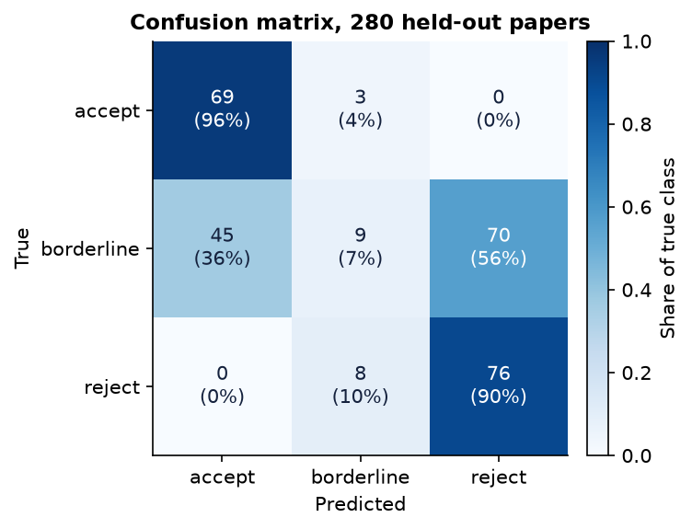  Figure 38: Confusion matrix of the shipped model. | 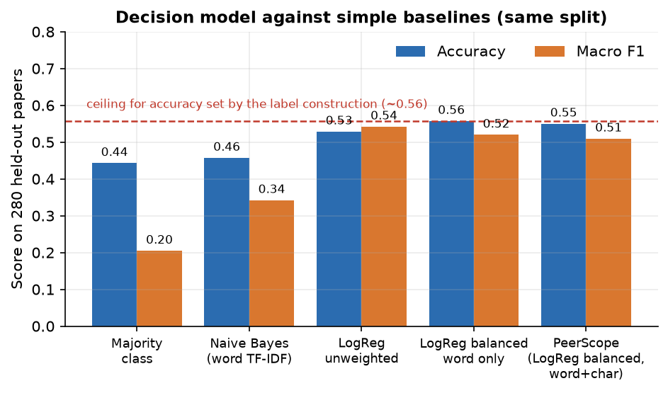  Figure 39: Shipped model against baselines and the label-construction ceiling (dashed).

8.4 Reviewer-matching results
Reviewer matching was evaluated on the 40-abstract probe set described in Section 8.1: six topic areas with six abstracts each, plus four cross-area abstracts for which either of two reviewers is acceptable. For each abstract the full ranking of the six demo reviewers was produced by the production code, with no conflict text added, and the position of the best acceptable reviewer was recorded. Top-1 is the share of abstracts for which an acceptable reviewer is ranked first, top-3 the share for which one is in the first three, and MRR the mean reciprocal rank of the best acceptable reviewer. The labels were written by the project team and the abstracts avoid copying the reviewers' keyword lists, but the evaluation is still small and not independent; it measures whether the machinery behaves sensibly, not how it would perform on real submissions.
With sentence embeddings the shipped hybrid score ranks an acceptable reviewer first for 95.0% of the abstracts (MRR 0.965), against a random expectation of 18.3%. Semantic similarity alone is marginally better (97.5% top-1): the keyword, method and availability terms do not improve the ranking on this probe set; their purpose is auditability and the handling of load, not accuracy. The keyword and method overlap on its own reaches 62.5%: on these abstracts, which are short and use varied vocabulary, a dense encoder is clearly stronger than lexical overlap; in the base paper the relative merit of lexical and dense measures depends on the text view that is matched [1]. Removing availability changes the result by at most one abstract (95.0% top-1 with MiniLM).
The offline fallback is clearly worse: 75.0% top-1 and 92.5% top-3 for the shipped weights. The fallback vectoriser is fitted once on the texts of the first request and then frozen, so its vocabulary reflects whichever paper was analysed first; the probe set reproduces that behaviour by ranking the 40 abstracts in sequence.
With MiniLM five areas are matched perfectly and the cross-area cases three out of four. The two misses are shown below. In both, the generalist Reviewer Gamma (applied machine learning and statistics) outscored the security specialist: abstracts on malware classifiers and on learning-based intrusion detection use machine-learning vocabulary heavily and security vocabulary lightly. With the TF-IDF fallback there are 10 top-1 misses, concentrated in the vision and security areas (three of six each).
Mean gap between the first- and second-ranked reviewer is 12.6 points with MiniLM (about 7.7 with the fallback), so rankings are usually decisive on the probe set, but not on real papers outside the demo pool: the ReViewGraph paper obtained a top score of only 28.4 and a tie between two reviewers (Section 8.10).

8.4.1 Cost of ranking
Ranking time grows linearly with the pool because every reviewer profile is embedded again for each request: 86 ms for the six demo reviewers, 578 ms for 50, 1.7 s for 200 and 5.2 s for 500. That is acceptable next to the minutes spent on the language model, but a cache of profile vectors would be the first change for a larger directory (Chapter 10).
Table 37: Matching quality on 40 probe abstracts
Configuration | MiniLM top-1 | top-3 | MRR | TF-IDF top-1 | top-3 | MRR
Hybrid, shipped weights | 0.950 | 0.975 | 0.965 | 0.750 | 0.925 | 0.844
Semantic similarity only | 0.975 | 1.000 | 0.983 | 0.725 | 0.925 | 0.838
Keyword and method overlap only | 0.625 | 0.825 | 0.741 | 0.625 | 0.825 | 0.741
Hybrid without availability | 0.950 | 1.000 | 0.971 | 0.775 | 0.975 | 0.872
Random (expectation) | 0.183 | 0.530 | - | 0.183 | 0.530 | -

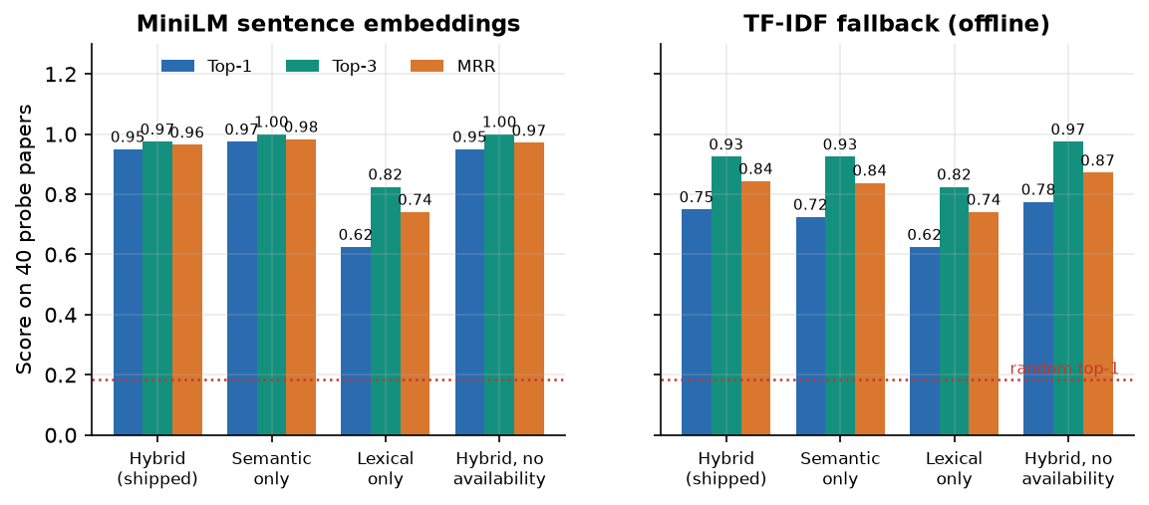
Figure 40: Top-1, top-3 and MRR for four score configurations, MiniLM (left) and TF-IDF fallback (right).

8.5 Conflict-of-interest results
Conflict handling was tested by injection. One sentence containing a known link was appended to a probe abstract, the six reviewers were ranked again and the flag, score and rank of the linked reviewer were compared with the clean ranking. Fifteen injections were made: six conflict terms, four affiliations, two full names and three links the matcher cannot see because they are paraphrased. In addition, all 40 clean probe abstracts were ranked against all six reviewers and the flags counted (240 pairs).
All twelve literal links were flagged and none of the three paraphrased ones was. The false-flag count on clean papers is 0 of 240 pairs. When a link is flagged, the penalty of 0.60 is subtracted before scaling, so the score of a flagged reviewer falls to zero in every injected case and the reviewer drops to the last rank; the card then shows "Penalized" with the reason and the instruction to verify before assigning.
These results describe a literal matcher doing what it was designed to do. They do not describe conflict-of-interest detection in the sense of the base paper's setting, where co-authorship, shared funding and institutional ties are the relevant relations and are not visible as strings in the submission. The three misses (paraphrased affiliation, paraphrased affiliation, first name only) show the gap; a co-author graph and normalised affiliations are listed as future work.
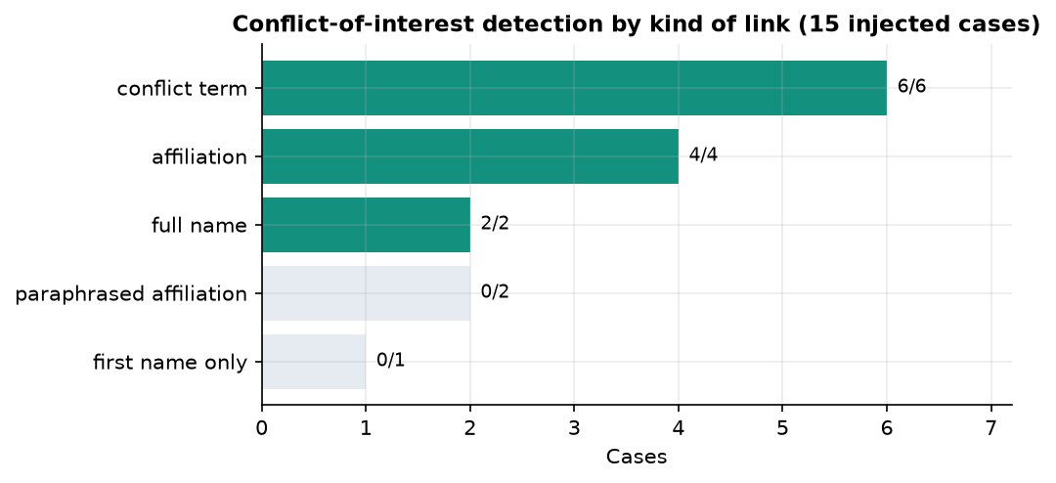  Figure 41: Conflict detection by kind of link. | Figure 42: Weighted score components of the five active reviewers for the demo paper.

8.6 The pipeline on real papers
Four PDFs were run through the same code as an uploaded file: the three-page demo fixture generated by scripts/make_demo_pdf.py and three real research papers kept with the batch, the base paper [1], the survey [6] and the ReViewGraph paper [7]. No ground truth exists for these files, so the table reports what the pipeline extracted and what it concluded, not whether it was right.
Four observations follow. First, extraction works on text-based academic PDFs of 17 to 30 pages in under half a second after the library is loaded. Second, the structural score varies little (65.2 to 75.9) because three of its four components saturate for any normal paper; the evidence component, which depends on references per page, is the one that moves (17.3 to 50.3). Third, the extraction is not robust to layout conventions: the base paper from IEEE Access uses roman-numeral headings, so its introduction is not detected (six of nine sections found), and its title heuristic returns the "Digital Object Identifier" line. Fourth, the decision model returned "borderline" for all four papers with confidences between 0.55 and 0.66. A classifier trained on templated synthetic sentences has no basis for judging real manuscripts, and the output is what that implies; the interface presents it as a weak signal for this reason.
Table 38: Extraction and signals on four PDFs
File | Pages | Words | Sections | Structural | Decision signal | Title extracted
Demo fixture | 3 | 431 | 9 / 9 | 68.10 | borderline (0.66) | Efficient Retrieval-Grounded Text Cl
Survey [6] | 30 | 19,877 | 8 / 9 | 68.50 | borderline (0.55) | Can AI Be a Good Peer Reviewer? A Su
ReViewGraph [7] | 17 | 11,562 | 7 / 9 | 65.20 | borderline (0.58) | Automatic Paper Reviewing with Heter
IEEE base paper [1] | 30 | 21,708 | 6 / 9 | 75.90 | borderline (0.55) | Digital Object Identifier 10.1109/AC

8.7 Performance and latency
Latency was measured in two ways: stage by stage in one process (the model files already cached on disk), and over HTTP on 127.0.0.1 against a running server. The local address matters: on this machine localhost adds about two seconds per call through an IPv6 fallback, which would hide the real figures.
The local language model takes 99.1% of the time of an analysis: 509.4 s for three generation calls producing 1,410 tokens, about 2.8 tokens per second. Everything else together takes 4.9 s. The first PDF extraction of a process is slower (2.4 s) because the PDF library is imported lazily; later extractions of a 30-page paper take 383 ms. Loading the encoder took 20.4 s and the language model 9.0 s once, from the local cache, in the measuring process. Through the server, with a cold process, the complete analysis took 534 s for the base paper and 621 s for the survey, and 946 s when driven through the browser while Chrome was rendering.
With the language model switched off the whole analysis of a 3-page or 30-page paper takes about 1.2 to 1.3 seconds over HTTP, of which the OpenAlex lookup is the largest part; simple reads take a few milliseconds. The application is therefore interactive in its deterministic mode and a background job in its full mode. No job queue exists in the code, and two simultaneous full analyses would compete for the same cores.
Table 39: Time per stage and over HTTP (127.0.0.1)
Stage or request | Demo paper, 3 pages | Survey, 30 pages
PDF extraction | 2.4 s | 383 ms
Local AI review (3 steps) | 509.4 s | 521.7 s
Literature (OpenAlex) | 2.3 s | 1.5 s
Reviewer matching | 136 ms | 664 ms
Total (model on) | 514.3 s | 524.5 s
HTTP analyze, model off (median) | 1.3 s | 1.2 s
Simple GET: health / model metrics (median) | 2.4 ms | 1.7 ms

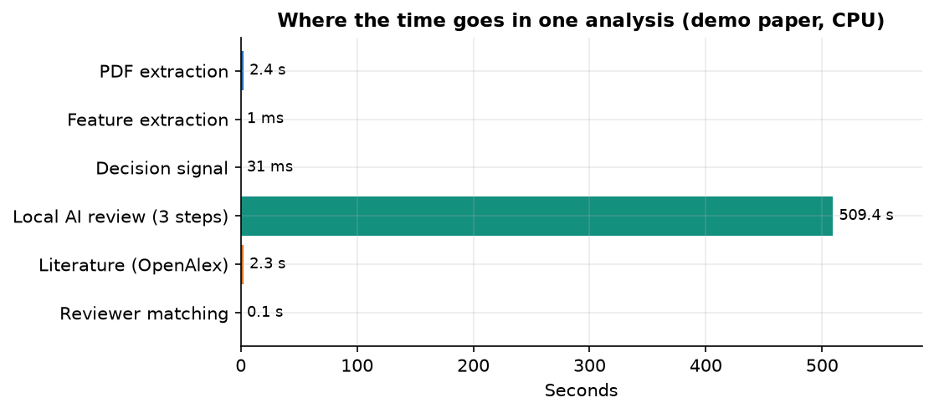
Figure 43: Where the time goes in one analysis of the demo paper (CPU only).

8.8 Comparison with the base paper
The base paper [1] studies one half of the editorial workload, reviewer assignment, on a large historical dataset, and its contribution is a way to make the affinity score auditable by restricting large language models to keyword induction. PeerScope adopts the auditability principle for its own, much simpler, score and adds the other half, the assessment of the submission. The two works are not comparable on results: they differ in task scope, data, metric and scale, and the table states this plainly.
Our top-1 of 0.950 must not be set beside the base paper's MRR@3 of about 0.78: ours ranks six candidate reviewers for 40 short abstracts the team wrote, with a random top-1 of 0.183; theirs ranks hundreds of reviewers for real submissions against historical assignments, with about three relevant reviewers per paper. The comparison that can be made honestly is qualitative. The base paper found that the ranking of lexical and dense measures depends on the text view (on abstracts SBERT cosine reached MRR@3 0.7023 against 0.6235 for TF-IDF cosine; on titles TF-IDF reached 0.7078 against 0.6571 for SBERT) and that most differences among text encoders were not statistically significant. Our probe set, a far smaller sample of short abstracts, favours the dense encoder; it cannot confirm or contradict the paper. PeerScope neither reproduces nor challenges the base paper's numbers.
Table 40: What the two works cover
Dimension | Base paper [1] | PeerScope
Task | Reviewer assignment only | Preliminary paper assessment and reviewer ranking
Data | 663 papers, 85 conferences, 1,989 assignments, 524 reviewers | 40 team-written abstracts, 6 demo reviewers; 1,400 synthetic rows
Labels | Historical assignments | The team's own judgement
Language model | Keyword induction by an ensemble and a judge, with audit trail | Local Qwen2.5-1.5B writes a review; does not rank
Metrics | MRR@3 up to 0.7778 (titles) and 0.7843 (abstracts) | Top-1 0.950, MRR 0.965 among 6 reviewers
Conflicts, capacity | Not benchmarked | In the score; measured by injection
Delivery | Offline experiments | Local web application with directory, history, export

8.9 Sample input and output
The input of the sample is the PDF of the ReViewGraph paper [7] (728 KB, 17 pages, 11,562 words, nine references detected by the parser), uploaded through the Analyze screen with the default filters (active reviewers only, minimum score 0). The server returns one JSON document of about 32 KB, stored in the analyses table and available through GET /api/analyses/3 and the export buttons. The listing shows its main fields with the values of that run; long text fields are shortened.
{
"product": "PeerScope",
"filename": "Automatic_Paper_Reviewing_ReViewGraph.pdf",
"paper": {"title": "Automatic Paper Reviewing with Heterogeneous Graph Reasoning over",
"page_count": 17, "word_count": 11562, "reference_count": 9,
"sections": ["introduction", "related_work", "methodology", "experiments", "results", "conclusion", "references"]},
"ml_decision_signal": {"status": "ok", "label": "borderline", "confidence": 0.5829,
"probabilities": {"accept": 0.2163, "borderline": 0.5829, "reject": 0.2009}},
"structural_assessment": {"overall_structural": 65.2, "structure_completeness": 77.8, "evidence_coverage": 21.7,
"method_clarity_signal": 70.0, "presentation_signal": 100.0},
"review": {"llm_status": "ok", "llm_model": "Qwen/Qwen2.5-1.5B-Instruct", "source": "deterministic+llm",
"major_concerns": ["Methodology clarity: methodology section is short; add architecture/training details, ..."],
"coverage": {"Method": 90, "Evidence": 90, "Clarity": 85, "Reproducibility": 80, "Novelty": 55, "Limitations": 70},
"ai_synthesis": "PAPER TITLE: Automatic Paper Reviewing with ... BACKGROUND: ... (about 4,000 characters)"},
"literature": {"literature_retrieval_status": "ok", "works": [{"year": 2025, "relevance": 0.8745}, "... 5 more"]},
"reviewers": [{"rank": 1, "display_name": "Reviewer Gamma", "score": 28.4, "match_strength": "Possible",
"breakdown": {"expertise_similarity": 0.2595, "keyword_score": 0.0, "method_score": 0.275,
"availability_score": 1.0, "conflict_penalty": 0.0}}, "... 4 more"],
"reviewer_pool_size": 6, "concern_count": 2, "recommendation_count": 5, "top_reviewer": "Reviewer Gamma"
}

A second sample shows how errors appear in the output rather than as crashes. For the survey paper the literature block was {"literature_retrieval_status": "unavailable", "works": [], "error": "OpenAlex retrieval failed (HTTPError): 400 Client Error: Bad Request ..."}, the rest of the analysis was complete, and the screen showed the notice instead of a table. Likewise, with the language model switched off the review block carries llm_status: "unavailable" and the reason, and only the deterministic review is shown.

8.10 Success and failure analysis
Table 41: Cases that worked
No. | Case | Evidence
S1 | Accept and reject papers separated | 145 of 156 decisive-class papers correct
S2 | Acceptable reviewer ranked first (MiniLM) | 95.0% top-1 on 40 probes
S3 | Literal conflicts penalised, no false flags | 12 of 12 flagged; 0 false flags in 240 pairs
S4 | Scores recomputable by hand; graceful degradation | Audit table; AI off, literature down and inactive reviewer handled (pytest 7 of 7, smoke 24 of 24)
S5 | Fast deterministic path, stored and exported analyses | About 1.3 s per analysis, model off

Table 42: Failure cases observed
No. | Case | What happened / cause
F1 | Language-model text has errors | Synthesis of the ReViewGraph paper: invented title suffix, wrong datasets, contradictory code statement, cut at 700 tokens; no fact checking
F2 | Literature problems | Survey title contains a question mark and OpenAlex answers HTTP 400; for ReViewGraph the paper itself is returned three times
F3 | Title and introduction missed | IEEE paper: title is the DOI line, 6 of 9 sections; roman-numeral headings not recognised
F4 | Same decision signal for all real papers | borderline, 0.55 to 0.66; classifier trained on templated synthetic text
F5 | Probe misses | 2 of 40 (MiniLM), 10 of 40 (fallback); generalist profile, frozen fallback vocabulary
F6 | Low and tied scores on a real paper | Top 28.4 (Possible); Gamma and Delta tied; NLP reviewer fourth; the demo pool is far from the topic
F7 | Paraphrased conflicts invisible | 0 of 3 flagged; literal string matching
F8 | Display and validation defects | Rank numbers skip; UTC times without zone; a corrupt file with a PDF header is accepted (HTTP 200)

8.11 Limitations of the results
The decision-model figures describe synthetic data; the probe set is small, team-written and friendly; the six reviewers are invented; nobody outside the team rated any output and no user study was run; novelty is a fixed value of 55, not a measurement; timings are single runs on one CPU-only PC; and accuracy on real decisions, scanned PDFs, non-English papers, GPU speed, concurrent users and language-model review quality were not measured.

8.12 Objectives against outcomes
Table 43: Objectives against outcomes
No. | Objective | Status | Evidence
1 | Corpus of papers and reviewer profiles | Partly | Analyses stored; 6 demo profiles, CSV import; synthetic corpus (1,400 rows)
2 | Topics, methods, keywords by NLP | Met (heuristic) | Frequency keywords, 21-term method lexicon, 18 topic hints
3 | Reviewer expertise as vectors | Met | MiniLM embeddings of profile text; no real publication histories
4 | Semantic similarity ranking | Met | Top-1 0.950 (MiniLM), 0.750 (fallback) on probes
5 | Preliminary assessment incl. novelty signals | Met except novelty | Structure, evidence, method, presentation, decision signal, AI review; novelty fixed
6 | Assignment quality vs experts; COI handling | Partly | Team labels, not experts; COI 12/12 literal, 0/3 paraphrased, 0 false flags
A | Abstract: deep-learning area classifier, originality, h-index, venue scope | Not implemented | Keyword hints and a linear model; no originality score or h-index

The engineering objectives are met; the evaluation objectives are met only at the scale of a demonstration.

CHAPTER 9: CONCLUSION

9.1 Summary
PeerScope is a working local application that turns a research-paper PDF into a preliminary assessment and an auditable ranking of candidate reviewers. It extracts the text, detects sections and references, computes structural signals, adds a decision signal from a TF-IDF and logistic-regression model, drafts a critique with a local Qwen2.5-1.5B model when it can be loaded, retrieves related work from OpenAlex and ranks reviewers with a score combining embedding similarity, keyword and method overlap, availability and a conflict penalty. Every result and its audit breakdown is shown in a React interface and stored for export. The whole system runs on one CPU-only PC.

9.2 Objectives achieved and key findings
Table 44: Objectives against outcomes
No. | Status | Outcome
1 | Partly met | Analyses stored; 6 demo reviewer profiles with CSV import; no real publication corpus; decision data synthetic
2 | Met (simple) | Frequency keywords, a 21-term method lexicon and 18 topic hints
3 | Met | Profile text and titles embedded with all-MiniLM-L6-v2; no real publication history
4 | Met | Top-1 95.0% with embeddings, 75.0% with the fall-back, on 40 probe abstracts
5 | Met except novelty | Structure, evidence, method clarity, presentation, decision signal and critique; novelty inconclusive
6 | Partly met | Team-written labels, not experts; 12 of 12 literal conflict links found, 0 of 3 paraphrased

• Embedding similarity carries the matching: semantic-only top-1 97.5%, hybrid 95.0%, lexical overlap alone 62.5%; the TF-IDF fall-back is weaker, so the interface states which embedder ran.
• The decision model shows the pipeline works, not that it predicts real decisions: accuracy 0.55, macro F1 0.509, accept against reject 93% correct, borderline recall 7%, accuracy ceiling near 0.56.
• The local language model costs about 509 s of the 514 s of an analysis; without it a paper takes about a second. Conflict detection is reliable for literal links but blind to paraphrase.
• Against the base paper [1], PeerScope adds paper assessment, availability and conflict handling and an application, and gives up its keyword-induction ensemble and large evaluation; results are not comparable.

9.3 Applications and known limitations
Applications: first-pass screening for an editor, a reviewer short list with reasons and conflict warnings, a teaching example of auditable decision support, and a local workflow where manuscripts must not leave the machine. Limitations: synthetic decision data, demo reviewer pool, team-written probe labels, no novelty assessment, literal conflict matching, a slow unverified local model, no authentication and no user study. It is a prototype for decision support, not the sole basis for publication decisions.

CHAPTER 10: FUTURE SCOPE

10.1 Improvements and additional features
• Real data first. Replace the synthetic corpus with PeerRead [22] or OpenReview decisions, and judge matching against independent expert labels or historical assignments, reporting MRR@3 and P@3 for comparability.
• Assessment. Measure novelty from embedding neighbours and citation context, recognise roman-numeral headings, take titles from metadata and fit the structural weights on human ratings.
• Reviewer data and matching. Build profiles from OpenAlex or Semantic Scholar records with h-index and recency, add load-balanced global assignment, co-authorship and fuzzy conflict checks.
• Robustness. Sanitise OpenAlex queries (a question mark gives HTTP 400), show times in the user's zone and report skipped CSV rows.

10.2 Scalability and deployment
• Cache profile embeddings (500 reviewers currently take about 5.2 s), run a quantised or GPU model and stream the critique, add authentication and roles, package the system in a container with a multi-user database, and run the measurements in continuous integration.

10.3 Further research
• Test LLM keyword induction with a judge [1]; filter and evaluate prompt injection hidden in PDFs [2, 27]; check the faithfulness of the critique; run a user study with editors; examine fairness effects of embedding-based ranking.

REFERENCES
[1] F. Bagheri, D. Buscaldi and D. Reforgiato Recupero, "LLM-assisted reviewer assignment via auditable expertise matching," IEEE Access, vol. 14, pp. 127834-127863, 2026, doi: 10.1109/ACCESS.2026.3724622.
[2] F. Torrielli, S. Locci, A. Rapp and L. Di Caro, "How to get your paper accepted by an AI reviewer: indirect prompt injection in peer review," Research Square preprint, Jan. 2026, doi: 10.21203/rs.3.rs-8432945/v1. (Published as "Exploiting large language models in peer review: indirect prompt injection attacks and integrity probes," Scientometrics, vol. 131, no. 7, pp. 4889-4951, 2026, doi: 10.1007/s11192-026-05695-x.)
[3] Y. Sermet and I. Demir, "Unveiling the reviewer mindset: evidence-based insights into scholarly peer review," ScienceOpen, May 2025, doi: 10.14293/ease.2025.037.
[4] Anonymous reviewer, "Review of: Performance evaluation of adaptive introgression classification methods. Round#1/Reviewer#2," Peer Community in Evolutionary Biology, Jun. 2024, doi: 10.24072/pci.evolbiol.100835.rev12.
[5] Anonymous reviewer, "Review of: Performance evaluation of adaptive introgression classification methods. Round#2/Reviewer#2," Peer Community in Evolutionary Biology, Dec. 2024, doi: 10.24072/pci.evolbiol.100835.rev22.
[6] S. Wu, O. Jiang, Y. Zhao, T. Hu, Y. Ma, K. Zhang, M. Patwardhan and A. Cohan, "Can AI be a good peer reviewer? A survey of peer review process, evaluation, and the future," arXiv:2604.27924, Apr. 2026.
[7] S. Li, L. Fan, Y. Lin, Z. Li, X. Wei, S. Ni, H. Alinejad-Rokny and M. Yang, "Automatic paper reviewing with heterogeneous graph reasoning over LLM-simulated reviewer-author debates," arXiv:2511.08317, Nov. 2025 (AAAI 2026 copyright notice on the PDF).
[8] J. Jovanovic and E. Bagheri, "Reviewer assignment problem: a scoping review," arXiv:2305.07887, May 2023.
[9] X. Zhao and Y. Zhang, "Reviewer assignment algorithms for peer review automation: a survey," Inf. Process. Manage., vol. 59, no. 5, Art. no. 103028, Sep. 2022, doi: 10.1016/j.ipm.2022.103028.
[10] L. Charlin, R. S. Zemel and C. Boutilier, "A framework for optimizing paper matching," arXiv:1202.3706, Feb. 2012.
[11] D. Mimno and A. McCallum, "Expertise modeling for matching papers with reviewers," in Proc. 13th ACM SIGKDD Int. Conf. Knowl. Discovery Data Mining, 2007, pp. 500-509, doi: 10.1145/1281192.1281247.
[12] I. Stelmakh, N. B. Shah and A. Singh, "PeerReview4All: fair and accurate reviewer assignment in peer review," arXiv:1806.06237, 2018 (Proc. Algorithmic Learn. Theory, 2019, pp. 828-856, as cited in [1]).
[13] A. Beygelzimer, Y. N. Dauphin, P. Liang and J. W. Vaughan, "Has the machine learning review process become more arbitrary as the field has grown? The NeurIPS 2021 consistency experiment," arXiv:2306.03262, Jun. 2023.
[14] K. Bouanane, A. N. Medakene, A. Benbelghit and S. B. Belhaouari, "FairColor: an efficient algorithm for the balanced and fair reviewer assignment problem," Inf. Process. Manage., vol. 61, no. 6, Art. no. 103865, Nov. 2024, doi: 10.1016/j.ipm.2024.103865.
[15] S. Jecmen, H. Zhang, R. Liu, N. B. Shah, V. Conitzer and F. Fang, "Mitigating manipulation in peer review via randomized reviewer assignments," arXiv:2006.16437, Jun. 2020.
[16] Y. Zhang, Y. Shen, S. Kang, X. Chen, B. Jin and J. Han, "Chain-of-factors paper-reviewer matching," in Proc. ACM Web Conf. 2025, Apr. 2025, pp. 1901-1910, doi: 10.1145/3696410.3714708.
[17] G. Salton and C. Buckley, "Term-weighting approaches in automatic text retrieval," Inf. Process. Manage., vol. 24, no. 5, pp. 513-523, 1988, doi: 10.1016/0306-4573(88)90021-0.
[18] K. Sparck Jones, "A statistical interpretation of term specificity and its application in retrieval," J. Documentation, vol. 28, no. 1, pp. 11-21, 1972, doi: 10.1108/eb026526.
[19] N. Reimers and I. Gurevych, "Sentence-BERT: sentence embeddings using Siamese BERT-networks," in Proc. EMNLP-IJCNLP, 2019, pp. 3980-3990, doi: 10.18653/v1/D19-1410.
[20] W. Wang, F. Wei, L. Dong, H. Bao, N. Yang and M. Zhou, "MiniLM: deep self-attention distillation for task-agnostic compression of pre-trained transformers," arXiv:2002.10957, Feb. 2020.
[21] A. Cohan, S. Feldman, I. Beltagy, D. Downey and D. S. Weld, "SPECTER: document-level representation learning using citation-informed transformers," in Proc. 58th Annu. Meeting Assoc. Comput. Linguistics, 2020, pp. 2270-2282, doi: 10.18653/v1/2020.acl-main.207.
[22] D. Kang, W. Ammar, B. Dalvi, M. van Zuylen, S. Kohlmeier, E. Hovy and R. Schwartz, "A dataset of peer reviews (PeerRead): collection, insights and NLP applications," in Proc. NAACL-HLT, 2018, pp. 1647-1661, doi: 10.18653/v1/N18-1149.
[23] W. Yuan, P. Liu and G. Neubig, "Can we automate scientific reviewing?," J. Artif. Intell. Res., vol. 75, pp. 171-212, 2022, doi: 10.1613/jair.1.12862.
[24] W. Liang et al., "Can large language models provide useful feedback on research papers? A large-scale empirical analysis," NEJM AI, vol. 1, no. 8, Jul. 2024, doi: 10.1056/AIoa2400196.
[25] M. Zhu, Y. Weng, L. Yang and Y. Zhang, "DeepReview: improving LLM-based paper review with human-like deep thinking process," in Proc. 63rd Annu. Meeting Assoc. Comput. Linguistics, 2025, pp. 29330-29355, doi: 10.18653/v1/2025.acl-long.1420.
[26] Z. Zhuang, J. Chen, H. Xu, Y. Jiang and J. Lin, "Large language models for automated scholarly paper review: a survey," Inf. Fusion, vol. 124, Art. no. 103332, Dec. 2025, doi: 10.1016/j.inffus.2025.103332.
[27] J. Keuper, "Prompt injection attacks on LLM generated reviews of scientific publications," arXiv:2509.10248, Sep. 2025.
[28] A. Vaswani et al., "Attention is all you need," in Proc. Adv. Neural Inf. Process. Syst., vol. 30, 2017 (arXiv:1706.03762).
[29] A. Yang et al. (Qwen Team), "Qwen2.5 technical report," arXiv:2412.15115, Dec. 2024.
[30] T. Wolf et al., "Transformers: state-of-the-art natural language processing," in Proc. EMNLP: System Demonstrations, 2020, pp. 38-45, doi: 10.18653/v1/2020.emnlp-demos.6.
[31] F. Pedregosa et al., "Scikit-learn: machine learning in Python," J. Mach. Learn. Res., 2011 (arXiv:1201.0490).
[32] J. Priem, H. Piwowar and R. Orr, "OpenAlex: a fully-open index of scholarly works, authors, venues, institutions, and concepts," arXiv:2205.01833, 2022.

APPENDIX A: IMPORTANT CODE
Listings are copied from 8.ProjectCode in the state in which the results were measured; line ranges are whole statements.

A.1 Section detection (`app/services/pdf_extract.py`)
def _detect_sections(full_text: str) -> dict[str, dict]:
found: dict[str, dict] = {}
lines = full_text.split("\n")
# Candidate headings: short lines (<80 chars).
positions: list[tuple[int, str]] = []
for idx, ln in enumerate(lines):
s = ln.strip()
if not s or len(s) > 80:
continue
low = s.lower().strip("0123456789. ")
for key, pats in SECTION_PATTERNS.items():
if any(re.search(p, low) for p in pats):
if key not in found:
positions.append((idx, key))
break
positions.sort()
for n, (line_idx, key) in enumerate(positions):
end = positions[n + 1][0] if n + 1 < len(positions) else len(lines)
body = "\n".join(lines[line_idx + 1 : end]).strip()
found[key] = {
"heading_line": lines[line_idx].strip(),
"char_count": len(body),
"word_count": len(re.findall(r"[A-Za-z0-9']+", body)),
"preview": body[:600],
}
return found

A.2 Structural score (`app/services/features.py`)
def extract_features(doc: dict) -> dict:
text = doc.get("full_text", "")
sections = doc.get("sections", {})
words = re.findall(r"[A-Za-z0-9']+", text)
sentences = [s for s in re.split(r"(?<=[.!?])\s+", text) if s.strip()]
avg_sent = round(sum(len(s.split()) for s in sentences) / max(len(sentences), 1), 2)

present = [k for k in EXPECTED if k in sections]
missing = [k for k in EXPECTED if k not in sections]
short_sections = [k for k, v in sections.items() if v.get("word_count", 0) < 40]
pct_short = round(100.0 * len(short_sections) / max(len(sections), 1), 1) if sections else 100.0

title = doc.get("title", "")
summary = doc.get("paper_summary", "")
ref_count = doc.get("reference_count", 0)
pages = max(doc.get("page_count", 0), 1)
ref_density = round(ref_count / pages, 2)

toks = _tokens(text)
freq: dict[str, int] = {}
for t in toks:
if t not in STOP:
freq[t] = freq.get(t, 0) + 1
keywords = sorted(freq, key=lambda k: (-freq[k], k))[:15]

low = text.lower()
method_terms = sorted({m for m in METHOD_TERMS if m in low})
topics = sorted({h for h in TOPIC_HINTS if h in low})

struct = round(100.0 * len(present) / len(EXPECTED), 1)
evidence = min(100.0, round(ref_density * 22 + (10 if "experiments" in sections or "results" in sections else 0), 1))
method_sig = 100.0 if "methodology" in sections and sections["methodology"].get("word_count", 0) >= 120 else (
70.0 if "methodology" in sections else (45.0 if method_terms else 25.0))
present_sig = 100.0 if 12 <= avg_sent <= 26 and pct_short < 40 else (
75.0 if 8 <= avg_sent <= 32 else 50.0)

overall_struct = round(0.35 * struct + 0.25 * evidence + 0.25 * method_sig + 0.15 * present_sig, 1)

A.3 Conflict detection and reviewer ranking (`app/services/matching.py`)
def detect_conflict(paper_text: str, paper_title: str, r) -> dict:
low = f"{paper_text[:3000]} {paper_title}".lower()
terms = [t for t in _split(r.conflict_terms) if t]
hits = [t for t in terms if t and t in low]
name_hit = bool(r.display_name and r.display_name.lower().split()[0] in low and len(r.display_name.split()[0]) > 3 and r.display_name.lower() in low)
aff_hit = bool(r.affiliation and len(r.affiliation) > 4 and r.affiliation.lower() in low)
conflicted = bool(hits or name_hit or aff_hit)
reason = ""
if hits:
reason = f"Conflict term match: {', '.join(hits[:3])}."
elif name_hit:
reason = "Reviewer name appears in the paper text."
elif aff_hit:
reason = "Reviewer affiliation appears in the paper text."
return {"conflicted": conflicted, "reason": reason, "terms": hits}

def match_reviewers(paper: dict, reviewers: list, paper_text_extra: str = "") -> list[dict]:
texts = [paper["text"]] + [reviewer_profile(r)["text"] or " " for r in reviewers]
try:
vecs = embed_texts(texts)
pv = vecs[0]
sims = []
for v in vecs[1:]:
try:
sims.append(max(0.0, cosine(np.asarray(pv, dtype=float), np.asarray(v, dtype=float))))
except Exception:
sims.append(0.0)
except Exception:
sims = [0.0] * len(reviewers)

w = MATCH_WEIGHTS
ranked = []
for r, sim in zip(reviewers, sims):
rp = reviewer_profile(r)
kw_s, kw_hits = _overlap(paper["keywords"], rp["keywords"])
m_s, m_hits = _overlap(paper["methods"] + paper["topics"], rp["methods"] + rp["topics"])
maxload = max(int(r.maximum_load or 5), 1)
avail = max(0.0, min(1.0, 1.0 - (int(r.current_load or 0) / maxload)))
conf = detect_conflict(paper_text_extra, "", r)
penalty = float(w["conflict_penalty"]) if conf["conflicted"] else 0.0
raw = (w["expertise_similarity"] * sim + w["keyword_score"] * kw_s
+ w["method_score"] * m_s + w["availability_score"] * avail - penalty)
score100 = round(max(0.0, min(100.0, raw * 100)), 1)
strength = "Strong" if score100 >= 65 else ("Good" if score100 >= 45 else ("Possible" if score100 >= 25 else "Weak"))
expl = _explain(sim, kw_hits, m_hits, avail, conf)
ranked.append({
"reviewer_id": r.id, "display_name": r.display_name, "affiliation": r.affiliation or "",
"expertise": (r.expertise_description or "")[:400],
"score": score100, "match_strength": strength,
"matching_topics": kw_hits[:8], "matching_methods": m_hits[:8],
"availability": {"current_load": r.current_load, "maximum_load": r.maximum_load,
"score": round(avail, 3), "available": bool(r.is_active) and avail > 0},
"is_active": bool(r.is_active),
"conflict": conf,
"breakdown": {"expertise_similarity": round(float(sim), 4), "keyword_score": kw_s,
"method_score": m_s, "availability_score": round(avail, 4),
"conflict_penalty": round(penalty, 4),
"weights": dict(w)},
"explanation": expl,
})
ranked.sort(key=lambda d: d["score"], reverse=True)
for i, d in enumerate(ranked, start=1):
d["rank"] = i
return ranked

A.4 The analysis pipeline (`app/services/pipeline.py`)
def run_analysis(pdf_path: str | Path, filename: str, reviewers: list, session_options: dict | None = None) -> dict[str, Any]:
opts = session_options or {}
doc = pdf_svc.extract_pdf(pdf_path)
feats = feat_svc.extract_features(doc)
ml = ml_svc.predict_decision(doc.get("title", ""), doc.get("paper_summary", ""), doc.get("full_text", ""))
review = rev_svc.llm_review(doc, feats)
quality = rev_svc.review_quality(review)
lit = lit_svc.retrieve_literature(doc.get("title", ""), feats.get("keywords", []), feats.get("research_topics", []))
paper_prof = match_svc.paper_profile(doc.get("title", ""), doc.get("paper_summary", ""),
feats.get("keywords", []), feats.get("methodology_terms", []),
feats.get("research_topics", []))
ranked = match_svc.match_reviewers(paper_prof, reviewers, (doc.get("full_text", "") or "")[:4000])

# Apply UI filters
if opts.get("active_only", True):
ranked = [r for r in ranked if r.get("is_active")]
min_score = float(opts.get("min_score", 0.0) or 0.0)
ranked = [r for r in ranked if r.get("score", 0) >= min_score]
topic = (opts.get("topic") or "").strip().lower()
if topic:
ranked = [r for r in ranked if topic in (r.get("expertise", "") + " " + " ".join(r.get("matching_topics", []))).lower()]
method = (opts.get("method") or "").strip().lower()
if method:
ranked = [r for r in ranked if method in (r.get("expertise", "") + " " + " ".join(r.get("matching_methods", []))).lower()]
top5 = ranked[:5]

A.5 Training the decision model (`scripts/train_model.py`)
blob = (df["title"].fillna("") + " " + df["text"].fillna(""))
le = LabelEncoder()
y = le.fit_transform(df["label"].astype(str))
print("Classes:", list(le.classes_), "counts:", dict(Counter(df['label'])))
strat = y if len(set(y)) > 1 and min(Counter(y).values()) >= 2 else None
Xtr, Xte, ytr, yte = train_test_split(blob, y, test_size=0.2, random_state=RANDOM_SEED, stratify=strat)
wvec = TfidfVectorizer(max_features=8000, ngram_range=(1, 2), lowercase=True, stop_words="english")
cvec = TfidfVectorizer(max_features=4000, ngram_range=(3, 5), analyzer="char_wb", lowercase=True)
Xtr_f = hstack([wvec.fit_transform(Xtr), cvec.fit_transform(Xtr)])
Xte_f = hstack([wvec.transform(Xte), cvec.transform(Xte)])
clf = LogisticRegression(max_iter=1000, class_weight="balanced", C=1.0, random_state=RANDOM_SEED)
clf.fit(Xtr_f, ytr)
pred = clf.predict(Xte_f)
acc = accuracy_score(yte, pred)
prec = precision_score(yte, pred, average="macro", zero_division=0)
rec = recall_score(yte, pred, average="macro", zero_division=0)
f1 = f1_score(yte, pred, average="macro", zero_division=0)

APPENDIX B: INSTALLATION AND USER GUIDE

B.1 Requirements
• Windows PC (built on an 12th Gen Intel(R) Core(TM) i5-12500, 15.7 GB, no GPU), Python 3.11 or 3.12, Node.js 18 or newer, a current browser.
• Internet for the first installation and first analysis (MiniLM about 90 MB; Qwen2.5-1.5B-Instruct about 3 GB if the AI review is wanted; about 6 GB free memory while it runs) and for the literature tab.

B.2 Installation and start
Double-click run.bat in 8.ProjectCode: it creates .venv, installs the requirements, prepares the dataset, trains the decision model on the first run, installs the web packages and starts PeerScope API (port 8408) and PeerScope Web (port 5408); the browser opens http://localhost:5408. Manual start:
python -m venv .venv && .venv\Scripts\activate && python -m pip install -r requirements.txt
python scripts\prepare_dataset.py && python scripts\train_model.py && python scripts\make_demo_pdf.py
python -m uvicorn app.main:app --host 127.0.0.1 --port 8408
cd frontend && npm install && npm run dev # web app on http://localhost:5408

docker build -t peerscope . and docker run --rm -p 8408:8408 peerscope start the API only. Settings live in .env (PEERSCOPE_PORT, FRONTEND_PORT, PEERSCOPE_MAX_UPLOAD_MB = 20, PEERSCOPE_LLM_MODEL, PEERSCOPE_EMBED_MODEL, the five PEERSCOPE_W_* weights, PEERSCOPE_DB); an invalid model name switches the AI review off.
Table 45: Main settings (.env, defaults)
Variable | Default | Meaning
PEERSCOPE_PORT / FRONTEND_PORT | 8408 / 5408 | API and web ports (keep VITE_API_URL equal to the API address)
PEERSCOPE_MAX_UPLOAD_MB | 20 | Upload limit; larger files get HTTP 413
PEERSCOPE_LLM_MODEL / _FALLBACK | Qwen2.5-1.5B / 0.5B Instruct | Local review models; an invalid name switches the AI review off
PEERSCOPE_EMBED_MODEL | all-MiniLM-L6-v2 | Sentence encoder for matching and literature ranking
PEERSCOPE_W_EXPERTISE ... _CONFLICT | 0.55, 0.20, 0.15, 0.10, 0.60 | Match-score weights
PEERSCOPE_DB | SQLite file in data/ | A different file gives a clean history

B.3 Using the application
Table 46: User guide
Screen | How to use it
Landing | Overview of the product; "Analyze a paper" and "Open dashboard" start the work.
Dashboard | Reviewers in the directory, stored analyses, decision-model accuracy (with its synthetic-data caveat), local AI status and the latest analyses.
Analyze paper | Drop a PDF (up to 20 MB). Keep "active reviewers only" on, set a minimum score, or type a topic or method the reviewers must match, then press Analyze paper; with the local model the wait is several minutes on a CPU. Read the Overview, Review, Literature, Reviewers and Audit tabs; export JSON or PDF from the last one.
Reviewers | Search, add, edit, activate or deactivate and delete reviewers; import or export CSV. Set conflict terms (names, institutions, project names) to have them penalised when they appear in a paper.
Model performance | Metrics, confusion matrix and class counts of the decision model, read from models/metrics.json, with the synthetic-data warning.
Analysis history | Every stored analysis; open one to see it again, or export it.
About | Pipeline description, weights, responsible-use rules, privacy statement and live system status.

Reviewer CSV: export produces, and import expects, the columns id (ignored), display_name (required; rows without it are skipped), affiliation, expertise_description, research_topics, methods, keywords, publication_titles (list fields separated by commas, semicolons or vertical bars), current_load, maximum_load, is_active and conflict_terms. A file with a header but no names imports zero rows and reports imported: 0 without an error.

B.4 Tests and troubleshooting
python -m pytest tests # 7 tests, 7 passed in 34.09 s (model off)
python scripts/smoke_test.py # 24 live checks
python scripts/measure_metrics.py # all measured results -> docs/metrics/metrics.json

Table 47: Common problems
Symptom | Cause and remedy
Port in use / backend unreachable | Change the port in .env or start python -m uvicorn app.main:app --port 8408; use http://127.0.0.1:5408 if localhost resolves to IPv6.
AI review "unavailable" | Model not downloaded or too little memory; the deterministic review is still shown.
Analysis takes minutes | Normal with the local model on a CPU (about nine minutes here); disable it for a fast analysis.
Literature tab "unavailable" | No internet, or the title contains a question mark (known defect).
Very little text, wrong title or no introduction | Scanned PDF (no OCR), or roman-numeral headings (known limitation).
Python or Node.js not found | Install them and tick "Add python.exe to PATH"; reopen the terminal.
Dependency installation fails | Check the internet connection, delete .venv and run run.bat again; the pip error names the failing package.
Times appear several hours behind | Timestamps are stored in UTC; the History list shows them without a time zone.
Reviewer CSV imports nothing | The file has no display_name values; add names and import again.
Upload refused | Only text-based PDFs up to 20 MB with a valid PDF header are accepted (HTTP 400 or 413 otherwise).

APPENDIX C: ADDITIONAL SCREENS
Chapter 8 shows all 17 screens. The table lists the alternate states among them (theme, scrolled page, dialog); two further result figures not used in Chapter 8 follow.
Table 48: Alternate states of the application
Screen | State | What differs
Landing page | Dark, scrolled to how it works | The pipeline steps below the hero
Landing page | Light theme | Same layout and data, light colours; theme switched with the sun button
Dashboard | Light theme | Same tiles and recent analyses as the dark dashboard
Reviewers | Add-reviewer dialog | Eleven fields; the same columns as the CSV format

Figure 44: Class counts of the synthetic dataset and how each label relates to the phrases in the text. | Figure 45: Median ranking time against the number of reviewers (MiniLM and TF-IDF fallback).

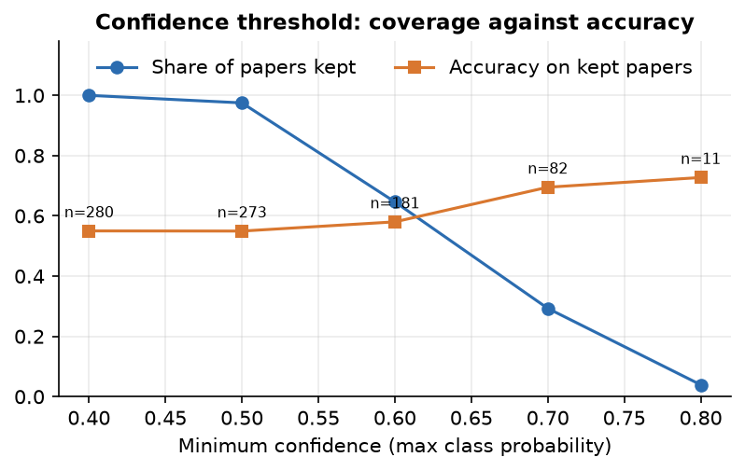  Figure 46: Share of papers kept and accuracy on them as the minimum confidence rises. | 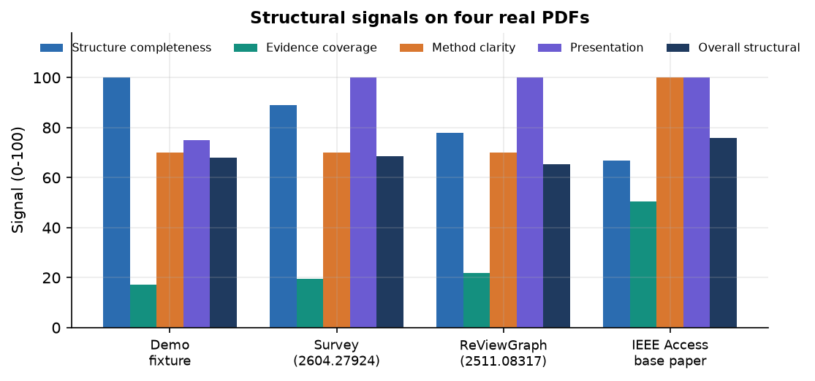  Figure 47: Structural signals on four real PDFs.

The first figure shows why the decision model cannot exceed about 0.56 accuracy on its data: the label of a paper is drawn from the same phrases that appear in its text, and the borderline class comes from both groups. The second shows that ranking time grows linearly with the directory because every reviewer profile is embedded again for each request; a cache of profile vectors is the first change for a larger pool. The light theme and the dialog above use the same code and data as the dark screens of Chapter 8, and were captured in the same session.

